FormulAI

Table of Contents

Document formatting 4

Analysis 5

Background 5

Idea Evolution 5

Original Idea 5

Final Idea 5

Supervisor 5

Research plan 6

Slot cars 6

Slot car racing 6

Slot car tracks 7

Slot cars 7

Hands on experience 8

Slot Car Research Summary 9

Existing solutions 10

Freescale Student’s Contest: Self-Driven Slot Car Racing 10

Freescale solution Reflection 13

Autonomous Slot-car System 13

Existing Solutions Research Summary 16

Reflection on Existing Solutions 17

Hardware Research 17

Microcontroller 18

Accelerometer 18

H-Bridge 20

Capacitor 21

Servo motors 21

Potentiometers and Controller Teardown 22

Line Detectors 23

Radio Receivers/Transmitters 24

Cameras 25

Hardware Research Reflection 28

Meeting 1 29

Meeting 1 Reflection 30

Similar solution: Amazon’s DeepRacer 31

Hardware 31

Software 33

Workflow 35

What I like about their solution 36

What I would do differently 37

AWS DeepRacer Summary 37

Reflection on the AWS DeepRacer example 37

Meeting 2 37

Meeting 2 Reflection 40

Motor drivers research 42

Technology and Algorithm Research 43

Programming Languages 43

OOP and Structural programming 44

Neural Networks 45

Supervised Learning 48

Reinforcement Learning 48

Neuro-evolution and NEAT 49

Computer vision 50

User Interface and Graphing 51

Technology and Algorithm research Reflection 51

Amended Project Statement 52

Initial Requirements 52

Initial Hardware Ideas 53

Digital potentiometer Idea 53

Servo Motor Idea 55

Motor Driver Idea 55

Initial Hardware Ideas Summary 56

Final Requirements 57

General Final Requirements 57

End User Interface Requirements 57

Data Collection and Processing Requirements 58

Machine Learning Requirements 58

Scope 59

Scope clarification 59

Potential Solution Modelling 60

Analysis summary and reflection 61

Documented Design 62

High-level Overview 62

IPSO considerations 65

Input 65

Processing 65

Storage 66

Output 67

Identifying Core Features 67

User Interface 68

Hardware Input 68

Hardware Output 69

Computer vision 69

Reinforcement Learning algorithm 69

Controlling Hardware 70

Hardware Input 70

Hardware Output 80

Reinforcement learning 84

Table Representation Research 84

Table Formatting considerations 85

Prototyping 86

Computer Vision 98

Image Classifiers 98

Colour Detection 98

Static Background Subtraction 98

Prototyping 98

Amending Final Requirement 9 119

Amending Final Requirement 11 120

User Interface 120

Diagram Explanation 121

Testing the User Interface 129

Documented Design Reflection 133

Glossary 134

References 135

# Document formatting

* Headings and subheadings will be larger text with a blue coloured font
* Reflections and Thoughts are labelled with a turquoise subheading. This makes my thought process throughout the investigation clearer.
* Each attachment should be labelled ‘*Figure*’, ‘*Diagram*’ or ‘*Code Snippet*’ along with a number.
* Meetings will be introduced in the format:
  + **Subject:**
  + **Duration:**
  + **Date:**
  + **In Attendance:**

and will be dictated using quotation marks and the Thin font style.

* Formulas and pseudo code will be in the Monaco Font.
* Green and Red coloured text indicates an advantage or disadvantage respectively.
* A blue asterisk * indicates that a hyperlink to the document referenced is included in the References section at the bottom of this document
* A red asterisk * indicates that the preceding word is defined in the Glossary section at the bottom of this document.

# Analysis

## Background

Since a young age I have always had an interest in cars and motorsport, so when I was deciding on a project to investigate, I had many ideas in relation to this topic. Growing up and studying at Dubai College has also fuelled my interest in STEM* subjects like Mathematics, Physics and Computer Science. A specific field of Computer Science I’m especially interested in is Machine Learning*. All of these interests led me to my original idea.

## Idea Evolution

### Original Idea

My original idea was to create a realistic racing simulator using accurate vehicle physics, then using the simulator I would try to find an optimum racing line around the track using machine learning. I was very enthusiastic about this idea, as it incorporated many of my biggest interests and looked like it would be a difficult problem to solve. However, after discussing this idea with my computer science teachers it became apparent that this project was far too complex to be an A-Level project and was closer to a master’s or PhD level project. After a long brainstorming session with both my Computer Science teachers, we finalized an idea that would interest me and be of sufficient complexity for an A-Level project.

### Final Idea

The idea we finalized was to create an Algorithm or Artificial intelligence that would be able to drive a slot car around a track. The main issue with my original idea was the difficulty of creating an accurate simulation. With this idea I don’t need to simulate physics, as I can just record data from a slot car obeying the laws of physics in real life. My investigative project is stated below

*To develop an Algorithm or Artificial intelligence that would be able to carefully and quickly drive around* *one or more slot car tracks.*

I realise that this statement is worded very vaguely, with the use of ‘carefully’ and ‘intelligently’. However, at this point in time I do not have a good enough understanding about my project to make this statement specific. Through further investigation I hope to modify this statement to be more quantitative, whether that be through a more specific and measurable investigation statement, or through detailed objectives and requirements.

## Supervisor

Since my project will be investigative, I will not have a client. However, I will have a supervisor that can give me good feedback and suggestions during the course of my investigation. Mr Mark Wood is the Head of Computer Science here at Dubai College and has been for almost 5 years. He will act as my supervisor for this project.

## Research plan

To give me a better insight into my project I will start with some research. To make sure I do a fully scoped analysis of my investigation, I decided to make a research plan. This will help me structure my analysis to result in a logical and complete collection of important information. A detailed analysis will help me make informed design choices.

|  |  |
| --- | --- |
| What I’m going to research | How will I research it |
| What is a slot car? | Primary and secondary research: Internet research and hands-on experience with a track I have purchased. |
| Existing and similar solutions | Secondary: Using the internet to find similar solutions and analyse them to see if there are any aspects I can use. |
| Hardware Research | Secondary: Using the internet to research and understand hardware components |
| My project’s scope and requirements | Primary: meeting with my supervisor |
| Hardware requirements | Primary: meeting with one of my Computer Science teachers who has experience with robotics and microcontrollers |
| Technology and algorithm research | Secondary: Using the internet to find examples of useful algorithms and libraries |
| Potential solutions based on requirements | Compare and contrasting my ideas to see which ones are the most suitable for my investigation. |

After I have finished my research and analysis, I can start to write up my requirements for this project. These requirements will be important, as everything I do for this project should be to fulfil the requirements. I will also be able to start modelling how I think my potential solutions might look like.

## Slot cars

A good starting point for this investigation is to research exactly what slot car racetracks are, and how they work. The results of this secondary research are summarized below.

### Slot car racing

Slot car racing is the competitive hobby of miniaturized racing using electrically powered vehicles, guided by grooves or slots within the track. Slot car racing ranges from casual gatherings to very serious competitions in which contestants thoroughly modify and improve their cars for optimum performance.

Slot car racing is based off real life motorsport events like Formula 1 Grand Prix; therefore, most slot car tracks are scale models of existing tracks like Silverstone in England. There are 3 common scales: 1:24, 1:32 and HO scale. The HO scale is a generalized scale, where scale models range from 1:76 to 1:87. Slot car sets are generally marketed as children’s toys, therefore there has been an increased demand for the smaller HO scale over time.

### Slot car tracks

Many commercially available tracks are made from injection-moulded plastic track pieces, which can be put together in multiple different arrangements, creating many possible tracks to race on. Professional tracks on the other hand are made with as few pieces as possible and have a single routed groove for the slot cars. This creates a smoother and more consistent surface to race on, but less flexibility for different track configurations.

The most important part of the track is the groove/slot in the middle (shown in figure 1). This groove provides two critical features for a slot car. Firstly, the cars don’t have any steering capabilities, therefore the slot is used to guide the car around the track. The second feature is to supply a voltage to the car. The maximum voltage that passes through a track can vary, but professional races use 12-14 volts and commercial tracks usually have 18-20 volts. To control the speed of the car, the voltage that passes through the slot can be controlled using the remote controller via a variable resistor (see page 22 for my controller teardown).

### Slot cars

A slot car is an electrically powered miniature vehicle that is guided by a slot in the track on which it runs. A pin or blade extends from below the car into the slot, which follows the slot in the track, causing the car to move around the track. Figure 1 below shows the internal components of a basic slot car.

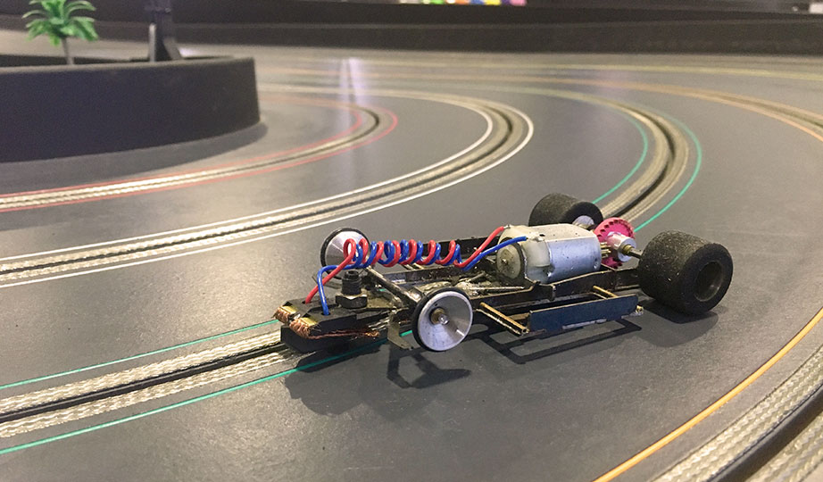

Electric Motor

Rear wheels drive the car forward

Electrical contacts

Front axle makes no contact with the track: no steering required

Figure 1 – Internals of a slot car

Slot cars have an electric motor that draws power from the track. The driver uses a handheld controller to control the voltage of the electricity passing through the track, in turn controlling the car’s speed. Since there is basically nothing holding the car to the track, except the pin at the bottom, it is very easy to get out of the groove (also called deslotting). Therefore, the goal for racers is to drive the car around the track as fast as possible, without coming out of the groove or flying off the track completely.

### Hands on experience

Scalextric is one of the leading manufacturers for commercial slot car tracks. I found and purchased a track listed on Amazon that I thought was suitable for my project (shown and annotated in figure 2).

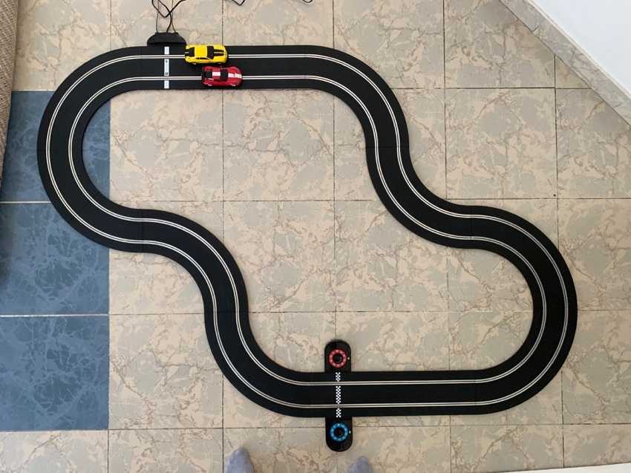

Power supply and controller connection

Total Track length: 484cm

150cm

200cm

Lap counter

Figure 2 – The track I purchased and the layout I will use throughout

The track I purchased has a total of 12 track pieces, which can be put together to make 4 different track layouts. Included are 2 slot cars, shown in figure 3, and 2 controllers.

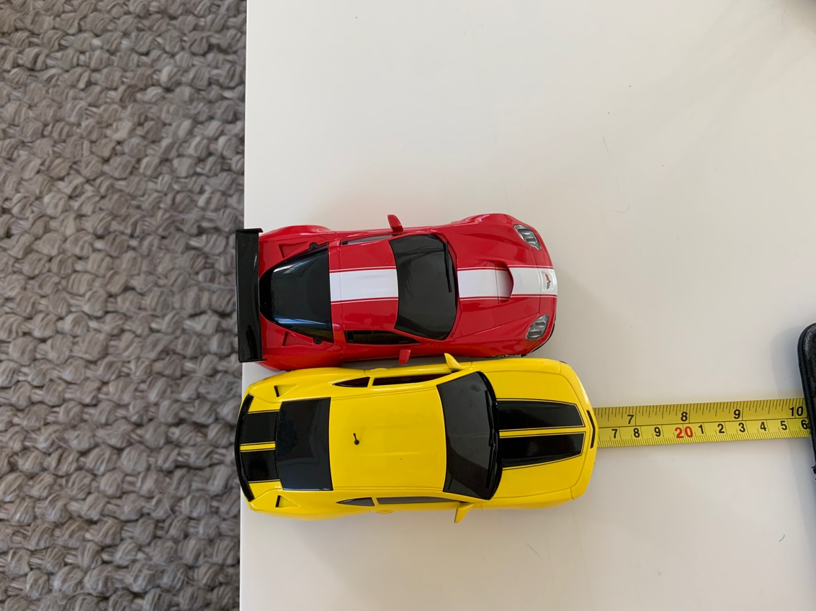After experimenting with the two cars, I realised a large difference between the two. The red car has a magnet which helps it stay on the track, allowing it to reach much higher speeds without deslotting, and making it much easier to drive. This also means that the voltage doesn’t have to be changed often, as the car doesn’t deslot with a high voltage around a turn. This makes it unsuitable for my investigation, as I want my AI to learn to drive a difficult car. Therefore, I will be using the yellow car in my investigation, as it doesn’t have a magnet. This means that the voltage has to be controlled constantly by the AI to prevent the car from deslotting, which is the exact purpose of this investigation.

Figure 3 – The two slot cars included in the set

The next aspects of the track I should consider are the 2 lanes. The inside lane is shorter, but has more severe turns, whilst the outside lane is longer and less severe. From my testing, I realised that the yellow car drifts around fast corners, and that it would often drift far enough that the back tyres would be off the edge of the track. Therefore, I decided it would be better to train the car on the inside lane of the track, as that provides the car with extra space to drift. Furthermore, this means that the car will experience more severe turns, therefore the voltage will have to be altered often and encourage the AI to learn to compensate for this.

On the packaging, it says that the track operates at 15V. I decided to prove this, and I brought the track to one of the physics labs and asked to use a multimeter to measure the voltage and current on the track.

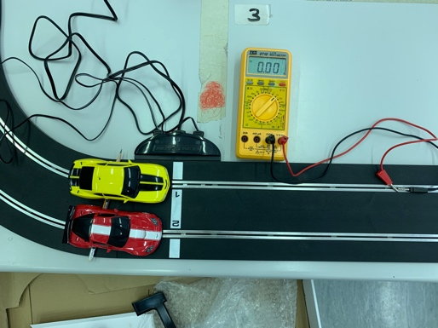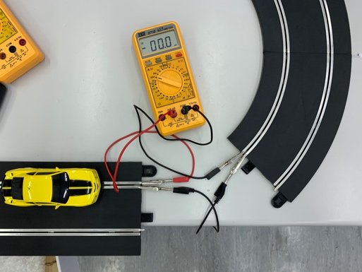

Figure 4 – testing the voltage and current on the track

From my testing I can prove that the voltage remained at a reliable 15V. What surprised me was that the current was so low. When the trigger was fully pulled (lowest resistance) the current reading was 1.2 mA. From these two measurements, I can calculate the total resistance in the circuit to be 12.5 kΩ. I measured these values to know which voltages and currents my hardware components need to be rated for.

The last aspect I measured was the height my iPhone camera needs to be set up at to get a full view of the track. To get an image like figure 2, I measured the height of the camera to be between 140-160cm above the track. However, I need to decide a way for my camera to be held, without obscuring the vision of the camera. See page 25-27 in the camera section of my hardware analysis for my proposed solution, and why I decided to use my iPhone camera as the input.

### Slot Car Research Summary

Slot car racing is a scaled down version of motorsport using miniature cars powered by an electric current flowing through the track. Slot car sets are usually sold commercially for casual use, but there are also highly competitive events where the same technology is used for intense miniature racing. The cars are controlled using a handheld controller, which regulates the voltage supplied to the track, more voltage results in a higher speed. The goal of slot car racing is to drive around the track as fast as possible, without the car coming out of the groove. The track I purchased has also given me some valuable information and two initial requirements that I can use in the later stages of my analysis. These requirements are:

1. The yellow, Chevrolet Camaro slot car will be used to train and evaluate my solution.
2. The slot car will be trained on the inside lane of the track.

This research has helped me to fully understand what a slot car is and how they work. Now that I have sufficient background knowledge, I can start looking into existing solutions.

## Existing solutions

I still have no idea what my solution will look like, therefore I decided it would be a good idea to research into existing solutions, to see if there is something I can learn from them. I will hopefully gain an understanding of what a solution might look like. At first, I didn’t think there would be any existing solutions, so I was expecting to have to search for self-driving RC cars or something else similar to my investigation. For good measure I decided to search for ‘Self driving slot cars’ on google. To my surprise I found many articles related to this topic. The first one I found was called ‘Self-driven slot cars powered by Freescale’. I decided this was a good place to start my research.

### Freescale Student’s Contest: Self-Driven Slot Car Racing

Freescale Semiconductor, Inc is an American semiconductor* manufacturer, which develops their products towards the automotive, embedded and communications markets. Freescale has collaborated with universities in Czech Republic, Slovakia and Romania to form a self-driving slot car competition. University students are provided with Freescale-made sensors and software to challenge them to make the fastest self-driving slot car.

I found a PDF document* from the Brno University of Technology outlining every aspect of the competition. Since my investigation is only concerned with the self-driving aspect, I will leave out the information like competition rules, and only include information that is relevant to my investigation.

The most important information about the competition is listed:

* Track is unknown to all contenders.
* Track is at a fixed voltage of 12 Volts.
* Track has a specified minimum and maximum distance
* Each contestant is given an Equipment and assembly guide.
* The car is allowed one practice lap to gather data.
* From the second lap onwards, the time is measured.

#### Hardware

I decided the first area I should research is the internal hardware in the slot cars. After a short while, I found the assembly guide* the students were given in 2010. The hardware requirements are listed below:

* Microcontroller
* Accelerometer
* H-Bridge
* Capacitor
* Mini USB connector
* MicroSD card slot
* 8,000MHz Crystal oscillator
* 1A Bridge Rectifier
* 3.3V Linear Voltage Regulator

This solution is extremely similar to my investigation, so there is a very high chance I will end up using many of the same components. Therefore, I decided to continue my research into some of these components in the Hardware Research section of my analysis. The information I’ll find will also help me during my meeting about the hardware requirements, as I will have some background knowledge.

#### Software

After assembling the slot cars with all the necessary hardware, the students are tasked to design a program that can control the car intelligently. I designed a workflow diagram (Diagram 1) that I believe most students adopted.

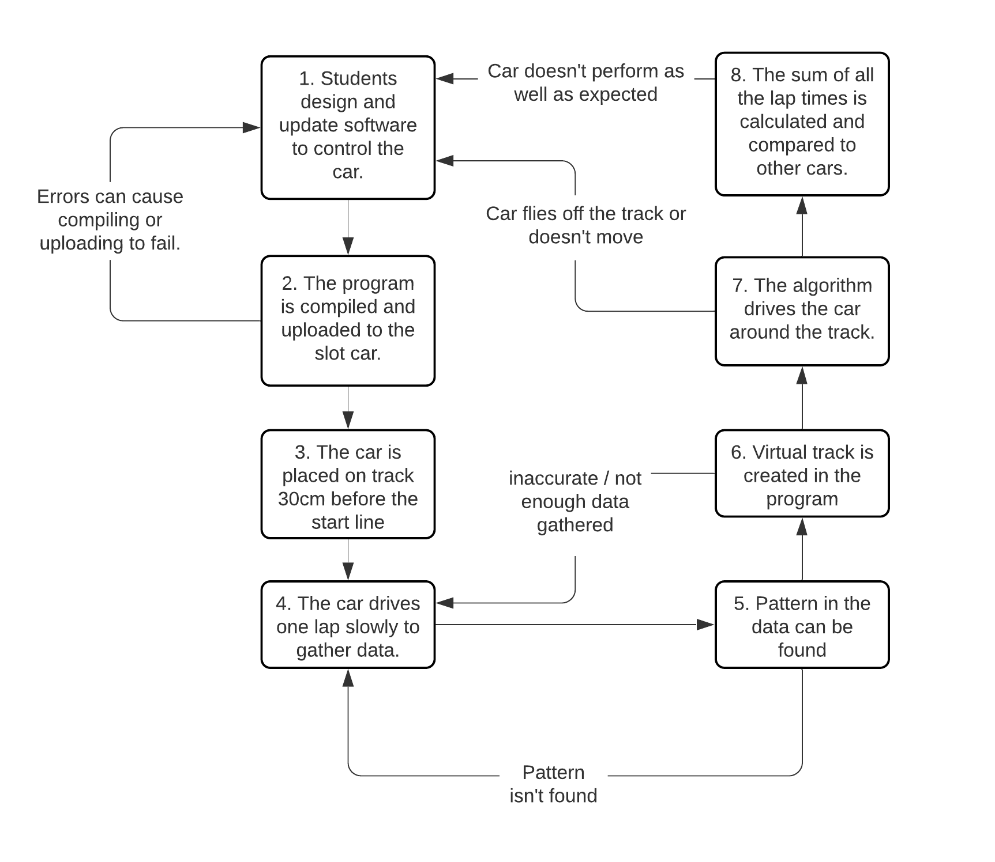

Step 6: Current accelerometer data is compared to predefined data to predict which track piece it could be on. These pieces are then put together to make a track.

Step 5: The car keeps track of its distance travelled. When it approaches the known value for the minimum and maximum distance, the 30cm of data is compared to the data within that range to see if it is repeated at any point. This is assumed to be the start of a new lap.

Step 3 is necessary for step 5.

Diagram 1 – Freescale slot car competition workflow diagram

#### What I like about their solution

The method by which the students controlled their car was very interesting. Every component needed was integrated onto the body of the slot car. This means that there is no need for any wireless communication between the car and an external computer, eliminating any delay this might cause. Moreover, this allows for very quick data transfer and computations within the car, which means that the car can make decisions more frequently.

Secondly, I like how this solution implements a microcontroller to control the car. The car becomes a standalone computer system* which can race without any computer or user input. This means the car is fully autonomous. Lastly, this solution is relatively cheap, and the hardware required is very common and easy to setup.

#### What I would do differently

The main issue I have with this solution is the way that they convert the accelerometer data into a virtual track (Step 6 on Diagram 1: explained in the annotations). I believe this prediction step in unnecessary and ineffective, as it can produce unreliable results and creates the need for this predefined data. This means that extra user input is required beforehand.

The next issue I have with this implementation is the pattern spotting needed to determine when a lap has passed (step 5). This step is another place where inaccuracies are produced, as the pattern spotting can lead to false assumptions and therefore unexpected results. For example, if it incorrectly assumes where the start line is, then every lap will have inconsistent accelerometer data. This means that the program can’t find patterns between laps and therefore not improve.

With regards to software, I wasn’t able to find any examples of the exact code the students produced. However, I did find a GitHub repository* that had code pertaining to another type of self-driving car competition also hosted by Freescale. Under the assumption that both competitions were given the same hardware components, I can predict that the code for both competitions will be very similar. A code snippet is shown below, and it is evident that they used a structural* programming paradigm*.

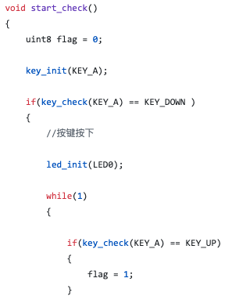

Microcontrollers usually have procedures like ‘setup’ and ‘update’ which encourages the use of structural programming. Structural programming has many advantages like making the code more reusable and easier to read. However, I believe that the Object-Oriented Programming* paradigm (OOP) is superior, as it drastically reduces the need for repeated code. Furthermore, the code can become more modular and protected, with the introduction of public and private attributes.

Code Snippet 1 – microcontroller code for freescale microcontrollers

My analysis of this solution has been summarised in Table 1 to make it more visual.

|  |  |
| --- | --- |
| What I like | What I don’t like |
| Every component is integrated onto the body of the slot car | Using predefined data to compare with current data to predict the track piece |
| No wireless communication needed | The pattern finding system to keep track of laps |
| Standalone computer system | One or more laps needed to create virtual track |
| High decision frequency (no delays caused by wireless communication) | Track needs to have a fixed voltage (controllers no longer work) |
| Cheap and easy to make | No use of OOP |
| little human input needed (no need to input track) |  |

Table 1

### Freescale solution Reflection

This analysis of the Freescale competition has given me a good understanding of what a solution to my investigation could look like. Additionally, the hardware they used is a good starting point for my hardware research. The table I produced at the end will also help me when I’m designing my own solution, as the information is neatly and clearly summarised. However, there were a few aspects of this solution that I wasn’t very fond of. Therefore, I decided to look for another possible solution to this investigation. I found another PDF document produced by university students from the Georgia Institute of Technology.

### Autonomous Slot-car System

Three students at a university in Atlanta, Georgia produced a report* on the topic of autonomous slot cars. I decided to research into their solution to see if they had solved the investigation differently to the students at the Freescale competitions.

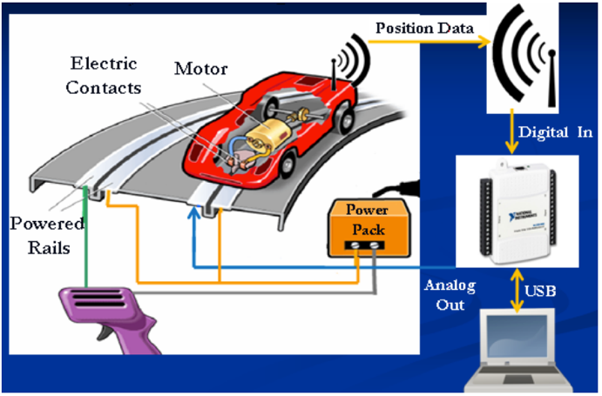The students’ goal was to modify an existing slot car so that it could control itself without the need for an externally held controller. They decided to use the following 3 subsystems to control the car.

* Determination of position
* Transmission of position data wirelessly
* Control of track voltage using the position data and a control algorithm

The basic idea of how three subsystems would interact is shown in Figure 5.

Figure 5 – A diagram showing how each system is interlinked

#### Diagram Description automatically generated with medium confidencePosition Detection

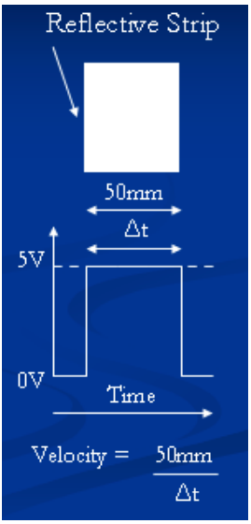The students decided to use a line detector and reflective tape to determine the instantaneous position of the slot car. The user would have to place a piece of reflective tape at regular intervals around the track (checkpoints, shown in figure 6). The Line detector would then output enough data to determine the speed and position of the car. The position of the car can be determined by counting the number of checkpoints passed. The speed can be calculated if the width of the tape is known. The formula for the calculation is shown in Figure 7.

Figure 6 – Checkpoints around a track

They use a second line detector at the start/finish line to detect when the car completes a lap. This is used to reset the car’s position in case it misses a checkpoint. This also prevents errors from accumulating over time.

The major problem of having checkpoints is that there is no continuous measure of position. The car’s location is a discrete measurement.

#### Wireless Transmission of Data

Figure 7 – Velocity calculation

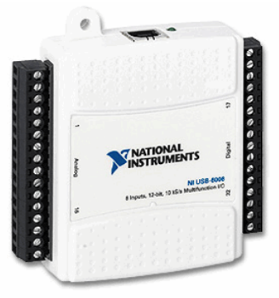Their solution uses a wireless transmitter attached to the car. It is necessary that the transmitter is very fast and has a strong signal, so that real time data can be sent to the controlling computer. The data is sent wirelessly to the computer via a National Instruments data acquisition device, what they call the NI-DAQ, Shown in figure 8. They did this because the device came with a software called LabVIEW, which allowed them to prototype and test their algorithms quickly. However, in the document they produced, they said that this was interchangeable with a microcontroller with network capabilities.

#### The Control Algorithm

Figure 8 – DI-NAQ

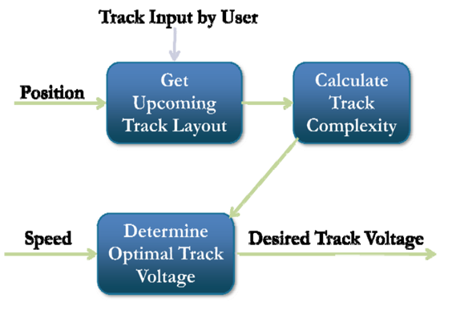Their algorithm has two main loops, the read loop and the control loop, which run simultaneously. The read loop gets input data from the NI-DAQ and determines when the car passes a checkpoint. This is then sent to the main control loop, which performs a calculation and returns the output voltage the track needs to be set at. A flowchart of the control loop is shown in figure 9. The track complexity is calculated using a simple formula and is a value between 0 and 1 (1 is most complex). The voltage is then determined with another simple formula. This output voltage is sent back to the NI-DAQ, which then controls the voltage to the track.

Figure 9 – control loop flow chart

The formulas they used is shown below.

k = Σ(1000mm – distance from car)(segment complexity)

* k is a measure for the final complexity (normalized to be between 0 and 1)
* Distance from car is determined using the checkpoint system
* Segment complexity is predefined for each part when the track is entered

Vest = 5 – 5k’

* Vest is the estimated output voltage
* K’ is the normalised value of k from the previous formula
* The number 5 is the max voltage that can be supplied
* For more complex parts, there is more subtracted from 5, Therefore lower voltage supplied.

The workflow diagram I designed for this solution is shown below (diagram 2)

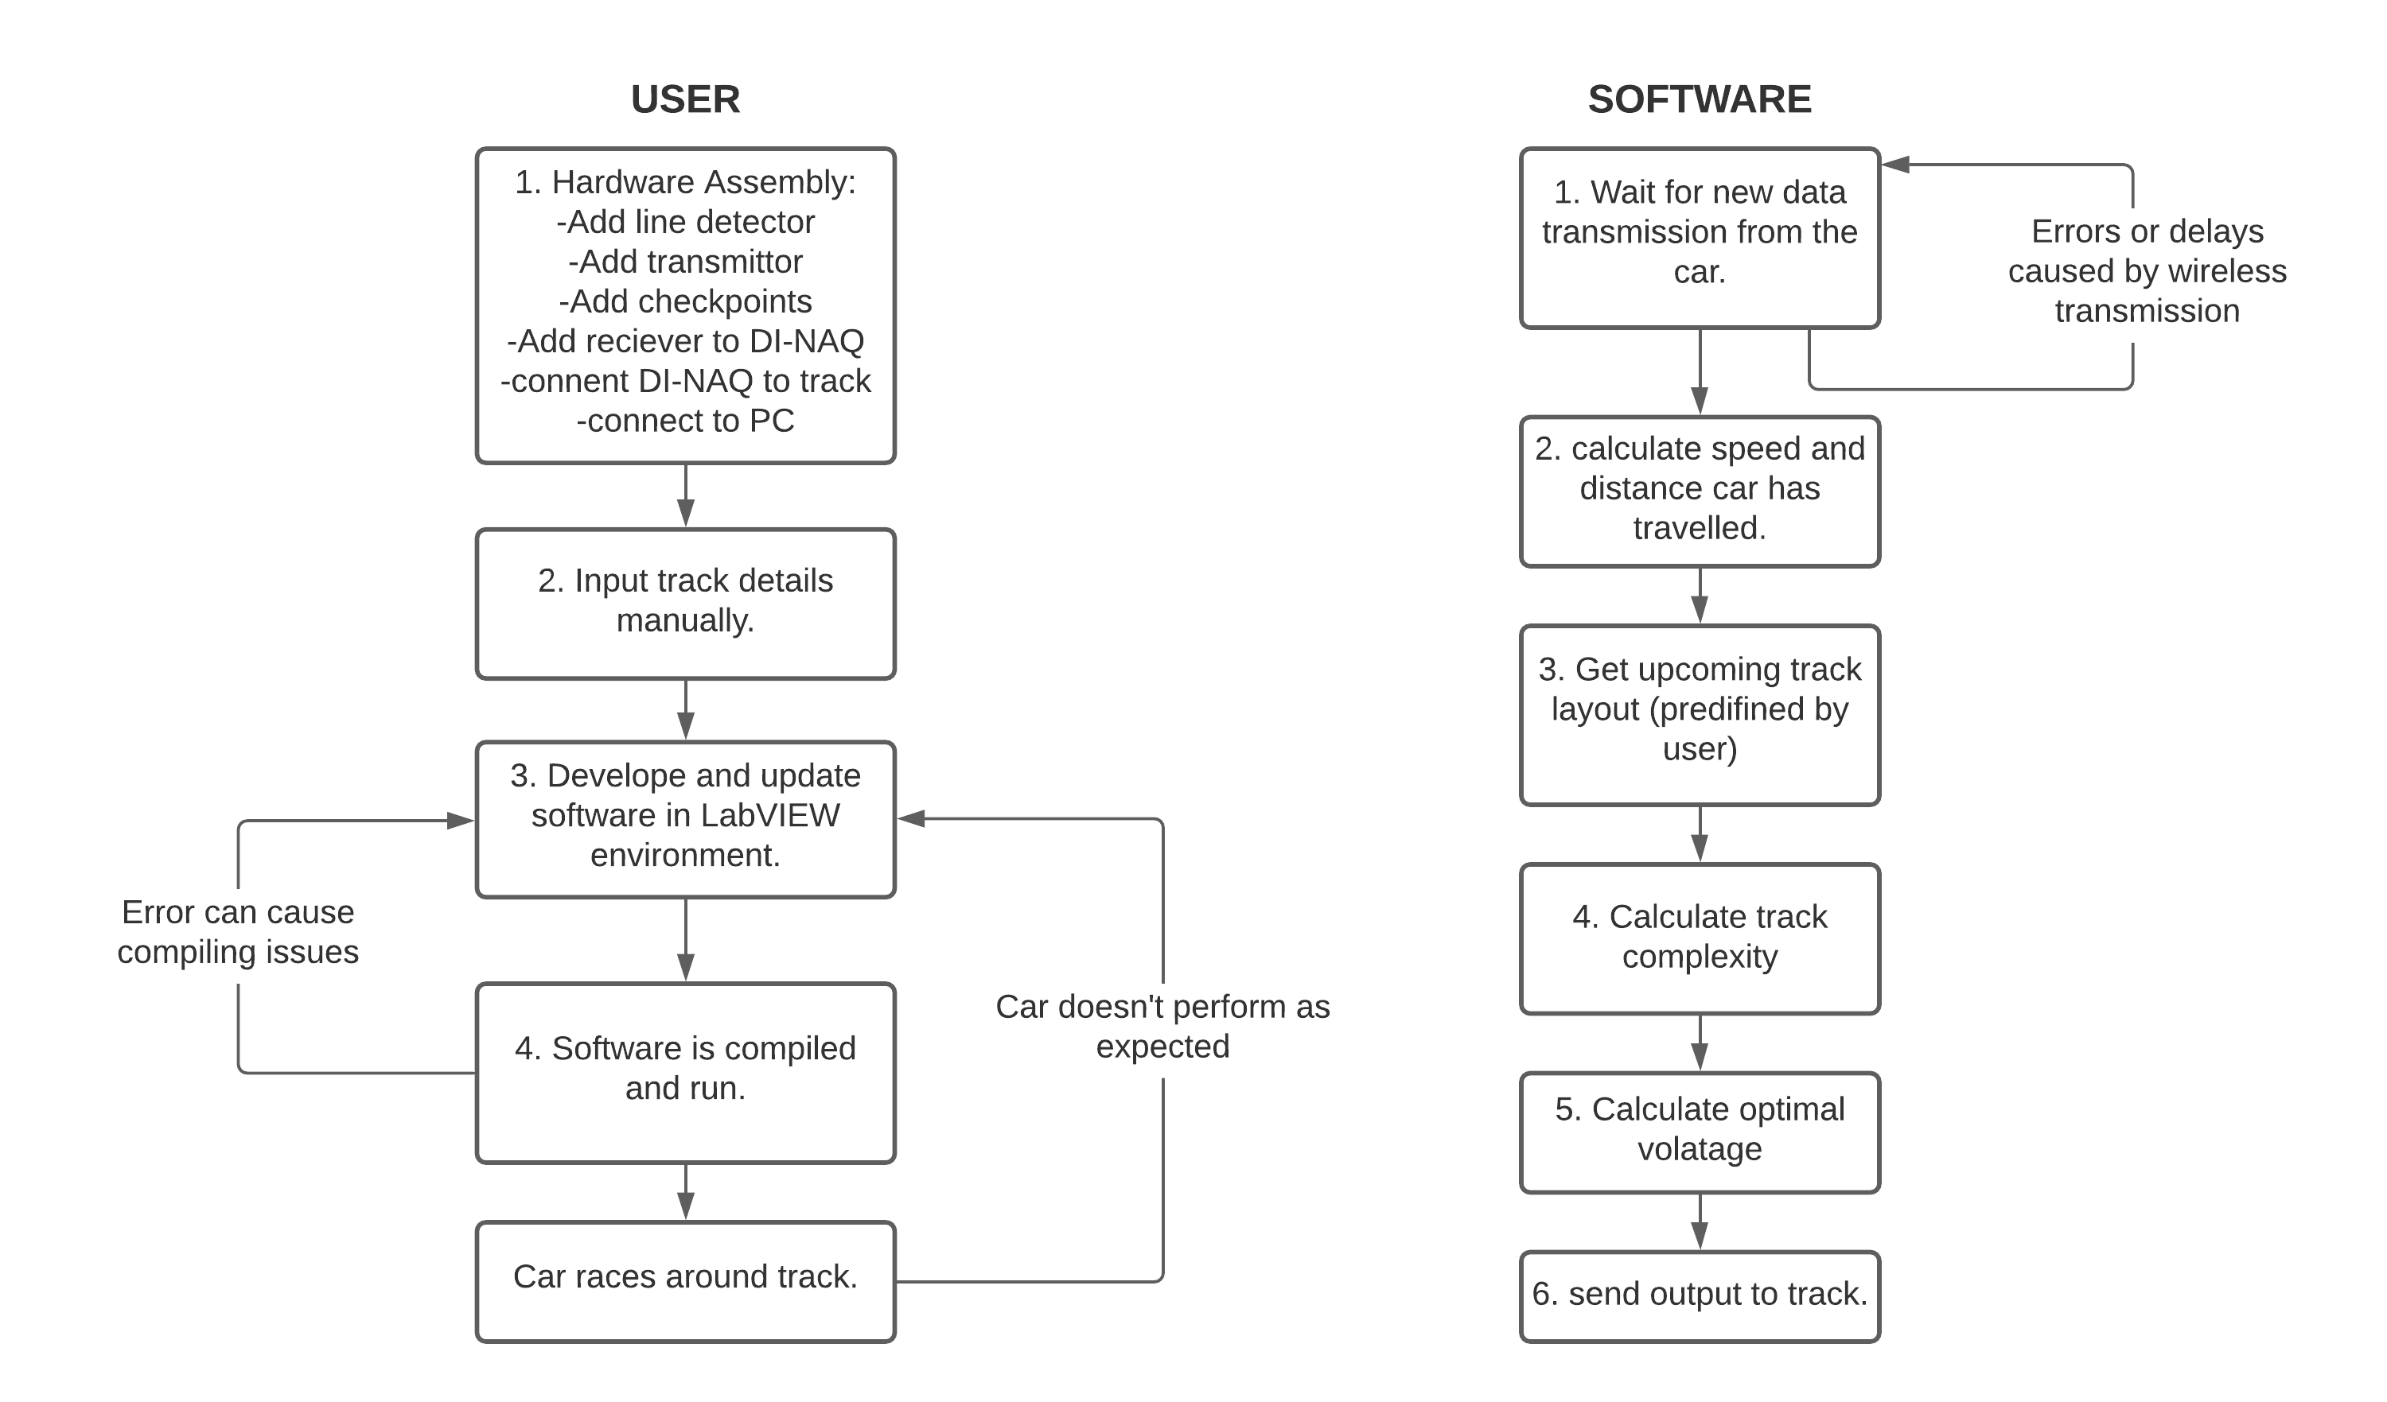

No need to have a practice lap

Software only has one source of error: Wireless communication (assuming user has input track accurately.)

Manual preparation has to be done

A lot of hardware installation.

Diagram 2 – UGA’s autonomous slot car workflow diagram

#### What I like about their solution

This solution uses a different approach to the problem. Instead of having the car as a standalone computer system, it communicates continuously with the computer controlling it. I like both solutions, but I can see a major advantage of this one. The progress of the car can be continuously monitored, which allows for fast debugging and updating. Furthermore, the behaviour of the car can be fully controlled from the computer.

I also the like the checkpoint idea they used. I think this method is very reliable and cost effective. The checkpoint idea is an easy solution to an otherwise difficult problem; finding the distance travelled. For example, the Freescale solution requires integration (a complex mathematical procedure) to determine the distance travelled. The checkpoint idea can also be more reliable than the Freescale solution, as small inaccuracies in data can cause big errors when doing integration, whereas the checkpoint system is much simpler.

Lastly, the algorithm they used to predict the optimum voltage is relatively simple, consisting of only 2 formulas. The simplicity results in a reliable and easy to debug algorithm. However, because of its simplicity, it could result in a sub-optimum solution when many environmental variables like a slope or friction are neglected.

#### What I would do differently

The one major issue I have with this solution is that the track details have to be manually input by the user. To be a fully autonomous slot car I believe that there should be minimal, or no user input. The Freescale example by comparison did not require the layout of the track to be input by the user.

Next, there is a lot of preparation that needs to be done before the car can start racing. Although I like the checkpoint idea, I believe that it might be too much effort to setup and rearrange if the track is changed. Furthermore, the fact that the user has to stick the tape on the track introduces human error. If a piece of tape is stuck diagonally or at the wrong distance, that entire part of the track will have inaccurate results. The car’s position is discrete, so if the data is wrong, that entire section of track will have wrong data.

Lastly, I think the use of the DI-NAQ just for the LabVIEW software isn’t smart. It is expensive and bulky (a big device). I think an alternative solution, like a microcontroller, would be cheaper and prettier. Furthermore, there are development environments similar to LabVIEW for most of the modern microcontrollers.

I decided to summarise my analysis of this solution into Table 2 to make it more visual and allow me to compare both solutions more easily. Sadly however, I was not able to find any documented code relating to this project, so I cannot criticise the programming paradigms and algorithms they used.

|  |  |
| --- | --- |
| What I like | What I don’t like |
| Continuous communication between car and computer | A lot of preparation needed |
| Easy to debug and update | A lot of user input needed |
| Reliable and cheap checkpoint idea | Hard to use on multiple different tracks |
| Simple control algorithm | Wireless communication can cause delays |
| Car doesn’t need a practice lap | DI-NAQ should be replaced with a microcontroller |
| No permanent changes to the track made (i.e., voltage isn’t changed to be constant) |  |

Table 2

### Existing Solutions Research Summary

The two solutions that I have analysed are both effective and relatively cheap solutions. They differ from each other, but there are three common aspects. In both solutions they have had to modify an existing slot car with extra hardware. The data from this hardware is then converted into a predicted / virtual image of the track. From this image, their software algorithm is able to intelligently control the slot car.

In the Freescale solution, the car is made to be a standalone computer system, which means that all the data collection, computations, and decisions are made on the car. In the other solution they used a wireless transmitter and receiver to transfer data from the car to the PC, which then controlled the voltage on the track.

The Freescale solution used an accelerometer to measure the acceleration felt by the vehicle in its practice lap around the track. Moreover, the integral of the acceleration can be used to calculate the car’s current velocity, and the double integral can be used to calculate distance travelled. The other solution used a cheap but effective checkpoint system, where they placed reflective markers on the track at regular intervals. When the car passed over these, they can determine the speed and position.

In the Freescale solution the track was at a fixed voltage, so the voltage was controlled using an H-bridge circuit. This means that the controllers are no longer connected. In the other solution the voltage was controlled by mimicking the job of the controllers. This also means that if the controllers are reconnected, the track could still function as normal.

### Reflection on Existing Solutions

After completing my existing solutions analysis, I feel that I have gained a basic idea of what solutions to my investigation might look like. Both solutions have their benefits and drawbacks, and I’m certain that I can benefit from this research when I start comparing potential solutions. Some initial requirements this research has provided me are:

1. Extra sensory hardware needs to be used to determine the car’s speed and displacement on the track.
2. The car will not be a standalone device and will instead be controlled by an external PC.

The reasoning behind initial requirement 4 is that a standalone device will not provide me with constant information on the status of the car. If there are bugs or errors in the code, it will provide me with no feedback, as all the data is collected and processed on-board, with no data transferred back to me. This makes debugging much harder. In contrast, if I control the car’s behaviour from my pc, I am able to access all the data, which makes debugging much easier. From these solutions it is evident that I will need to incorporate extra hardware into my solution. Therefore, I decided to do some Hardware research.

## Hardware Research

This section of my analysis is focused on researching hardware that I might need to use in my solution to the investigation. Researching each component individually will give me a better understanding of how they work, and how they should be used. Eventually I will be able to use this research to make informed choices about which pieces of hardware I will use. The components I will research are listed.

* Microcontrollers
* Accelerometers
* H-Bridges
* Capacitors
* Servo motors
* Potentiometers and controller teardown
* Line Detectors
* Radio Receivers/Transmitters
* Cameras

### Microcontroller

In the Freescale Racing competition, the microcontroller is the main electrical component that controls the car. It is capable of processing incoming data and giving an output. The full documentation* for the microcontroller supplied by Freescale can be found in the references section. There are two main reasons why I will not use this specific microcontroller in my investigation. Firstly, it is severely outdated (2010). Many newer microcontrollers have better performance in a smaller package (Arduino Pro Mini for example). Secondly, better performing microcontrollers are also more readily available.

This microcontroller can be replaced with many other microcontrollers that can perform the same purpose. Popular choices are Raspberry Pi’s or Arduinos. I decided to do some research into the most popular microcontrollers, just in case I decide to use one in my solution. Both Raspberry Pi’s and Arduino Uno’s are very popular, due to their availability, price, flexibility and performance. I decided to gather their pros and cons into a table so that it’s more visual and easier to understand.

|  |  |
| --- | --- |
| Raspberry Pi (RP) | Arduino Uno (AU) |
| Minicomputer: can run multiple programs at once | Only runs one program at a time |
| Difficult to power by battery | Lower power usage |
| Expensive | Lower cost |
| Can connect to internet network | Requires extra hardware to connect to networks |
| More I/O capabilities | Less I/O (out of the box) |
| Mainly Python | C / C++ |

Table 3

From the table it is evident that the Raspberry Pi is more powerful overall, however I believe that the Arduino Uno is more fitting for this investigation. Firstly, only 1 program will need to be executed at a time, therefore the RP and its own operating system will bring added unnecessary complexity to the investigation. Secondly, the RP has a high power-consumption. Although the track has a constant flow of electricity, if the car flies out of the track the source of power is removed and the program running on the RP will undoubtably crash with no progress saved. Due to these reasons, I believe a smaller microcontroller like the Arduino would be more suitable, as they can be powered by battery. If I do decide to use an Arduino Uno, I will have to learn C and C++, which I already have a little bit of experience with.

### Accelerometer

The next electrical component I wanted to focus on was the accelerometer. In the Freescale racing solution, each car is only allowed one practice lap around the unknown track, therefore accurate and continuous data is essential. The students chose to use an accelerometer as they are easily accessible, lightweight, very small and have a low power consumption. It’s possible that I’ll be using an Accelerometer, so I thought it would be beneficial if I researched how they worked exactly.

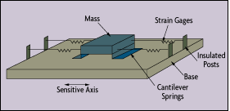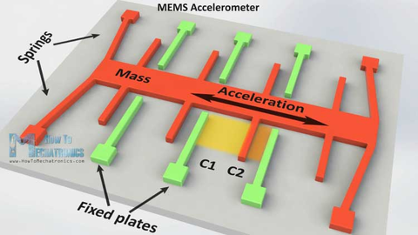An accelerometer is a device that can measure a change in motion of the component. Due to Newton First Law*, the force caused by a change in motion causes a suspended mass to “squeeze” the piezoelectric material, which produces an electrical charge. A piezoelectric material* is a material that releases an accumulated charge in response to mechanical stress being applied to it. The charge released is proportional to the acceleration, therefore harsher vibration means higher charge output. This type of accelerometer is called a piezoelectric accelerometer and is shown in figure 10. There is another type of accelerometer called a capacitive accelerometer, shown in figure 11. The image shows what is called a ‘g-cell’ made from semiconductor materials like polysilicon. The orange mass is suspended by springs and is able to move between fixed beams which are capacitors. As the mass moves, there will be a change in distance between the mass and the plates, which can be measured by the change in charge between the two capacitors. Acceleration is measured in g’s for both accelerometers.

Figure 11 – Capacitive accelerometer

Figure 10 – Piezoelectric accelerometer

When doing some research into the differences between these two accelerometers, I found a PDF document* titled ‘Choosing the right accelerometer’. I have summarised the contents of the document in the table below.

|  |  |
| --- | --- |
| AC Accelerometers | DC Accelerometers |
| Example: Piezoelectric accelerometer | Example: Capacitive accelerometer |
| Output is AC coupled | Output is DC coupled |
| Cannot measure static acceleration like gravity or centrifugal acceleration. | Can be used to measure static and dynamic acceleration |
| Small amplitude variations | Higher accuracy |
| Lightweight and small size | Cheap and widely used (in car airbags and mobile phones for example) |
| Suited for dynamic measurements in lightweight structures | High frequency noise can be missed. |

Table 4

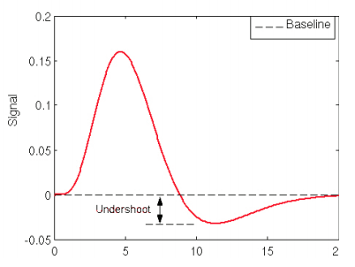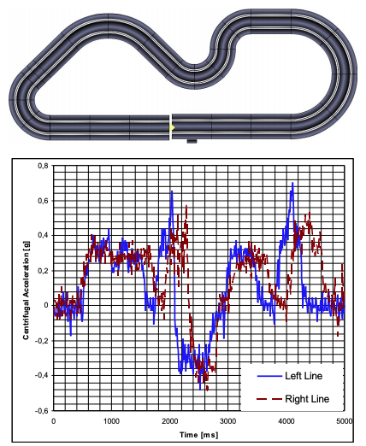From the table it is evident that the DC accelerometer is more suitable to my investigation. The major drawback of the AC accelerometer is that there are amplitude variations. An example is shown in figure 12. AC-accelerometers experience some undershoot when the mass returns to its resting position. These minor inaccuracies can cause problems if the acceleration reading is used to calculate velocity and distance through integration.

Slight delay

The primary reason why I believe the DC accelerometer is more suitable, is because of the higher accuracy. A slot car doesn’t experience massive accelerations, so accurate measurements for small values will be beneficial. Furthermore, a machine learning algorithm only performs well if it’s given accurate input data. The only major problem with a DC accelerometer is the low signal to noise ratio. Signal to noise ratio (SNR) is the ratio between the useful input (signal), and useless background input (noise). This means that with extremely small readings, it might be difficult to distinguish the useful data from the useless background noise. However, the car will experience values that are high enough to be easily distinguished from noise and I think the variability introduced by the background noise will be less detrimental than the undershoots experienced by AC accelerometers.

Figure 12 – AC accelerometer readings

Figure 13 – accelerometer reading for specific track

In the Freescale students’ competition, the competitors used a capacitive accelerometer to measure centrifugal forces* experienced by the car while it was on track. The results are shown in figure 13**.** The graph is the accelerometer reading from a car traveling around the circuit shown above it. This graph proves to me that implementing an accelerometer into my investigation will give me accurate and meaningful data to work with.

### H-Bridge

An H-bridge is an electronic circuit that switches the polarity of a voltage applied to a load. In other words, it can control which direction the motor will spin. In the case of the students’ competition, the H-bridge is integrated within another circuit which is able to vary the current given to the motor. Together, the user has complete control over the direction and speed of the motor. This usually isn’t seen on default slot cars, as the voltage is varied using the handheld controller. However, in the competition the voltage is fixed at 12V because there is no input from the controller. Therefore, this circuit is needed to control the speed of the car.

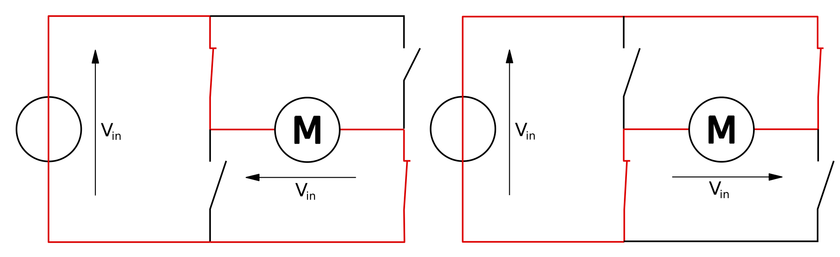

Voltage applied

4 switches

The motor

Figure 14 – H bridge circuit

Figure 14 shows the two possible states of the H bridge. The red line shows the path the current takes. This simplified diagram of an H-bridge has a problem where both sides can be open for the current, causing a massive current to pass through. However, most H-bridges have extra circuits which prevent this from happening. It is unlikely that I will need to integrate an H-bridge circuit, because they’re only used when the track is at a fixed voltage. I probably won’t be changing the voltage on the track to be fixed, because I still want to be able to control the car with the controllers.

### A picture containing indoor, footwear Description automatically generatedCapacitor

A capacitor is a passive electric component that can store electrical energy in the form of electrostatic energy in an electric field. They store very little amounts of energy compared to batteries. In the documentation about the students’ competition, it says that the capacitors are only used to supply a short burst of energy. When a car passes a crossing in a track (shown in figure 15) it loses contact with the track for a brief period. When the microcontroller experiences a sudden loss of power due to a deslot or a crossing point, the program running will stop. The capacitors are used to solve this. This can also be prevented by making the microcontroller battery powered, but that increases the weight of the car drastically. If I decide to use an on-board microcontroller, it is likely that I will need to use a capacitor or battery to power it when the car deslots.

Figure 15 - crossing

### Servo motors

A servo motor is a rotary or linear actuator that can be precisely controlled to provide a specific angular or linear position. There are three basic types of servo motor: Positional rotation, Continuous rotation, linear movement. Positional rotation servo motors have a rotation axis of 180°, whereas continuous rotation servo motors can rotate continuously in both directions. Linear servo motors use a rack and pinion mechanism to convert rotation into linear motion. What’s special about servo motors compared to others is that it provides feedback information on the position of the motor, which allows for small adjustments to be made if it’s not in the correct position. Both analogue and digital servo motors are controlled using PWM* (pulse width modulation), and most Arduino microcontrollers are able to output signals using this method. If I use a servo motor, I will likely use a microcontroller to control it.

### Potentiometers and Controller Teardown

A potentiometer is a type of variable resistor. A variable resistor is an electrical component that can change its ohmic resistance value through either mechanical action (potentiometer) or electronically (digital potentiometer).

#### Diagram Description automatically generated[Mechanical] Potentiometer

A potentiometer changes its ohmic resistance by changing the distance that a current has to flow through a resistive material. This has to be done through physical means like twisting (shown in Figure 16) or sliding. For my solution, the computer or the car will need to be able to control the voltage, therefore I might need to use a digital potentiometer.

Figure 16 – mechanical potentiometer

#### A picture containing text, hanger Description automatically generatedDigital potentiometers

A Digital potentiometer performs the same function as a Potentiometer but can be controlled using digital signals. This is done using a circuit called a resistor ladder (shown in Figure 17). At every step of the ladder there is an electrical switch. The current travels through the resistors until they reach a step where the switch is closed, and it can pass through. The resistance is changed by changing the number of resistors the current has to travel through.

Figure 17 – Digital Potentiometer

#### Controller Teardown

After finishing my experimentation with the track I purchased, I decided to teardown one of the controllers to see how they were altering the voltage applied to the track. Figure 18 shows two images I took showing the potentiometer inside of a controller.

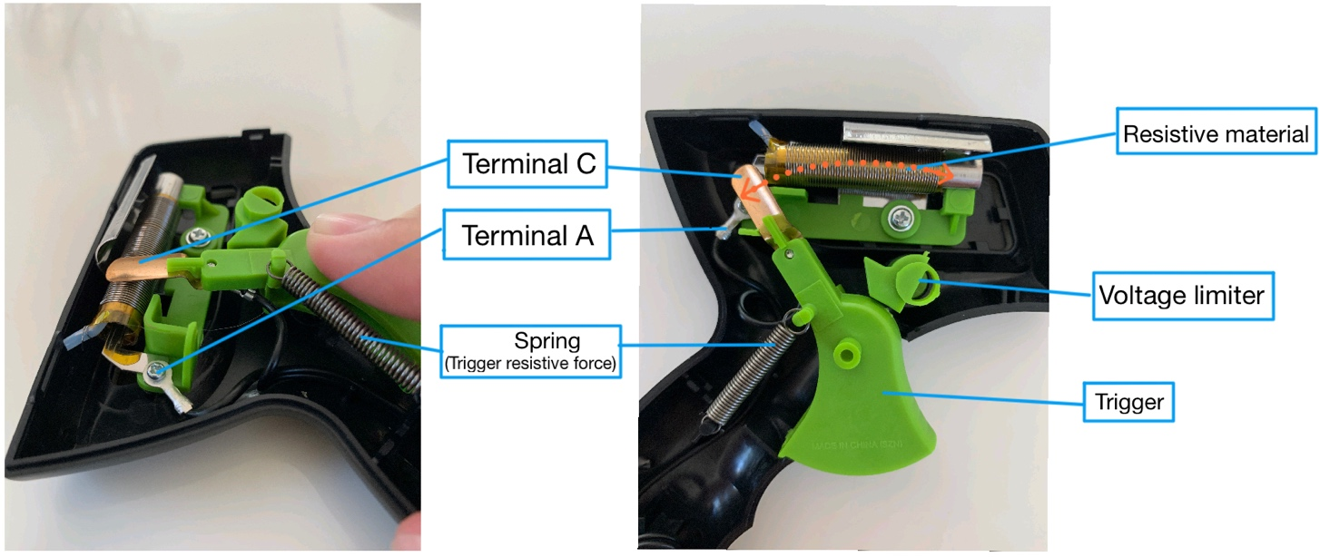

Figure 18 – Controller teardown

The potentiometer used is a sliding mechanical potentiometer. The trigger is attached to one terminal, which moves according to how much the trigger is pulled. When the trigger is not pulled, the circuit is broken and no current passes through, therefore the cars don’t move. As the trigger is pulled, the resistance becomes less and less which causes the cars to speed up. If I am able to attach these terminals to a potentiometer I can control, then I will be able to control the voltage applied to the track, by mimicking the function of the controller.

#### Resistance’s effect on the slot car

The slot car’s speed is dependent on the voltage it is supplied with. I decided to research how increasing the resistance in a circuit causes the slot car to slow down.

There are two important laws which explain this; the first is Ohm’s Law*. Ohm’s Law is the fundamental law of electricity. It states that:

Current = Voltage / Resistance

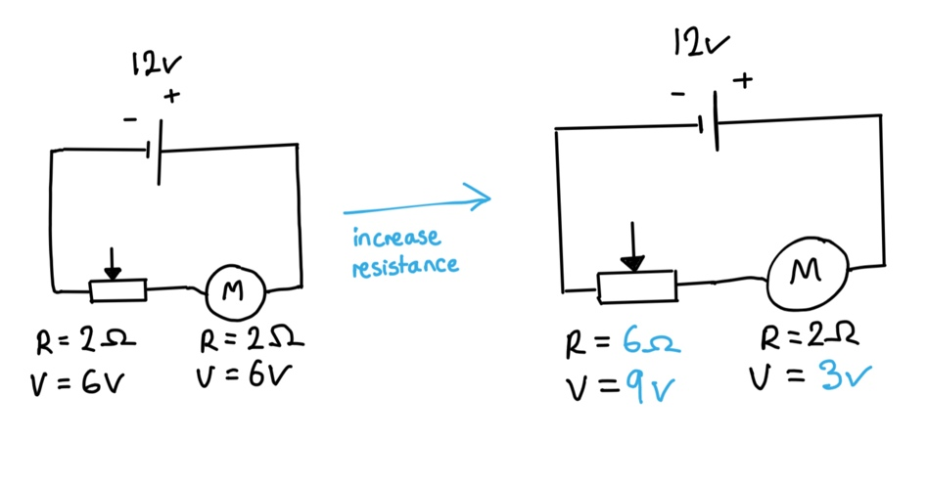Potentiometers allow the resistance to be changed, which in turn changes the voltage. If the potentiometer produces a higher resistance, the voltage across that individual component must increase. The second important law is Kirchhoff’s Voltage Law*, which states that the algebraic sum of the voltages in a closed loop is always equal to zero. In other words, the voltage supplied by the battery is shared between the components proportional to their resistances. If the voltage across the potentiometer increases, the voltage remaining must decrease. This is explained in the circuit I drew shown in Figure 19.

Figure 19 – Ohm’s and Kirchhoff’s Laws

When the resistance across the potentiometer is increased, so does the voltage due to Ohm’s Law. This means that the motor is supplied with less voltage, therefore making the car slow down.

### A picture containing text, device Description automatically generatedLine Detectors

Figure 20 – Line detectors

A line detector works by sending infra-red radiation at a surface and measuring the intensity of the reflected radiation. Lighter surfaces will reflect more IR than darker surfaces, which allows the detector to differentiate between the two. A line detector was used by the students in Georgia to measure when the car had reached a checkpoint. Figure 20 shows how a lighter surface will reflect more IR than a dark surface.

When electromagnetic radiation meets a surface, it is reflected or absorbed depending on the surface. If the radiation is absorbed, then less radiation can be given out. Objects that absorb more radiation, will also absorb more light and therefore look darker.

If I decide to use the checkpoint idea that those students adopted, I will probably need to use a line detector in my solution. They are relatively cheap and can be bought on amazon for less than $5.

### Radio Receivers/Transmitters

One method of transferring data wirelessly is to use radio waves to carry the data. There are two pieces of hardware necessary, a receiver and a transmitter. The transmitter creates the radio waves, and the receiver absorbs them and creates an output.

#### Radio transmitters

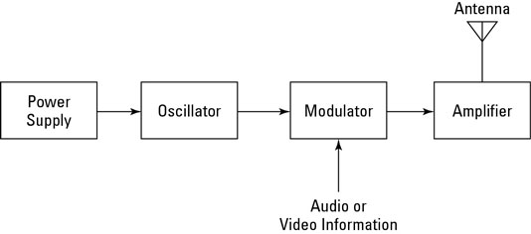The transmitter is responsible for creating and sending a radio wave encoded with data. It does this using the five parts listed.

* Power supply
* Oscillator
* Modulator
* Amplifier
* Antenna

The power supply provides the necessary power needed by the oscillator. The oscillator creates an AC current at a specific frequency, which is then called the carrier wave. The modulator encodes the carrier wave with the necessary information using either amplitude modulation* (AM) or frequency modulation* (FM). The modulator makes slight changes to the amplitude or frequency of the wave. The slight changes represent data and can be read by the receiver. The amplifier increases the carrier wave’s power and then the signal is converted to a radio wave and sent out via the antenna. This process is shown in Figure 21.

Figure 21 - Radio Transmitter

#### Radio receivers

The receiver does the opposite of the transmitter. It absorbs and decodes the data carried by the radio waves. The main components of the receiver are listed.

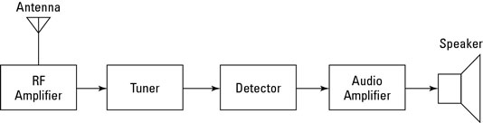

* Antenna
* RF amplifier
* Tuner
* Detector

Signal Amplifier

* Signal Amplifier

Figure 22 – Radio Receiver

When the antenna is exposed to radio waves, a small alternating current is induced in it. The RF amplifier strengthens the weak radio signal from the antenna. The antenna captures all frequencies of microwaves, so a tuner has to be used to select a specific frequency. It uses a circuit with a specific frequency, called the resonating frequency, to block out any AC signals that are below or above it. The detector then decodes the information from the carrier wave. The output is amplified by the signal amplifier and can be used by another device like a speaker.

There is a good chance that I will need to use both a transmitter and receiver in my solution. There are two ways I could transfer data gathered on the car to my PC: Wired and wireless. I decided to do some research into the advantages and disadvantages of wireless communication compared to wired.

|  |  |
| --- | --- |
| Advantages | Disadvantages |
| Enable mobility more easily (wires won’t get tangled when the car moves round the track) | Relatively expensive (usually wireless transmission is cheaper, but I’m using short range communication, so a single wire would be cheaper). |
| Easy to setup and expand | More unreliable than wired transmission |
| Increased range of use | Could have a slight delay between transmissions |

Table 5

The major advantage that wireless communication has for my investigation is that I don’t need to use a wire to connect to the car. This means I won’t have to deal with any tangled/unplugged wires, and the car is free to move without being affected by the weight of the wire. Furthermore, wireless transmission has become increasingly effective over time, meaning that data is rarely lost or corrupted. One drawback of wireless transmission is the delay. Although the signals travel very quickly, the converting and amplifying can cause a delay when transmitting data. I will need to work around this if I decide to use wireless transmission.

### Cameras

The last piece of hardware I wanted to research was cameras. My initial idea for data collection was to use a camera above the track to follow the movement of the car. I decided to research into a few cameras that I could use.

#### iPhone Camera

I own an iPhone which has a decent camera module in it (To see the exact specifications, go to page 28). If I can access the live camera feed on my computer and use it as data for an image processing software, I won’t need to buy a camera. Sadly, after researching this I found out that Apple doesn’t have this feature. However, there are a few third-party applications that can allow access to the camera for use as a webcam. I decided to try using EpocCam.

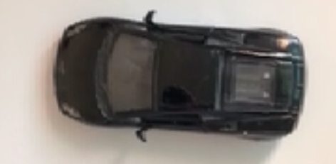For my first test I needed to install EpocCam on my iPhone and my Mac. After downloading the free version of the app on my phone and laptop, I was able to connect them. I decided to test it as a webcam first.

Figure 23 – Images from my iPhone camera to my laptop

Figure 23 is a collection of 3 screenshots I took on my mac from my iPhone camera. It is very obvious that the Free version of EpocCam doesn’t give a high-definition Image. However, the proof of concept has been established, since I could access the live feed from my laptop. The next test was to see if I could use this image feed as data into an OpenCV python program.

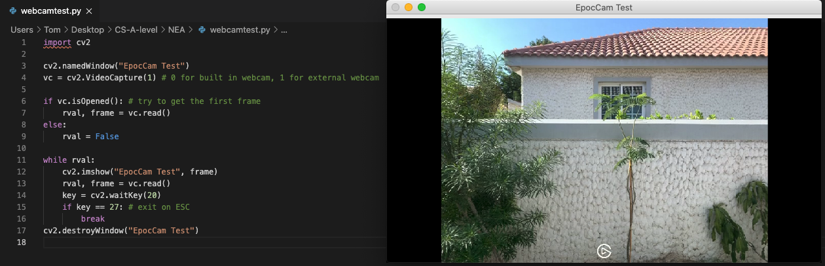

Figure 24 – test OpenCV for EpocCam video feed

Figure 24 shows a basic OpenCV test program and the output. OpenCV can support external webcams and luckily the EpocCam input could be used. The connection was made wirelessly over WIFI, which means that the phone doesn’t have to be plugged in via USB for this to work. I wasn’t able to find any guide online about connecting an iPhone camera to OpenCV, so it was a pleasant surprise when I got it working.

If I decide to use this camera approach, there are two important factors to consider. Firstly, I would need to purchase the $9 full EpocCam application. This would provide me with a higher quality image and therefore more accurate data. Secondly, there is quite a bit of delay between the camera feed and the feed shown on my laptop (about 200ms). This means that the data I gather will be delayed and therefore my algorithm’s output as well.

#### Camera Modules

If I decide to use a microcontroller, there is a chance that I’ll want to provide it with camera images. I decided to look into the OV7670 camera module that is compatible with the Arduino Uno microcontroller and can be bought for $5 on amazon.

I found an example project called face tracking camera*. It is a series of video tutorials of how to assemble and code a machine that will move to track a face. The image captured by the camera module is sent via the Arduino to the computer, which then instructs the servos powered by the Arduino to move a specific way. However, there are two issues with using a camera module for my application. Firstly, I need to use computer vision to analyse the image, so the faster CPU in my laptop will be better suited to this. This means that the image needs to be sent to my laptop, not the microcontroller, removing the need for a compatible camera module in the first place. Next, the camera quality on my iPhone will likely be better than the quality of a $5 one, which tempts me to use the iPhone camera instead.

#### Diagram Description automatically generatedCamera Mount

If I decide to use a camera, I will need a way of suspending it above the track. My first thought was to use a camera tripod, but there is an obvious flaw in this idea. Since the camera will be facing downwards, the tripod will just be getting in the way of the image produced. To counteract this, I thought of a relatively simple but silly solution shown in figure 25.

This solution will ensure that the phone remains stationary and has a full view of the track. However, there are multiple disadvantages to this design. Firstly, I will need to manufacture it myself, because it has to be a custom size. This means I will need to buy the raw materials and ask for permission from the DT department at DC. Furthermore, this design is very bulky and not very portable.

Figure 25 – camera holder v1

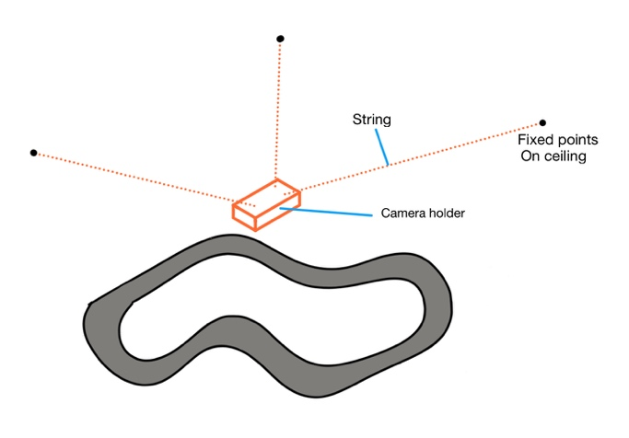The other thought I had was to suspend the camera from the ceiling using a rope. One obvious flaw in this approach is that the camera won’t be fully stationary, as it could start to swing due to wind from the AC or people moving around it. This led me to my final design, shown in figure 26. The design uses three strings connected to the ceiling to suspend the phone mount. The three strings in combination should counteract any forces caused by wind and cause the phone to remain relatively stationary. The solution is also cheap and easy to set up. For example, I could attach the string to the ceiling using duct tape or magnets.

Figure 26 – camera holder v2

#### Image Distortion

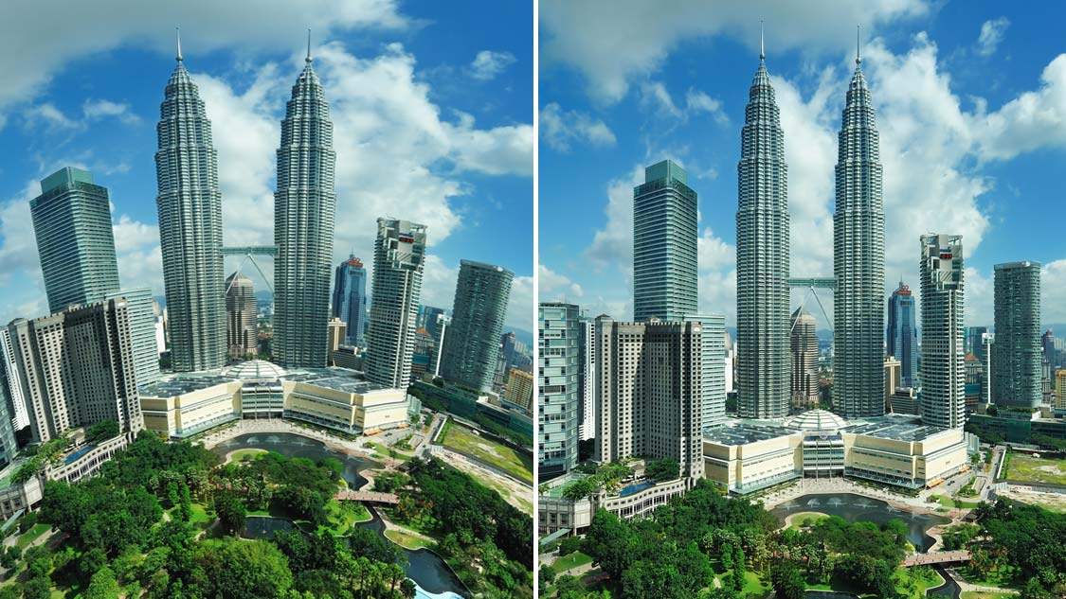With some wide-angle lenses on cameras, the image produced can be distorted. A good example of a distorted image can be seen on figure 27. I decided to do some research into image distortion on iPhone cameras, as image distortion could cause some issues with my data collection if I’m using computer vision. According to a user of photography StackExchange, iPhone cameras don’t have noticeable image distortion for 2D surfaces. Instead of blindly trusting this source, I decided to set up a small test to see if there is any visible image distortion on my camera. I wanted to make sure there was no distortion, because otherwise many of my speed and distance measurements from the camera could be unreliable.

Figure 27 – Image distortion

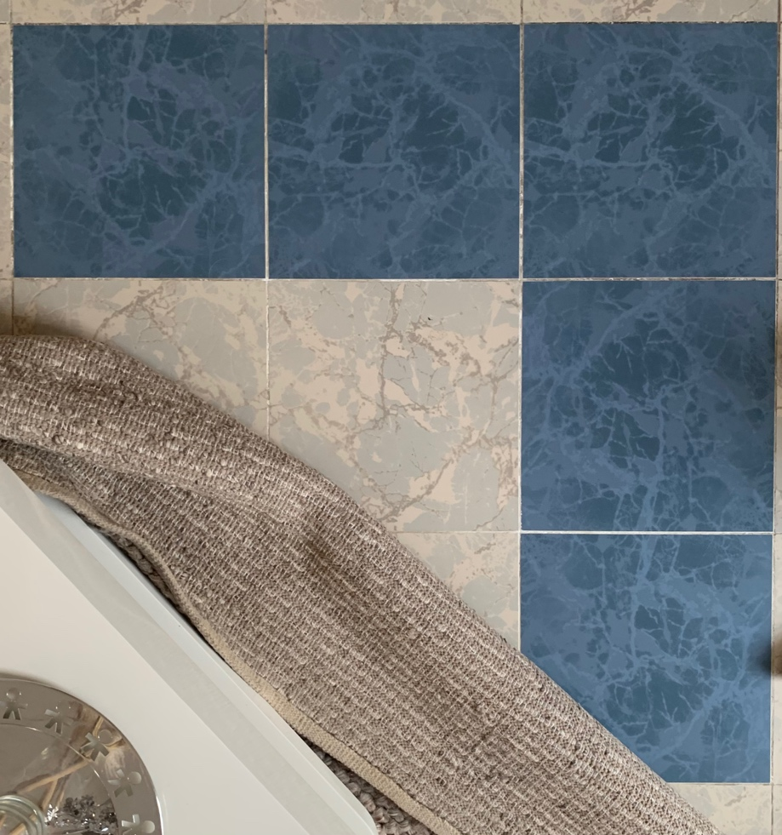

Figure 28 shows an image I took of a part of the floor in my house. I held the camera at the height measured in my track experiment section. The floor has regular repeating square patterns, so if there was any distortion, it would be easy to tell. From the image it is evident that there is very little, if any image distortion.

Figure 28 – Image distortion test

Thankfully, this means I don’t need to worry about using image correction software. The correction software would likely introduce more delay in my image feed and would be difficult to implement on top of a live camera feed.

After my experimentation, I’ve come to the conclusion that my iPhone camera would be the best device to use to provide me with a camera feed.

### Hardware Research Reflection

The hardware research I have conducted has given me a good understanding of how hardware components should be used. For many components I have outlined how I might implement them and how they are suitable for my project. This allows me to make informed decisions for the hardware I choose to use. Therefore, I can modify my initial requirement 3 to make it more specific.

1. My iPhone XR’s live camera feed will be used as the video input to determine the car’s speed and displacement on the track.

The next initial requirements I derived from this research are listed below

1. My iPhone camera will be suspended from the ceiling by three strings in a triangular arrangement.
2. I will control the voltage supplied to the track using the necessary hardware.

Initial requirement 6 is very vague right now, but will be improved in the Initial Hardware Ideas section of my analysis (See page 55), where I decide which approach I’m going to use for the hardware.

This research has also given me some background knowledge I can use in my meeting with Mr Forsyth.

## Meeting 1

After I complete my research, I will have to write up my requirements. I decided to organise a meeting with my supervisor to discuss how I will start to write my investigation requirements.

**Subject: Investigation requirements**

**Duration: 7 minutes**

**Date: 1.2.2021**

**In Attendance: Me – TR, Mark Wood – MWD**

**NOTE***:* I had this meeting before I had derived any initial requirements and was unsure how I would write my final requirements.

TR: “Hi Sir, I have asked to meet with you regarding my investigative project. At this point in my analysis, I’m not entirely sure how I should structure and write my requirements. Since I’m not doing a problem-based project, I’m not solving a problem for a client and therefore I don’t have any client requirements. Do you have any suggestions on how I should write my requirements for this hardware-based project?”

MWD: “Yeah ok, the first thing is to make sure that every requirement is specific and measurable; that’s because the specification says that. Writing generic things is not only not going to get you good marks, but it’s also not going to help you, because these requirements should drive you forward in terms of everything you’re building and everything you’re solving. They’re also the reflective requirements, that when you come to the testing section, you need to be able to measure quantitively, so that you can prove that you have fulfilled it. That’s why you need to make sure, where possible, to make them specific early on. Fundamentally I know what it is you want to achieve, but specifically, with regards to the AI and your implementation of it, I’m not exactly sure what you want to do. Could you give me a quick overview of what it is you want to achieve? What is your overall aim for this project? What do you want your AI to be able to achieve?”

TR: “Yes, the overall idea I have right now is to implement an AI that can be evaluated by measuring if it improves over time. So, it’s not necessarily racing against a human, it just testing if it’s improving lap after lap.”

MWD: “Ok, with regards to the AI, I don’t think there is much I can help you with, but are there any requirements you have already considered?”

TR: “Not yet, but I can think of some now. In one of my existing solutions the cars had to do a practice lap. Could one requirement be: the car should do one practice lap to gather data; it should gather data about x, y, z?”

MWD: “Yes definitely. Another requirement could be that it should be able to drive around various tracks. From what I understand, Scalextric tracks can have multiple layouts. Is this something you considered?”

TR: “No, but that will definitely be one. I think the track we purchased has six possible layouts, so if I mention that I want the car to be able to race on at least six tracks, that could definitely be another requirement.”

MWD: “Yes, absolutely. And like you said, here’s the six tracks, it should be able to run a test lap on each track. When it does a lap, it should record this data, at these points, at these intervals. And that’s just the testing, when it comes to actually executing it, that’s another thing. You also might need to consider if the data is going to be gathered in real time or not. So that’s a good starting point. I did get shared something that I want to share with you. I don’t know much about it; it was just suggested when communicating with our external moderator about your project. I’ll put a link in the chat. Have you seen this: Amazon’s deep racer?”

TR: “I have not.”

MWD: “There were a couple things that came up as suggestions. He says, ‘Has your student looked at this?’ It’s basically a machine learning system for racing cars. So have a look in there, there might be something worth looking at in terms of exploring alternative solutions. Another comment he made was: ‘are you sure that a Neural Network is the best way? Perhaps look at other ideas.’ Let’s not make this the end of our conversation, because I don’t feel like I’ve given you too much to work with. Maybe something you could do for me is send me what your analysis looks like so far, maybe I’ll come up with something else when reading it.”

TR: “Alright thank you so much, I’ll definitely look into that amazon racer example.”

MWD: “Take care, goodbye.”

TR: “Goodbye.”

### Meeting 1 Reflection

This was the first meeting I had with my project’s supervisor, Mr. Wood. Although the meeting was relatively short, I have definitely gained a better understanding of how I’m going to document my requirements. Instead of them being client based, I can write them to be hardware and testing based. I have come away from this meeting with a solid example of a requirement, which I can use or reference to help create my final requirements. Additionally, Mr Wood showed me a suggestion for another similar solution I can investigate, given to him by our external moderator. One concern I have from this meeting is their comment on the suitability of machine Learning for a solution. I started this project believing that an AI was necessary, but after analysing existing solutions, there is no evidence of any machine learning algorithms. This means that I should continue my research into the possible technologies and algorithms, to fully understand the benefits and drawbacks of various approaches.

## Similar solution: Amazon’s DeepRacer

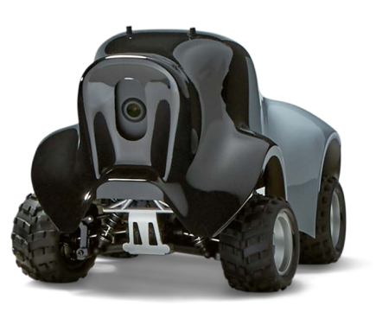The AWS DeepRacer* is advertised as a fully autonomous 1/18th scale race car for developers with any level of programming experience. At the moment there are two versions commercially available. The basic one is sold in a package purchasable from Amazon for $400. The package includes the following products:

Figure 29 – AWS DeepRacer

* The car itself which contains:
  + Car chassis with compute and camera modules
  + Car body
  + Drive battery and charger
  + Compute module battery and charger
  + Multiple USB ports
* Access to a simulation environment called SageMaker.
* 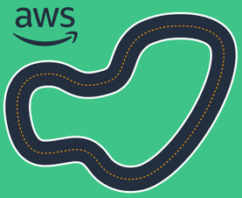Access to a machine learning course specifically made to teach developers of all skill levels to code their own software.
* Invitation to participate in global tournaments hosted by Amazon.

The Amazon DeepRacer is designed to complete a flat track with a line through the centre, as shown in figure 30. It varies to a slot car in a few ways. Firstly, the car has to steer itself around the track, which means that this will have to be incorporated into the software. The steering will make the algorithm a lot more complex, as variables like steering angle and timing have to be considered. Secondly, the car has to power itself using a large, heavy battery pack instead of the constant power from the track. Despite the differences, I’m certain that there are a few aspects of this car that I can learn from.

Figure 30 – Example Track

### A picture containing toy, decorated Description automatically generatedHardware

Figure 31 – Internal hardware

360˚ Lidar sensor

These racing cars have a massive assortment of cutting-edge technology onboard, shown on figure 31. They have 360˚ LiDAR sensors, two stereo 4 Megapixel cameras, 32GB expandable storage and a range of ports ranging from USB-C to HDMI. All of the sensors collect data about the environment, with different sensors providing data at different scales.

Battery and microcontroller

2x 4MP cameras

The LiDAR sensor intrigued me and I didn’t cover in my hardware analysis. Therefore, I decided to include some extra research into this component.

LiDAR stands for Light Detection and Ranging. It works in a similar way to Sonar but using laser light instead of sound. The system measures how long it takes for light to hit an object and reflect back to the sensor. The device sends out hundreds of thousands of pulses per second. The pulses reflect off objects and the measurements, or returns, can be processed into a 3D visualisation of the environment. The final output is known as a point cloud*. The diagram I produced illustrating the process and result is shown in figure 32.

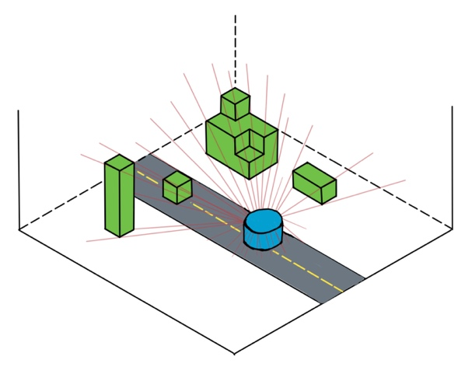

Example of the point cloud produced. Distances can be represented as colours but are stored as numerical values.

3D environment with obstacles

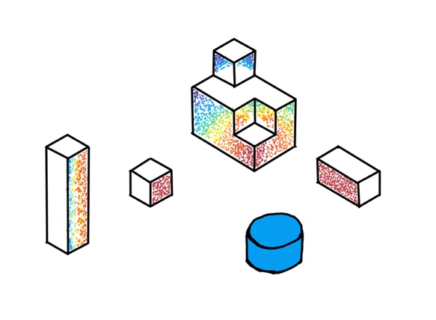

LiDAR sensor sending multiple rays.

Figure 32

LiDAR sensors are a very powerful type of sensor that can gather accurate data very frequently, however, it has one major drawback. Good quality LiDAR sensors are quite expensive, ranging between $200 and $300. Since purchasing the Scalextric track was quite expensive, it’s unlikely that I can receive another budget to buy a LiDAR sensor.

The next piece of hardware I want to research is the 4MP Stereo cameras used. Stereo cameras are a type of camera with two or more lenses with independent image sensors. This allows the camera to simulate human binocular vision, which is the ability to see depth in an image. Stereo photography can create 3D pictures or videos and can also be used for range imaging. An example of stereo photography is Portrait Mode on an IOS device, shown in figure 33. Each pixel in the image is measured using a colour and distance value, allowing clever software to create images with depth effects.

Figure 33 – Portrait mode

Since I decided that I would use my iPhone camera as the video input, I decided to look into the technical specifications of the cameras in my iPhone XR to see if there were any stereo cameras. There are two cameras on my phone: one TrueDepth selfie camera, and the main camera on the back. I have listed the important specifications of the two cameras below.

**Main Camera:**

**TrueDepth Camera:**

* 7 Mega Pixel camera
* Advanced bokeh and Depth Control
* 1080HD video at 60 fps
* Used for FaceID
* 12 Mega Pixel camera
* Advanced bokeh and Depth Control
* Optical Image stabilization
* 4K video at 60 fps
* Slow motion video support at 1080p at 240 fps

The camera module on my phone is capable of capturing a high-definition video at 60 frames per second, which will be more than enough for my investigation if I intend to use a camera. Sadly however, I was not able to find any way of directly getting the distance measurements directly from the camera. One solution to this would be to have my camera set up at a fixed height, then measure a specific distance and then use that as a scale to work out the distance of other objects.

### Software

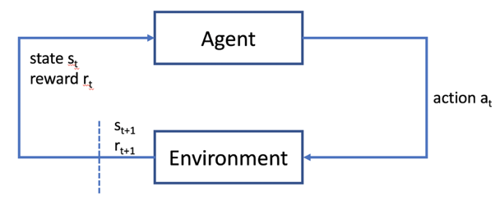The most important part of Amazon’s DeepRacer package is the software development. In the documentation for the product, they mention that the car uses a reinforcement machine learning algorithm. I found the developer guide* given to the consumers when they buy the product. It goes into depth about the exact method of machine learning used.

Figure 34 – State reward pair flowchart

The diagram in figure 34 shows a highly abstracted diagram of how a reinforcement learning model works. The agent has a set of rules it has made itself during the learning process. The collection of these rules is called the policy (the rules are technically a Neural Network’s* output). The agent is given two input arguments: the current state of the environment and the reward from the previous action / decision it’s made. It uses the previous reward to slightly change its policy to try improving its performance. To determine its next action, it follows the rules defined in the policy and the state parameter. The output is performed by the machine (in this case the car moves). The next important step is calculating the reward. A reward function is used to evaluate the action done; a better action deserves a better reward. There are three types of reward: positive, neutral and negative. The agent then slightly changes its policy again in the way that it believes it can produce a better action. Then the cycle continues until a termination condition is reached.

There is a lot of complexity that is abstracted away for the user in the learning process. For example, the racers use a form of reinforcement learning called Policy Optimisation. There are a few different Policy optimisation algorithms, but the ones that the AWS racer focuses on are Proximal Policy Optimisation (PPO) and Soft Actor Critic (SAC). After looking into the documentation of both the PPO* and the SAC* algorithms, it is evident that the algorithms and mathematics used are far too complex for an A-Level scope. An example of the SAC learning algorithm is given in the pseudocode shown in figure 35.

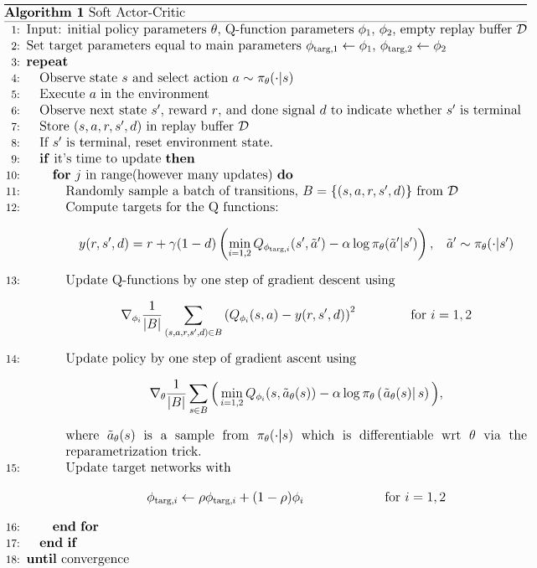

Figure 35 – SAC pseudo code example

For the consumer, all of this complexity is abstracted away in the form of an easy-to-use framework where developers can just focus on the car. I decided that trying to research and understand these specific algorithms would be an inefficient use of my time, and that I should instead use this time to research into more general and simple reinforcement learning algorithms that I can actually understand and effectively implement. This research can be found in the Technology and Algorithm requirements section in this analysis (pg 47-48).

### Workflow

The document proposes a workflow that consumers can follow to create their first solution. The workflow diagram I produced to illustrate my interpretation of this is shown in diagram 3.

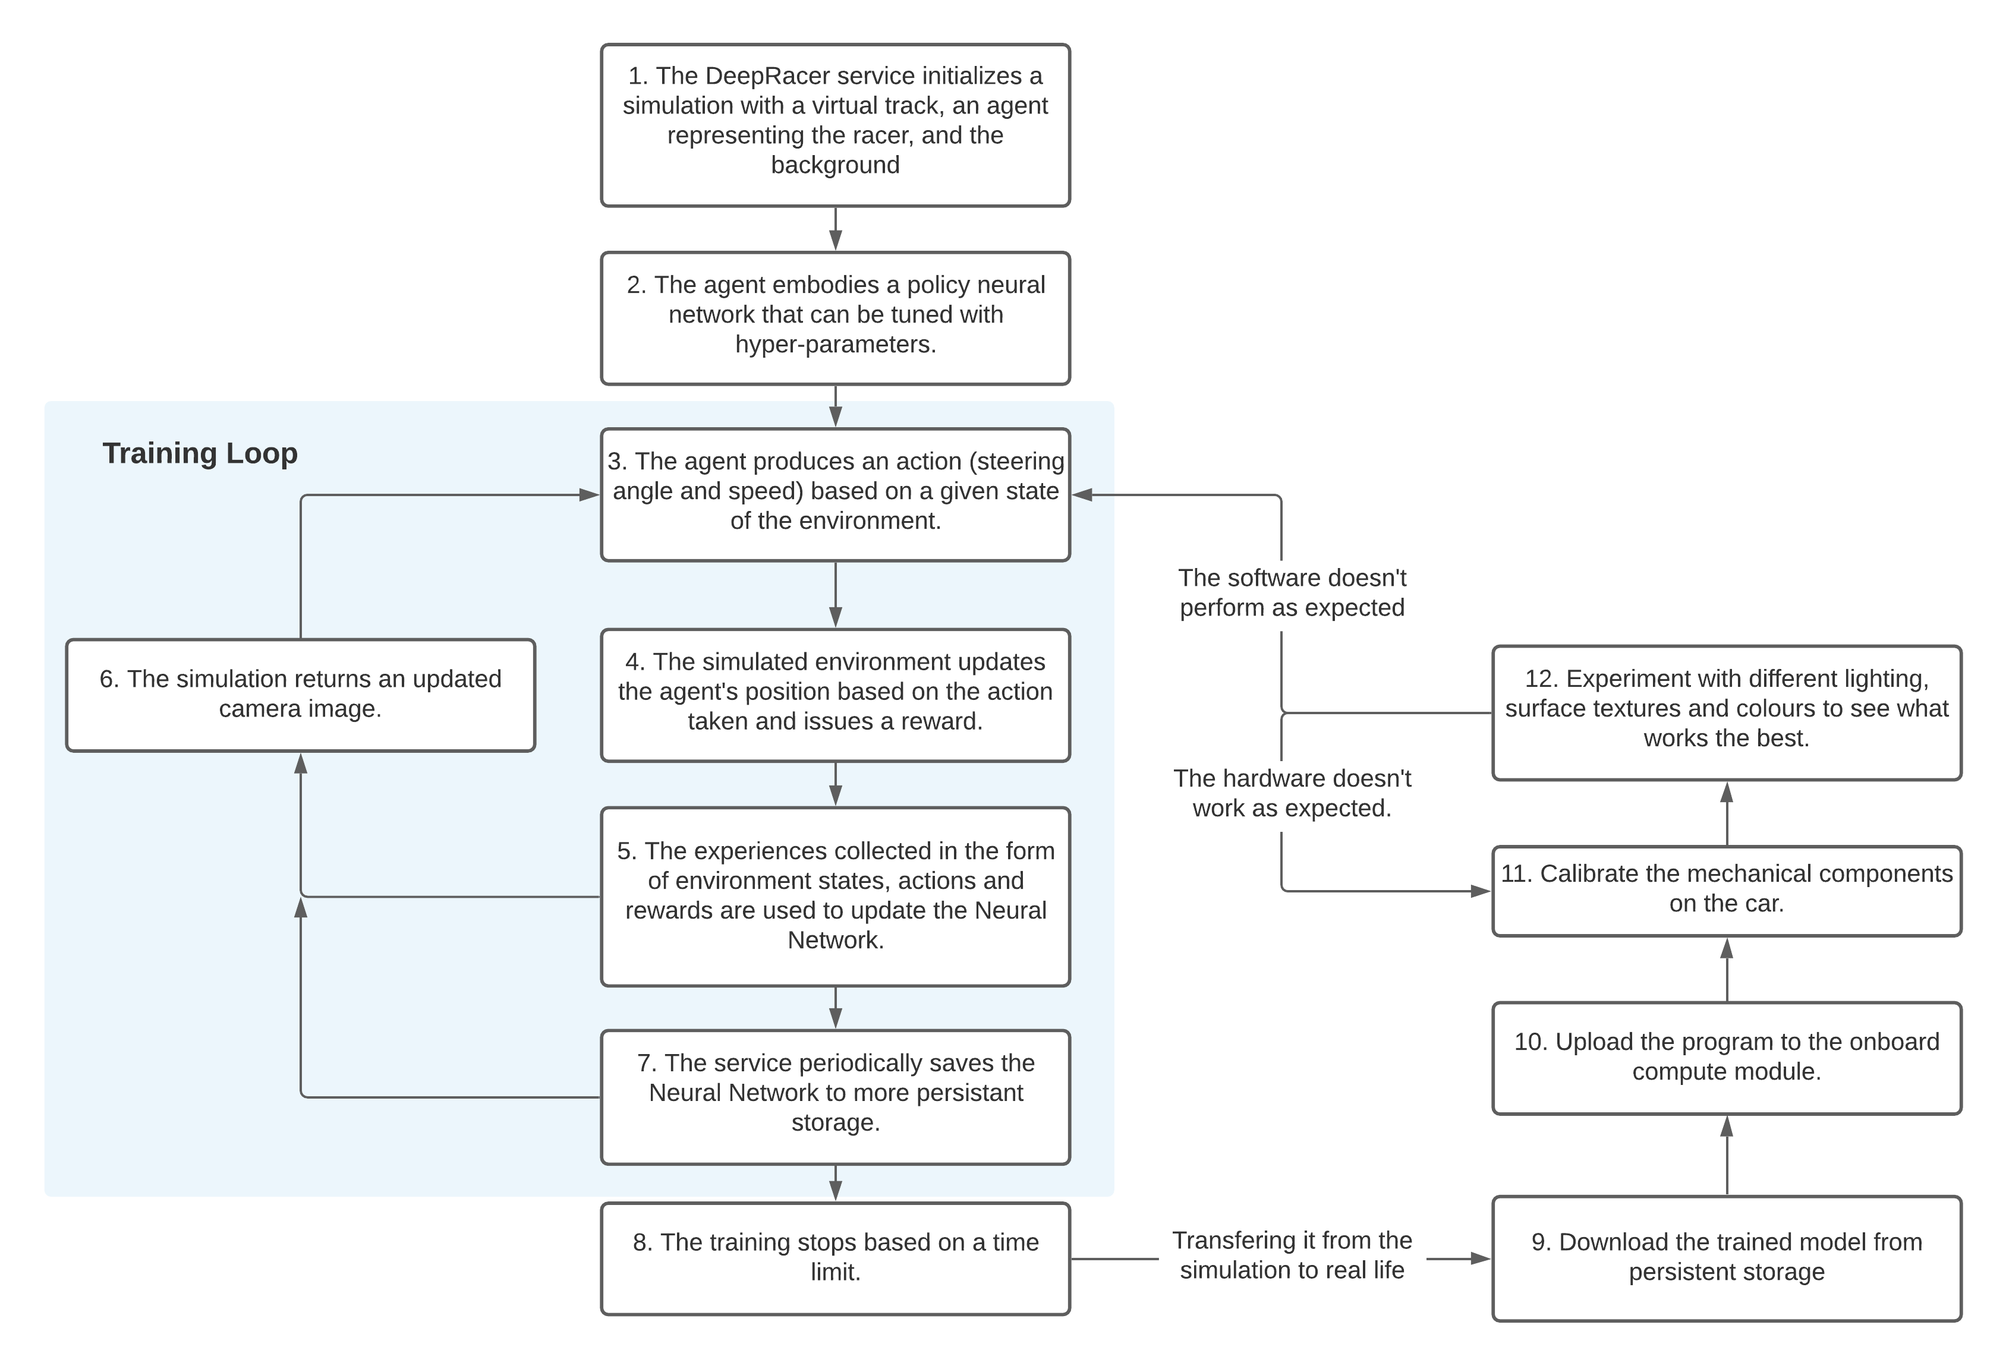

Diagram 3

From the workflow diagram, it is evident that most of the training is done in a simulated environment. One advantage of training in a simulated environment is that they can run the training a lot faster. This is because the computer can execute all the logic much more frequently, without having to wait for a physical car to move around the track. However, I won’t be able to use the simulation approach for my training as that would require me to code the simulation environment myself. This would add additional complexity to this already quite complex investigation.

Next, I wanted to research into the programming paradigms used by the AWS DeepRacer. In the same documentation I found a section called ‘Reward Function examples.’ Code Snippet 2 shows an example of a reward function written in Python.

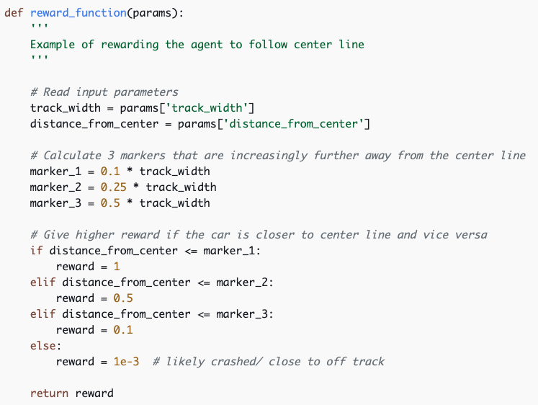From this example it would seem that a structural programming paradigm is used. There is no evidence of the ‘self’ keyword or any other object manipulation. However, this function is likely to be implemented as a static method with the OOP paradigm. There are two main reasons for this. Firstly, the method is not dependant on the instance creation and is not using any instance variable. Secondly, this code is likely to be shared by all instance of the class.

Although I wasn’t able to find any evidence of code written in OOP, I’m quite certain that there is a use of it, but that it’s abstracted away from the consumer. For example, if a user wanted to create a new agent, they could do that really easily by creating a new instance from an Agent class. Or if they wanted a custom agent class, they could create a class inheriting from an Agent class. However, as this is all an estimate and not proven by the documentation, I will not include this information in my overall evaluation of this solution.

Code Snippet 2

### What I like about their solution

Firstly, the car has a multitude of high-quality sensors built into the car. The LiDAR and camera modules provide a huge collection or accurate data frequently. This means that the data is fast and reliable, which makes it easier for a machine learning model to learn effectively. For my investigation I will also need to collect accurate data if I want to use ML. The LiDAR or camera could both be a valid solution.

Secondly, the package provides a simulation environment which is used to train the car. As evident from diagram 3, the training loop (performed in the simulation) is the part of the workflow that takes the longest time to complete. The simulation allows for a controlled, risk-free environment to evaluate and develop an effective machine learning model. Although I like simulation, I will not be able to replicate it for my own investigation as that would introduce too much complexity.

Lastly, this solution is similar to the Freescale example with the fact that the car becomes its own standalone computer system. This means that it can independently race around the track. Like before, the car doesn’t have any sources of delay due to wireless transmission, as all of the data is collected and analysed onboard.

### What I would do differently

The main concern I have with this solution is the price. The high-tech sensors as well as the software environment cause the price to rise dramatically. The $400 price, roughly 1500DHS (Local Currency), makes the product less attractive to potential customers.

Another concern I have is the lack of feedback from the car to another computer. The policy the car develops in the simulation environment could completely misbehave when used in physicality. If this does happen, there is no way for the developer to analyse the problem and detect where the issue lies. This makes debugging and updating the software difficult.

### AWS DeepRacer Summary

I decided to summarise my analysis of this solution in table 6 to make it more visual and allow me to compare it easily to the other existing solutions I have analysed.

|  |  |
| --- | --- |
| What I like | What I don’t like |
| Many high-quality sensors provide accurate data frequently | Very expensive |
| Simulation environment allows for rapid training and testing | Lack of feedback from the car |
| Car becomes a standalone computer system |  |
| Doesn’t need a practice lap |  |
| Reinforcement learning is made easy to use and allows new software developers to gain experience. |  |
| The product is well documented with videos and code examples, which makes starting out very easy. |  |

Table 6

### Reflection on the AWS DeepRacer example

Although the solution doesn’t have much relation to slot cars, I have learnt a lot from the hardware and software that was used. For example, I did some research into LiDAR which could prove helpful when I have my meeting with Mr Forsyth. It has also given me a starting point for my Technology and Algorithm requirements section. This example shows that a machine learning model using a Neural Network is capable of solving my investigation, therefore a proof of concept has been established that I could use a machine learning algorithm for my solution.

## Meeting 2

Mr Forsyth is a Computer Science teacher here at Dubai College. He has a lot of experience with various aspects of robotics and hardware, partly because he organises and runs a Robotics extra-curricular club. I decided to contact him to organise a meeting.

**Subject: Hardware discussion**

**Duration: 12 minutes**

**Date: 3.2.2021**

**In Attendance: Me – TR, Stuart Forsyth - SFO**

TR: “Hello Mr. Forsyth, thank you for meeting with me today. I’ve prepared a few questions about hardware components related to my investigation. Are you familiar with what it is, or would you like me to give you a quick summary?”

SFO: “I’m pretty sure I know what it is. It’s the Scalextric thing, right?”

TR: “Yes exactly. So as a quick introduction, could you briefly summarise your experience using hardware and robotics?”

SFO: “I don’t really think that is a question that can be answered to be honest. I think the most important thing to know about hardware, is that everything is perfect in simulation, when you’re looking at it in the virtual world. But in the real world, robotics basically has errors and it never moves quite as perfectly as you expect it to. So, you always have to put checking mechanisms in place to make sure that it delivers the voltage you’re wanting, its going the speed you wanted, how far did it actually move compared to how far you expected it to move. You need this so called ‘feedback loop’ that’s set up to be observing, recording or monitoring the action you took, so that you can then modify the actions that you’re taking until you achieve your desired outputs.”

TR: “That’s really insightful thank you. When we came up with this investigation, we had a few initial solutions in mind. One of them was the camera above the track. Would you still believe this to be the best solution, or would you try to solve it differently?”

SFO: “There are lots of perfectly good solution and each of them have got their pros and cons, I mean as I’ve just described in the answer to your first question, you just need something that is going to give you a good measure. Generally speaking, you’re better off with fusion solutions, so detecting the same information in different ways and then comparing or averaging the results. Or if one of them appears to be a non-sensical result, discarding it and using the result from the other sensor.”

TR: “That’s very interesting actually, I haven’t thought about using a fusion solution. Now that you say that I think my solution will definitely be a fusion solution. Moving on to the next question, I’ve done some research into hardware components already and LiDAR came up. Do you think that would be a viable solution?”

SFO: “I don’t see why not, but they are generally quite expensive and low-quality LiDAR is definitely not what you want. So, you need to look at your exact use case, the exact track you’re going to have set up, the range of the LiDAR, people in the way. You know, is your track going to go up and down and be multi-level? How appropriate is it? Where can you mount the LiDAR? You certainly don’t want to buy multiple LiDAR; it will be far too expensive for that. Better LiDAR tend to have multiple beams rather than a single rotating beam, but then they get ridiculously expensive. So, yes, but you need to look at it in the context of your particular use case.”

TR: “Alright yes, you raise a valid point. In terms of your fusion idea, would you say that an overhead camera and then an onboard camera or accelerometer would be viable?”

SFO: “I would have a camera above which is measured and have specific points on the track that I’ve pained certain colours, so they stand out to a computer vision software. That means that when they get covered, you know the exact location of the car. And then what I’d do is have sensors embedded into the track, so that when the car drives over them you know exactly where it is. Then you can work out the velocity using the speed = distance over time equation.”

TR: “So sensors within the track you say. Is that possible?”

SFO: “Well you would need to make holes in the plastic track, but it would be very easy to make a hole and then just tape the sensor underneath the track.”

TR: “So the sensor would be like a line detector or light gate.”

SFO: “Yeah, like a light gate. You can place the sensor across the track as well and then the line literally gets broken when the car passes it. It’s very, very easy to do as well.”

TR: “Are they cheap to buy as well?”

SFO: “Yeah very cheap. All of those sensors are very cheap, except for the LiDAR.”

TR: “Ok, LiDAR may not be the optimal solution them. Moving on to cameras; I’ve managed to connect my phone camera to an OpenCV Program. If I can get a high-resolution image from the camera, do you think it would be a good option to use as a camera?”

SFO: “Well, the only reason I’m going to say no is because I wouldn’t want to have to put my phone there while I was using it; it would drive me nuts, personally. But you do get a huge number of advantages from putting your phone there because you’ve got all the built-in Bluetooth and WIFI. So, I’d say in terms of your NEA project, that’s a perfectly good solution.”

TR: “I hadn’t thought of that drawback so thank you for pointing that out to me. My next question is regarding a concern I had from my meeting with Mr Wood earlier this week. The external moderator had a few concerns about an AI implementation in this project. Do you have any opinion on that? My plan was to use some sort of machine learning to understand the environment and then output the needed voltage, but I’m not sure if that would be an optimum solution.”

SFO: “It doesn’t matter whether it’s the best solution or the optimal solution, if it will potentially lead you to an optimal drive for the car, even if it’s a bit of a sledgehammer to crack a walnut, then I don’t see what’s wrong with it. I mean I imagine that he’s probably thinking more about solutions regarding coding in the physics of it, putting various measures on the track, then tuning parameters in terms of braking and acceleration. But if you set up the features for your AI appropriately, then it should eventually so the same thing using machine learning.”

TR: “So essentially what you’re saying is that instead of putting in individual formulas, I can put all the data into one machine learning model?”

SFO: “Just pick your features smartly from your track. So obviously you’re going to need to be able to measure all the necessary features like velocity. I’m just thinking about distance to the turn. It’s all very well getting it to learn a specific track, but you don’t want is disastrous performance on a new track necessarily. If it’s got a way of seeing the track somehow. Remember, if you’re using a fusion solution, you’ve got the overhead camera and you’ve got sensors to know where it is and how fast its moving, so you could be talking about distance to turn and severity of turn. So, you could do feature extraction based on the road ahead.”

TR: “Would that be very complex OpenCV code, or would it be relatively simple?”

SFO: “Probably somewhere in between.”

TR: “That means there’s probably quite a bit of learning I have to do then.”

SFO: “But definitely worth it! I mean, it’s not that difficult really. Assuming you’ve managed to colour the track appropriately, it just needs to stand out, then you just need the distance measurements with your sensors. If your phone is going to go in a fixed mount, which it will do, then you will have distance measures anyway. So, you will have double distance measurements.”

TR: “That is true. For my last question I want to talk about controlling the car. The Scalextric track hasn’t arrived yet, but when it does, I plan to do a controller teardown. I’m predicting that It’s going to be a potentiometer. If I’m to control the voltage on the track, I will need to be able to control the resistor. Are there any pieces of hardware you know of that can do this? For example, would an Arduino have the capabilities of changing the resistance output?”

SFO: “Built-in definitely not. It depends how it ends up working. If it is literally just modifying the voltage, then you probably want a motor driver. They usually tend to deal with outputting voltage. We will need to look at the specifics, but basically, you will need to have an Arduino and then buy another component to go with. You will definitely need to use another component. I’m sure that they will exist, the ability to control a potentiometer digitally.”

TR: “Yes actually, they’re just called digital potentiometers.”

SFO: “As I say, certain that components like that exist.”

TR: “Those were all the questions I had for you. Thank you for your time today, it has been very helpful.”

SFO: “You’re very welcome.”

### Meeting 2 Reflection

After having my meeting with Mr Forsyth, I have gained a clear understanding of how I should be using hardware in my project. For example, Mr Forsyth said I should put checking mechanisms in place to see if my hardware was performing as expected. I hadn’t thought of this before, because I just assumed that it would work perfectly. Evidently this is not the case, as the first thing he said to me was that hardware can be unreliable.

The next important thing Mr Forsyth advised, is that I should implement a fusion solution. Once again, I hadn’t thought of using two or more sensors in combination, but after he pointed it out to me, it is

extremely evident that this would be the best solution. As Mr F. said in the meeting, the results from the different sensors can be compared to see if there are inaccuracies or errors. This can be used to check if my hardware components are working correctly, but I can also take an average of those results and use it as accurate data for my control algorithm. I decided to immediately add this to my list of initial requirements.

1. My solution must make use of two different sensors working in combination (Fusion solution).

Next, we talked about LiDAR. This meeting has dissuaded me to use a LiDAR sensor, as I believe it isn’t suitable for my exact use case. LiDAR is good at detecting objects, and since I don’t need to steer the slot car, object avoidance isn’t necessary. Furthermore, he said that good-quality LiDAR is expensive, and I think it is unlikely that I will have sufficient budget to purchase one.

Afterwards, Mr F explained his proposed solution to me. He proposed having a fusion solution including a camera above the track and line detectors at points on the track. Together they can provide accurate and continuous data on the position of the car, the speed of the car and the layout of the track. I quite like this solution except for one aspect. He mentioned that I would have to colour the track pieces so that the software can distinguish between track pieces, however, I don’t like the idea of changing the track aesthetics and I think it might cause problems when the track is changed.

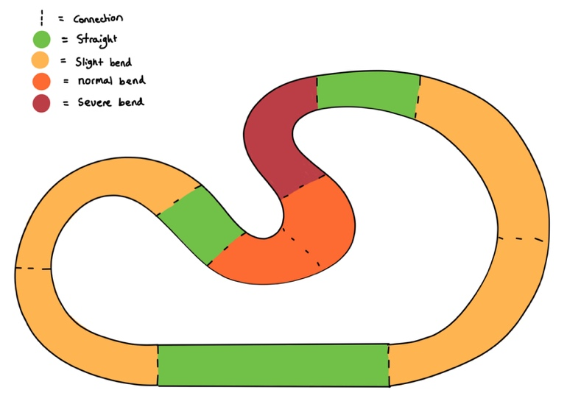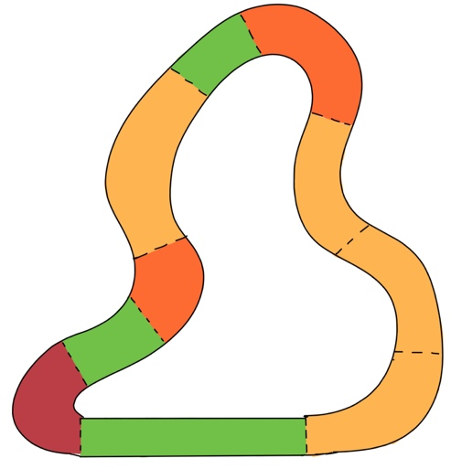

Figure 36 – track with coloured pieces

Figure 36 shows how I envision the coloured track pieces looking. If the model is trained for the track on the left, there is a chance it learns to accelerate on the red track. The reasoning for this is because the slot car will already be moving slowly after coming out of the orange turn, meaning that the slot car should accelerate towards the end of the red to carry speed into the green and yellow sections. If the same model is used to race on the right track, the car will not have learned to slow down before the red, therefore it will continue accelerating resulting in the car deslotting. I think this problem can be prevented if I tune the model to focus only on the current speed, distance to corner, etc, and not the colour. Furthermore, instead of colouring the entire track pieces, I could just add a small, coloured dot on the centre of a piece. This would allow the image recognition software to find each track piece.

Next, we spoke about my phone camera idea. He mentioned the fact that the camera would have to be stationary and therefore the phone can’t be used, but that for an NEA project it would be a viable solution with many benefits. I agree with him, and I believe using my phone camera will be a very good solution since I’ve already proven that I can access the camera feed.

The next subject we covered was the AI implementation concern our external moderator had. Mr F. believed that an AI implementation was a viable solution to the problem, as long as I picked the features from my track carefully. I think that a machine learning algorithm would be the most interesting algorithm to implement, so I’m leaning towards an AI based solution like my original investigation statement said.

Lastly, we spoke about actually controlling the car via altering the voltage. He spoke about using a motor-driver, so I will do some research into that component. Additionally, we spoke about using a digital potentiometer to control the resistance. We came to the conclusion that I would need to purchase an extra hardware component to control the voltage via a microcontroller.

Overall, the meeting has taught me many things I hadn’t thought about. From this meeting and prior research, I will be able to start looking at writing my hardware requirements for this investigation.

## Motor drivers research

Motor drivers act as an interface between motors and the circuit which controls it. Motors usually require high amounts of current, whereas the controlling circuit works on low amounts. The function of the motor driver is to amplify the low current to provide a higher current to the motor. A motor driver usually also has a built in H-bride to control the direction of the motor. Figure 37 shows how a motor driver can be used in combination with an Arduino Uno microcontroller to control two motors simultaneously.

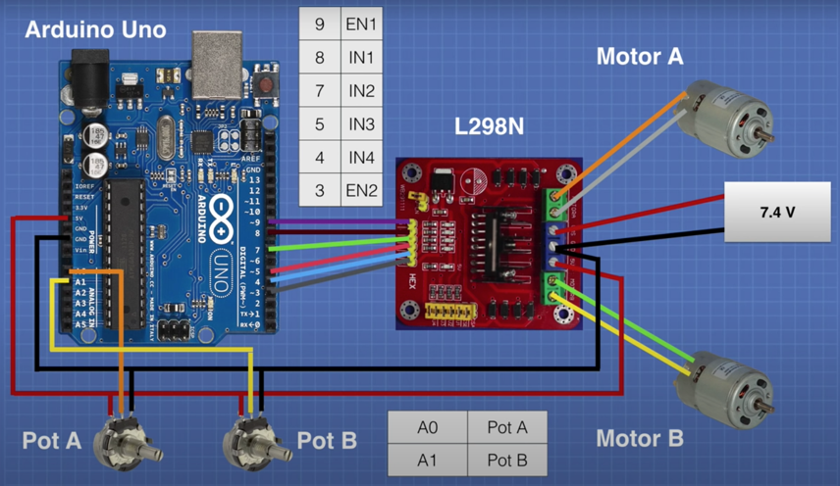

Arduino compatible motor driver

Power supply. Power will be supplied by the track.

One potentiometer for each motor to control the speed

Figure 37 – motor driver circuit

If I decide to use an on-board microcontroller, I will need to purchase a compatible motor driver to accommodate it. This is because the current used by the microcontroller is too low to be used by the motor. However, as shown in figure 37, to vary the speed of the motor, a potentiometer has to be used as well. Instead of using a microcontroller, motor driver and potentiometer, it would be easier to just use a potentiometer to vary the voltage given to the track.

## Technology and Algorithm Research

This part of my analysis is focused on the technologies and algorithms which can be used in order to solve my investigation. A detailed analysis of possible technologies will guide me to choosing an optimum and achievable solution. I will consider why they are suitable, and how I can implement them. The technologies I will research are listed.

* Programming languages
* OOP VS Structural
* Learning Neural Networks
  + Supervised
  + Reinforcement
  + Genetic Algorithms and NEAT
* Computer Vision
* User Interface

### Programming Languages

As I have coded using Python since year 7, I have built up a lot of experience working with the language and its intricacies. As such, I started this investigation knowing I would use python to implement it. However, there are many different programming languages that I could use, so I decided to briefly look into them. I decided to investigate JavaScript, C#, C++ and Python.

|  |  |  |  |
| --- | --- | --- | --- |
| JavaScript | C# | C++ | Python |
| I have some but little experience | I have some but little experience | I have no experience | I have the most experience. |
| Interpreted language | Compiled language | Compiled language | Interpreted language |
| Specialised for website development. | Widely used for developing desktop and web applications | Widely used for applications that requires fast processing like graphics and hardware manipulation | General-purpose language that can be used for many types of programming. |
| Generally, runs faster than python. | Runs much faster than Python, and generally runs faster than JavaScript | Runs much faster than all other languages on this table. | Runs the slowest |
| Has a bigger quantity and variety of extensions |

Python is very versatile and can be used to implement all the features I need for this investigation. Although it may not be the most efficient, it has extremely many libraries that I can use to help me and it’s the language I have the most experience with. Realistically, the code I would write in C# or C++ would be far from optimal, as I would still be learning the language, making the lack of efficiency from Python negligible. Therefore, I have decided that Python is the most suitable language for me to use. Furthermore, As I will be using a microcontroller to control hardware, I will need to code the Arduino using its specific language. The Arduino language is very similar to C++, which means that is has many of the same benefits.

### OOP and Structural programming

There are many different programming paradigms, but object-oriented programming and structural programming are some of the most popular. Although I have already briefly covered these topologies during my analysis of existing solutions, I decided I would do some more research into the advantages and drawbacks of both OOP and Structural programming. My research is summarised in table 7.

|  |  |
| --- | --- |
| Object-Oriented Programming | Structural Programming |
| Shorter and easier to read code | Shorter and easier to read code |
| Each class can be tested individually, making the code easier to debug. | Subroutines can be tested individually, therefore code is easier to debug |
| Code is centralised, so it is easier to maintain and create new code. | Allows for teamwork, as each member can work on their own individual subroutine |
| Allows for parallel development, as each member can work independently from another. | Subroutines can be used multiple times, reducing the need for repeated code. |
| Modular classes are often reusable | Each subroutine has a local scope, therefore can only modify data within its own subroutine. |
| Each class can have custom methods specifically made for objects of that class | Structural programming languages tend to be less efficient with their use of CPU and memory than languages like C. |
| Each instance of a class can have its own individual attributes. |  |
| Attributes of an object can be private or protected, allowing for more protected code. |  |
| Tend to use more CPU and memory |  |
| More difficult to learn |  |

Table 7

As evident by the table, both programming paradigms have a lot of benefits. However, object-oriented programming has a few added benefits like protection of code and the ability to have multiple objects with individual attributes. OOP is more suitable to my project because it allows for more modularised coding and protection of code. Furthermore, If I decide to use a neural network, implementing it using OOP will allow me to instantiate multiple individual neural nets. This is especially suitable if I want to create a population of agents, each with their own neural net.

To implement OOP into my programming I will need to make use of classes in Python. The pseudocode below shows an example the constructor method for a neural network class.

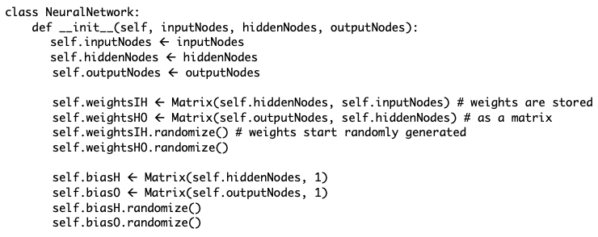

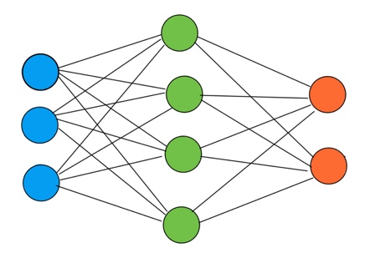

Nn ß NeuralNet(3,4,2)

The pseudocode above would result in a neural network with the structure shown in figure 38.

Figure 38 – Neural network example

### Neural Networks

Artificial Neural Networks*, sometimes shortened to Neural Nets or NNs, are a computational model which vaguely mimics the neurons in our brain. An example of a neural network is shown in figure 38. Neural Nets are sometimes called universal function approximators, because a well-trained model can predict the output of any given function given its inputs. They are capable of representing relationships that are too complex for biological brains to understand, therefore they are widely used in many machine learning applications.

The inputs given to a neural net are usually normalised values between 0 and 1. In a fully connected NN, like figure 38, these values are passed to each node in the next layer. The connection has a weight, which represents the strength of the connection between the two nodes. At each node, all the inputs are multiplied by the weights that they travelled on, then summed to make a new output value. This output value is given to the next layer of nodes and the process is repeated. This is called forward propagation. The maths behind a neural Network is relatively simple and is illustrated in figure 39.

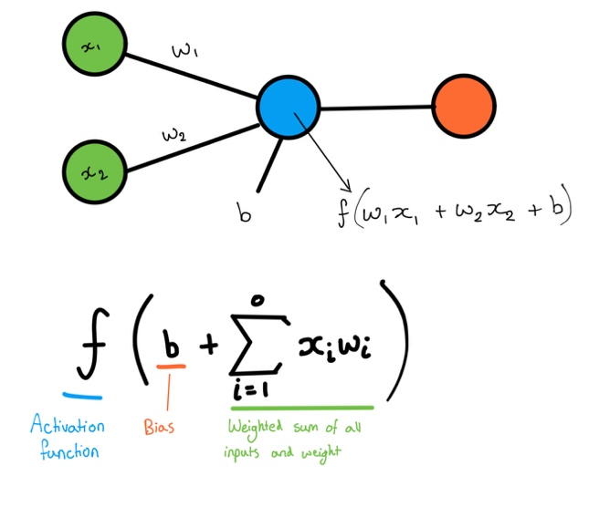Figure 39 shows a perceptron, the simplest possible neural network. A perceptron is only able to predict linear relationships, but the concepts of forward propagation are the same for a more complex neural net. At each node (circle) the formula shown is applied. There are three important parts to the formula shown. The first is calculating the weighted sum. In practice, the weighted sum is calculated by doing the dot product of the weight’s matrix and the input vector. An example calculation for the perceptron is shown in figure 40 for the perceptron and a more complex neural net. (The perceptron weights matrix is a 1 row matrix but is represented as a vector for simplicity.)

Figure 39 - forward propagation math’s

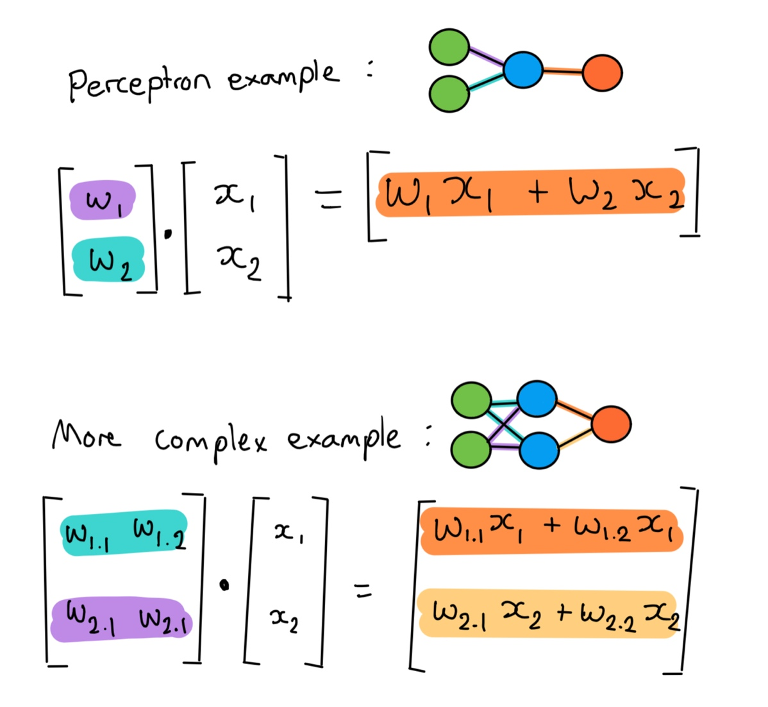

Figure 40 – Matrix multiplication

After the weighted sum of the inputs is calculated, the bias is added on. The bias is extremely important, as it allows the function to be shifted to better fit the data. It can be thought of as analogous to the role of the constant term in a linear function, effectively moving the line up and down. The bias values are usually stored in a matrix as well and are just added to the result of the weighted sum.

The next important part is the activation function. The job of the activation function is to apply a non-linear transformation to the inputs. This non-linearity allows the neural net to represent more complex relationships. There are multiple functions, but the most common ones are Sigmoid, Tanh and ReLu. After the weighted sum and bias calculations, the output values could be out of the range of 0 to 1. An activation function like sigmoid is used to transform the value back into the range of 0-1, so that they can be passed to the next layer as inputs. Some activation functions are shown in figure 41.

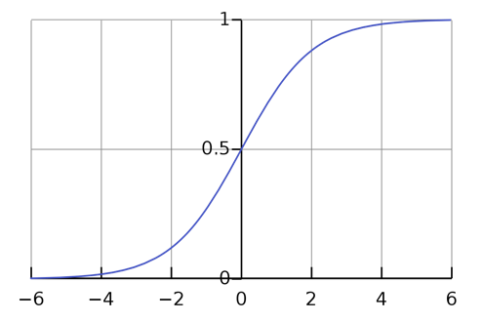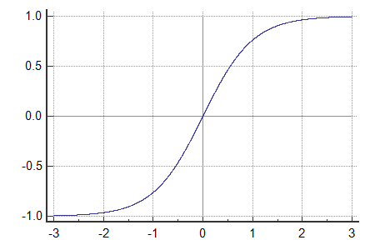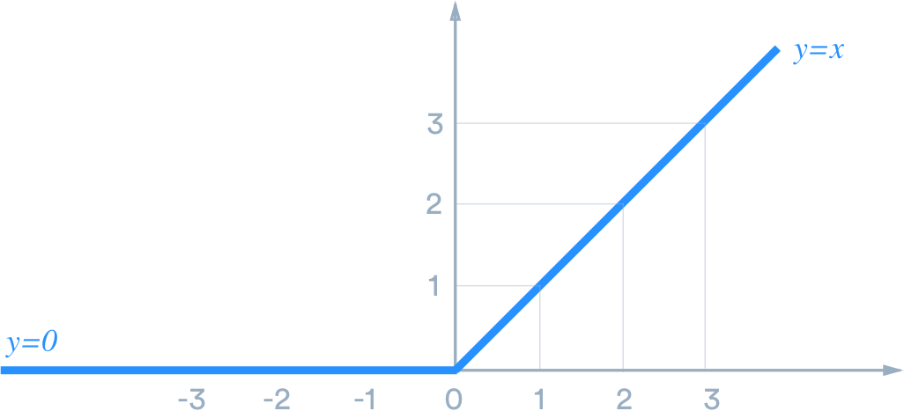

ReLU

Tanh

Sigmoid

Figure 41 – a collection of activation functions

The sigmoid and Tanh functions are very similar to each other. The sigmoid function used to be the most popular activation function. It is shown in figure 41 and can be defined as:

F(x) = 1/(1+e-x)

However, there was an issue with the Sigmoid function. It was discovered that if the value was beyond 3 or -3, the model didn’t learn very quickly. Therefore, people moved to using the Tanh function. The only difference between the two is that tanh was symmetric around the origin and had a greater gradient. The Tanh graph is shown in Figure 41 and is defined as:

Tanh(x) = 2sigmoid(2x) -1

= 2/(1+e(-2x)) -1

The last activation function is called Rectified Linear Unit (ReLU). It is dissimilar to Sigmoid and Tanh, as it doesn’t transform the value to be within a range. Instead, all negative values are set to 0, and positive values remain the same. An advantage of ReLU is that it can deactivate neurons. It is shown in figure 41 and is defined by:

f(x) = max(0, x)

For negative values of x, the neuron is deactivated. This is much more computationally friendly than the sigmoid or Tanh functions.

If I decide to use a machine learning algorithm, it is likely that I will need to use a Neural Network. They are widely used for most machine learning purposes, mainly because they are very flexible. For my investigation, the choice of activation function doesn’t matter too much, as they all have the same purpose. However, I already have some experience using the sigmoid function, so it’s likely that I will use the Tanh function, as it is basically an improved sigmoid function. Lastly, there is a library called NumPy, which I can use to perform the matrix maths operations. The operations I will need to do are matrix multiplication, matrix addition and randomisation.

### Supervised Learning

Supervised learning is one of many methods to train a machine learning model like a neural network. Supervised learning involves the use of labelled training data. This is data that contains both the input and the output expected.

To train the model, there are three important steps: prediction, cost/loss calculation and adjusting the network. In the prediction step, the inputs are given to the neural net and the process of forward propagation is applied. The outputs are then passed into the cost function. This function calculates how wrong the prediction is using the correct output as a reference. This is usually done using the formula:

Cost = (Prediction – Target)2

A bad prediction will have a high cost associated to it.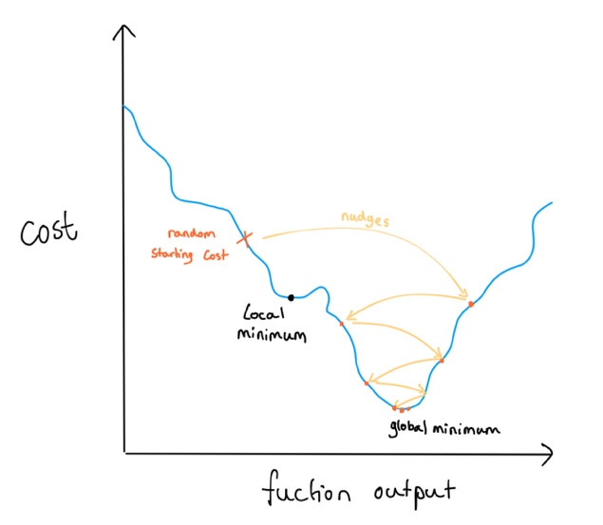

The most important step of supervised learning is the process of adjusting the weights. One algorithm that is often used is called back-propagation or gradient descent. It is the process of recursively nudging the weights and biases in relation to the derivative(gradient) of the cost function. The magnitude of the changes applied can be controlled using a learning rate. Starting off, the nudges will have a greater impact on the output. Towards the end, only minor nudges are made to the model. This is shown with the yellow lines in figure 42. The goal is to reach the global minimum, but sometimes models can become stuck in local minima. This is why the learning rate is important, as this can be experimented with to prevent this from happening. Once a model reaches a global minimum, the training is complete. It can then be tested on unseen, labelled data to evaluate the performance. If it performs well on the unseen data, then the model is likely to perform well on new unlabelled data.

Figure 42 – cost function

The supervised learning approach is unsuitable for my investigation, as labelled training data is required. It is impossible for me to label the data I record, as the data from the sensors is frequently changing, and I don’t know the needed output voltage. I decided to do some research into the two learning algorithms that seem the most suitable: reinforcement learning and Neuro-evolution.

### Reinforcement Learning

Reinforcement learning is another machine learning paradigm. It is concerned with how intelligent agents take actions in an environment in order to maximise its cumulative reward. In other words, it learns based off good and bad experiences, just like humans do. RL is more suitable to my investigation as it doesn’t require labelled training data. One important concept in RL is finding the balance between exploration (of a new environment) and exploitation (of current knowledge). The environment is typically stated in the form of a Markov decision process (MDP). MDP provides a mathematical framework for modelling decision making in situations where outcomes are partly random and partly under the control of the decision maker.

The advantages and disadvantages of reinforcement are shown in table 8.

|  |  |
| --- | --- |
| Advantages | Disadvantages |
| Doesn’t require labelled data | Quite complex to learn/code |
| RL can be unambiguously modelled using a Markov decision process. | Too much learning can cause an overload of states, which diminishes the results |
| Concerned with only one agent: For my training, I will not be able to simulate a whole population of agents since I only have 1 or 2 slot cars that can race. | Needs a lot of data and computation. This isn’t a disadvantage for my implementation though, as I will have a lot of collected data from the sensors. |
| This technique is preferred to achieve long-term results. I want the car to be able to drive a long time, therefore RL is suitable. |  |
| RL is the only paradigm that can find a balance between exploration and exploitation. |  |

Table 8

If I want to implement Reinforcement learning into my investigation, there is a library in Python called Gym, which provides a basic reinforcement learning framework for me to use. However, if I decide I don’t want to use Gym, there are simpler reinforcement learning algorithms which don’t use neural nets, but instead use lookup tables storing Q-values. I will experiment with different Reinforcement learning techniques in the Design section of this investigation.

### Neuro-evolution and NEAT

The next algorithm I researched is called Neuro-evolution. Neuro-evolution is the process of simulating Darwin’s theory of evolution using a large population of agents. The better performing agents are more likely to breed and create the next generation. Overtime the population becomes increasingly better at completing the given task. Neuro-evolution is done using a genetic algorithm. Genetic algorithms have four basic steps:

* Initialise the starting population, each with random genetics.
* Genetics control how the agents behave. In Neuro-evolution the genetics is a neural network.
* Calculate each member’s fitness: a score defining how well each member performs.
* Better scoring members get to breed to produce the next generation.

In the breeding step, there are two important things that can be done. The first is gene crossover, which mimics sexual reproduction in animals. The two genes of the parents are crossed to create a new gene in the child. With neural nets this is difficult to do, therefore the NEAT algorithm is used instead. The next source of variation is mutation. Depending on the mutation probability, one random gene is mutated by changing/ randomising the value of the gene. This is very important, as there is a finite amount of gene combinations given in the starting population. The mutations allow for an infinite amount of variation.

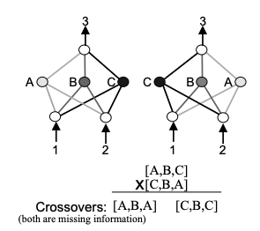The NEAT algorithm stands for Neuro-Evolution of Augmenting Topologies. A document produced by MIT* outlines the drawbacks of conventional crossover when using neural nets. When a crossover is done on two nets, the child often has some missing or duplicated functionality from the parents. This is called the competing conventions problem, shown in figure 43. The two nets compute the same function even though they are represented by different chromosomes. When crossover is performed, both possible children have missing information. NEAT solves this by adding hereditary data, which can be used to determine if the two nets are suitable for crossover.

Figure 43 – competing conventions

If I want to implement Neuro-evolution, there are two options I can choose. Either I use the NEAT algorithm, or I use a genetic algorithm without using crossover and relying on mutations for the variation. I have summarised their benefits and drawbacks in table 9.

|  |  |
| --- | --- |
| NEAT | Only Mutations |
| The NEAT algorithm can learn faster than using only mutations. | I can code the algorithm from scratch which will earn me marks for my solution |
| Networks created by NEAT solve the same problem in a simpler topology (neural net structure) which is more computationally friendly. | I already have experience coding using this method: I have created a Flappy Bird AI from scratch which learns using this method. |
| I would have to import the NEAT library in python which would earn me less marks for my solution. | Less computationally friendly and more complex network, as the topology isn’t changed and would remain being a fully connected neural net. |

Table 9

After researching into Neuro-Evolution, there is one major drawback which makes it unsuitable for my exact investigation. All genetic algorithms require a large population of agents. Although I could theoretically run them all consecutively, it would take an unreasonable amount of time and effort. A learning algorithm that is concerned with training a single agent would be ideal, therefore it is likely that I will use a reinforcement learning algorithm.

### Computer vision

Since I will probably be using a camera in my solution, I need to be able to process the image given. There are a few image processing libraries available in Python, so I decided to research into the benefits and drawbacks of each. I decided to look at TensorFlow, OpenCV and Scikit-Image. The results of this research are summarised in table 10.

|  |  |  |
| --- | --- | --- |
| TensorFlow | OpenCV | Scikit-Image |
| Highly optimised, open-source, machine learning framework. | Designed for computational efficiency | Good at image processing |
| Focused on Machine learning. Although computer vision is possible, its focus lies elsewhere | Strong focus on real-time computer vision | Not as efficient as OpenCV at real time computer vision |

Table 10

I decided to research into OpenCV as my research suggests that it’s the most suitable for my investigation. OpenCV is an open-source library which has a multitude of programming functions mainly aimed at real-time computer vision. It is originally written in C++ but has extensions in other languages like Python and Java.

OpenCV is very suitable for my investigation, as it is the most popular image processing library that can be used in python. OpenCV provides many functions that encompass various aspects of computer vision. However, in my meeting with Mr Forsyth he mentioned that I’ll need to learn OpenCV well enough to be able to write some complex code. At the moment, I have very little experience with OpenCV, so I will have to learn it before I can code my solution.

### User Interface and Graphing

To provide my user with a Graphic User Interface, I will need to use a library in Python that will allow me to do so. I decided to research into Tkinter, as I already have a lot of experience with it. Tkinter is a Python binding to the Tk GUI toolkit and is the standard Python interface to it. It is suitable to my project as it provides me with a framework in which I can have full creative freedom, and it’s in Python, like the other libraries I will be using. Furthermore, it is compatible with Pyplot from Matplotlib, which will allow me to display a graph to the user.

MatPlotLib is the most popular library used to display graphs of mathematical data. Matplotlib provides an object-oriented API for embedding plots into applications like Tkinter. This will allow me to display graphs to the user if I need to. I also have some experience plotting graphs using this software, as well as integrating the graphs into a Tkinter window. Therefore, the combination of Tkinter and Matplotlib is very suitable for use in my investigation.

### Technology and Algorithm research Reflection

The research I have carried out in this section has allowed me to choose the most suitable programming paradigms, libraries, and algorithms that I will need to use for my solution. Firstly, I have decided that the Object-Oriented programming paradigm will be the most suitable for my solution. I will implement this using classes in the Python programming language. Secondly, my research into Neural Network and Learning paradigms has led me to decide that the Reinforcement learning approach is the most suitable for my investigation. To implement this, I will need to learn the theory behind some reinforcement learning algorithms, and maybe learn to use the gym library in Python. Next, I have decided to use OpenCV to do the computer vision in this project. To implement this, I will use the Python extension of OpenCV. Lastly, I will use Tkinter in combination with Matplotlib – both being Python libraries - to provide the user with a GUI that’s able to display graphs. This research has provided me with a few more initial requirements listed below.

1. My solution must employ the Object-Oriented Programming Paradigm
2. A Reinforcement Learning algorithm (or variation like Q-value lookup table) will be used to train the model.
3. The Open CV Library should be used to compute data from the iPhone camera input.
4. Tkinter and Matplotlib will be used to provide the user with a graphic user interface.

Overall, I believe that I now have a solid idea of what my final solution will look like, which means that I can start to write my requirements.

## Amended Project Statement

After completing most of my research and analysis I am able to define a clear project statement for my investigation. I will write my requirements with reference to this project statement.

*Investigation:*

*To design and create a reinforcement machine learning algorithm with the necessary hardware that is able to determine and control the voltage applied to the track to ensure that a physical slot car can complete at least 10* laps around the track without deslotting, while keeping the same or improving the lap time with every lap, given the current environment - including distance to corner, severity of corner and current speed- as input data.*

* The number 10 was chosen as I believe it to be a good threshold to measure from. If the algorithm doesn’t perform well, it will consistently deslot within the 10 laps. Furthermore, 10 laps also provide sufficient time measurements to see if the car makes any improvement.

## Initial Requirements

Before I start my final requirements, I wanted to outline my vague initial requirements that I want the program to be able to do, and how I arrived at them. This will help me structure my Final requirements. The initial requirements I have derived though my analysis are listed below:

1. The yellow, Chevrolet Camaro slot car will be used to train and evaluate my solution.
2. The slot car will be trained on the inside lane of the track.
3. My iPhone XR’s live camera feed will be used as the video input to determine the car’s speed and displacement on the track.
4. The car will not be a standalone device and will instead be controlled by an external PC.
5. My iPhone camera will be suspended from the ceiling by three strings in a triangular arrangement.
6. I will control the voltage supplied to the track using the necessary hardware.
7. My solution must make use of two different sensors working in combination (Fusion solution).
   1. The values of the two sensors will be compared to determine if they are reliable
   2. An average of the two values will be used for the prediction
8. My solution must employ the Object-Oriented Programming Paradigm
9. A Reinforcement Learning algorithm (or variation like Q-value lookup table) will be used to train the model.
10. The Open CV Library should be used to compute data from the iPhone camera input.
11. Tkinter and Matplotlib will be used to provide the user with a graphic user interface.

I decided to add two more important requirements to this list. I have also included why I believe they are important.

1. There should also be some validation before the training can begin to see if all the sensors are working. I arrived at this requirement after my meeting with Mr. Forsyth, who said I should put checking mechanisms in place to make sure my hardware was working correctly.
2. There should be some sort of emergency stop that can be used when things go wrong. This wasn’t arrived at though any research, but I decided it should be implemented to make sure my project remains safe.

## Initial Hardware Ideas

In this section of my analysis, I wanted to focus on initial requirement 6. To gain a better understanding of the necessary hardware, I have documented a few of my potential ideas for the hardware aspect of this investigation. These will act as initial concepts I can compare and analyse. Lastly, I will make an informed decision for the most suitable idea, which I can then refine in my design section to eventually lead me to my final solution.

### Digital potentiometer Idea

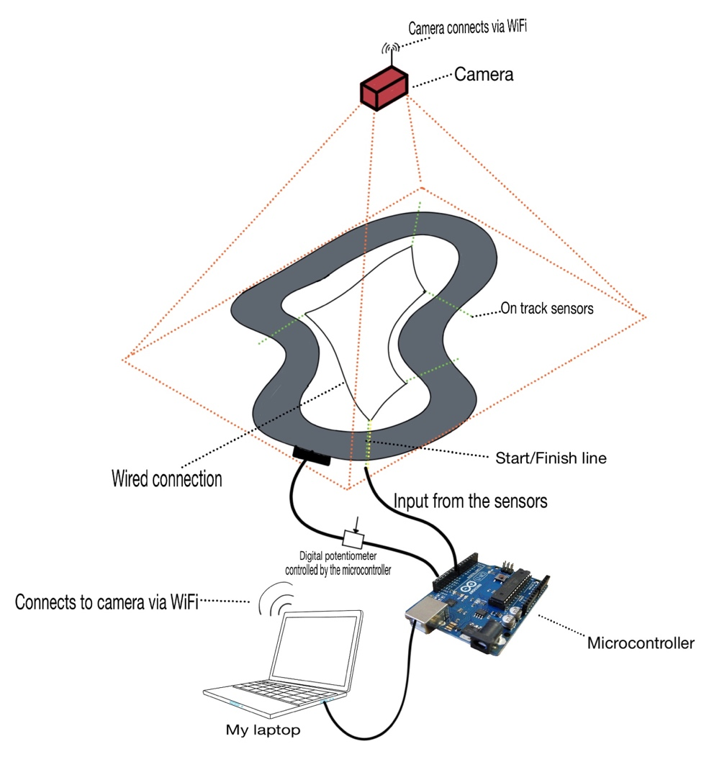

Diagram 4

The basic idea of this solution is to replace the mechanical potentiometer in the track with a digital potentiometer I can control. However, whilst researching into digital potentiometers, I had a few initial concerns; most digital pots that can be used with microcontrollers are only rated for 5V (the same voltage used by the microcontroller), but my Scalextric track requires up to 15V. I decided to approach Mr Forsyth about this issue to see if he had any suggestions. Mr Forsyth suggested that the control system of the digital pot was independent of the terminal voltage inputs. This means that the pot uses a 5V circuit from the Arduino to control the position of the wiper terminal (the controlled voltage is the output via the wiper terminal), but that the actual voltage passing through the resistors could be higher than 5V. The circuit diagram I believe would be suitable is shown in diagram 5.

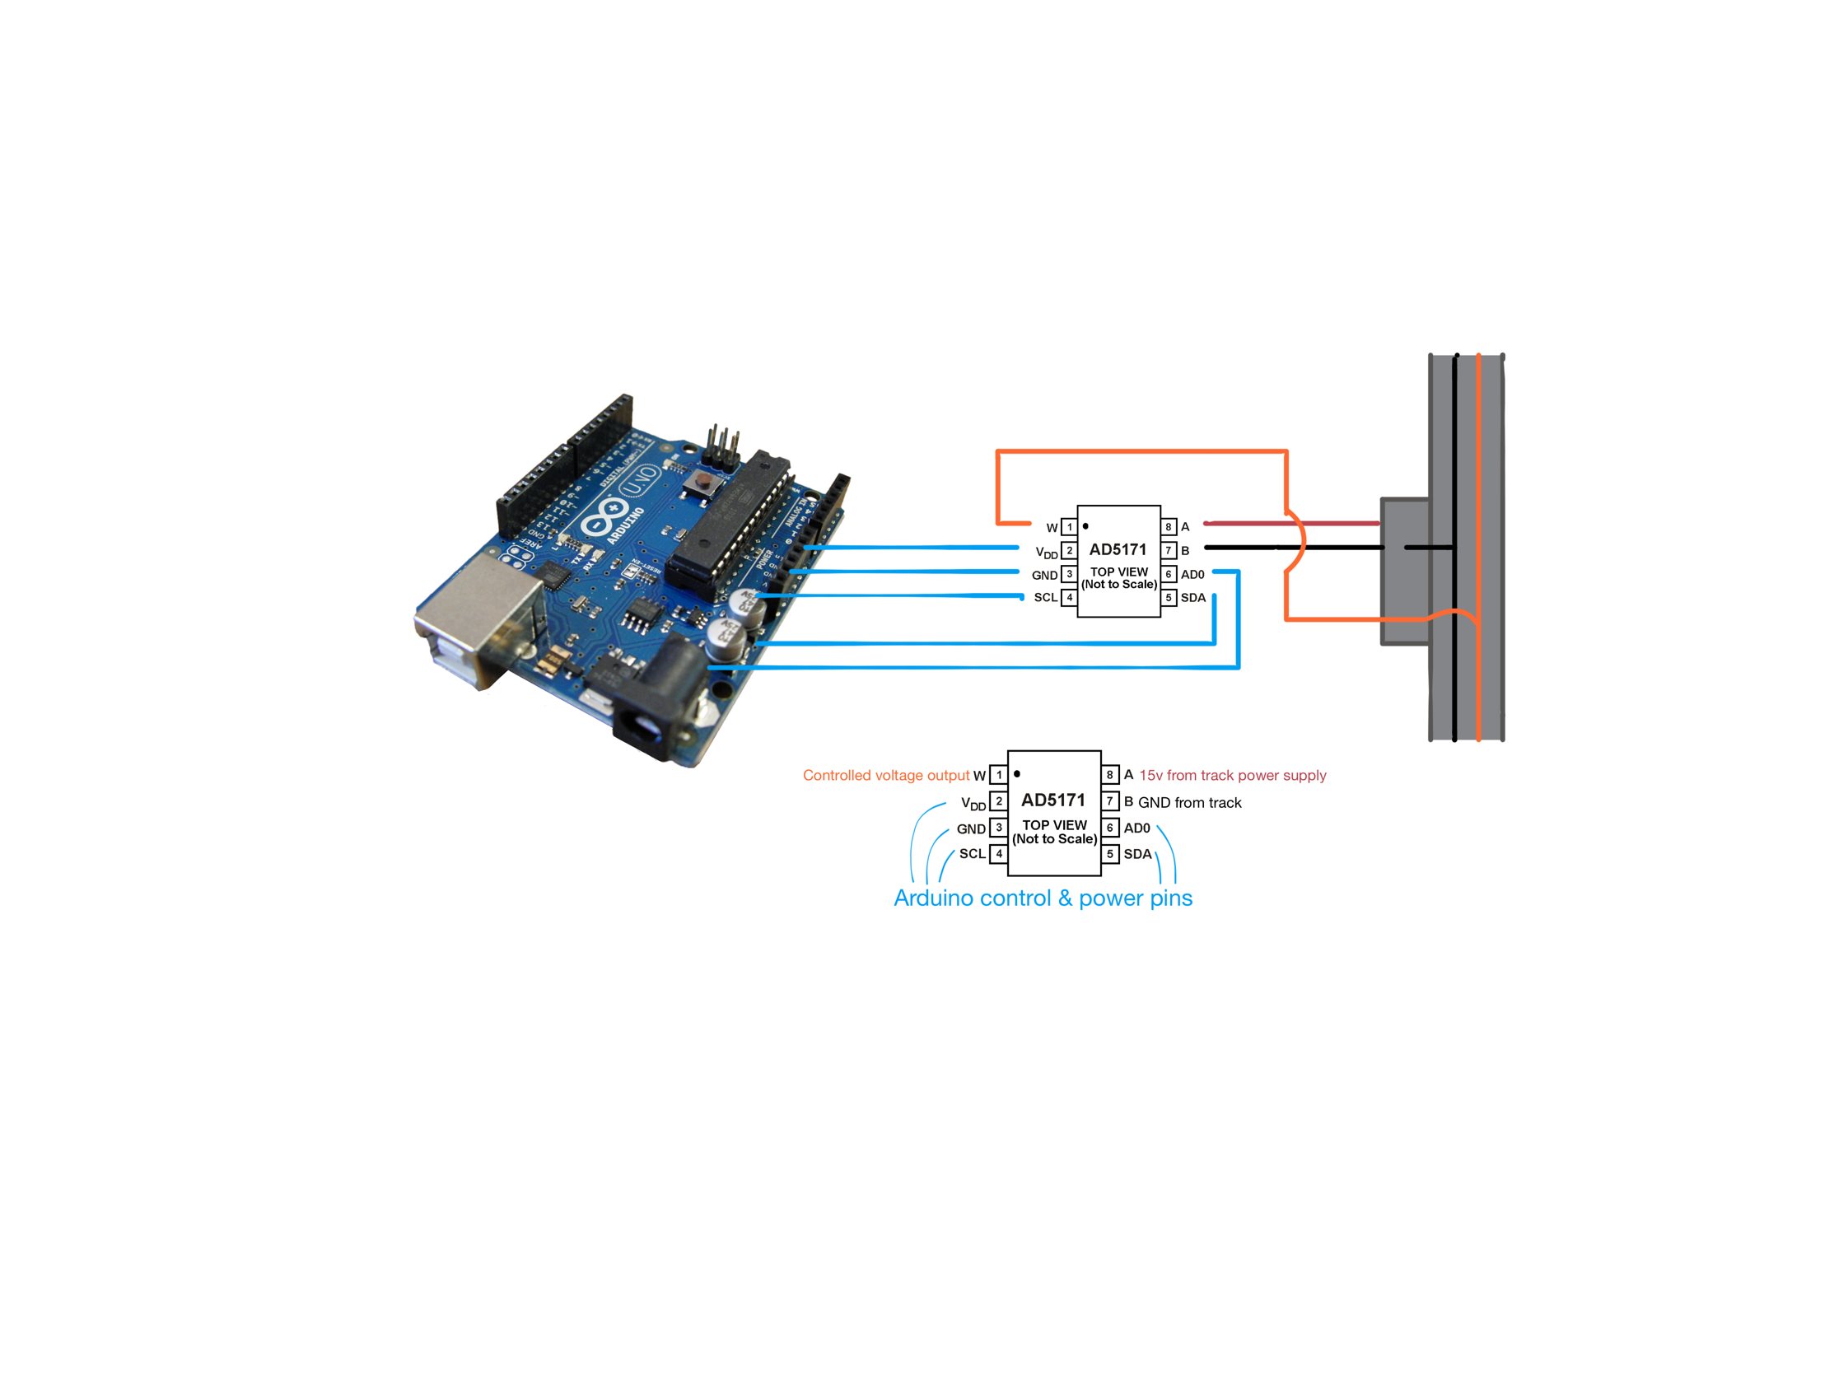

Diagram 5 – NOTE: This circuit diagram will not work as explained below:

I found the documentation for a 5V digital potentiometer* used as an example project from the Arduino website. After reading the documentation, it is evident that this digital potentiometer idea will not work.

Figure 44 shows a screenshot of a table showing the function of each pin.

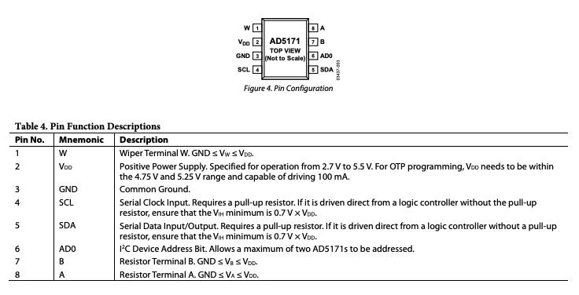

Figure 44

Looking at pins 1,2,7 and 8, it states that the operating voltages must be within the range of GND and VDD, and that the VDD pin is only rated for a range of 2.7V – 5.5V. Therefore, this digital potentiometer will not be able to handle the 15V power supply from the track. After researching into digital potentiometers that are rated for 15V, I realise that they introduce a lot more complexity; they have more control system and pins and require their own specific controllers which might not be able to interface with my laptop. I decided that the added complexity and uncertainty would make this idea unsuitable for my investigation.

### Servo Motor Idea

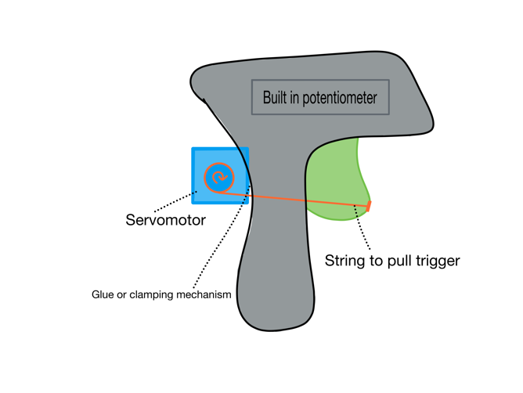The next idea I had was to use a servo motor controlled by an Arduino to physically pull the trigger on the controller. There is a multitude of tutorials regarding servo motor control using Arduino, which means that it would be easier to learn and debug. Furthermore, the Arduino starter kit comes with a servo motor that is guaranteed to work with the microcontroller. The only downside to this idea is that I will need to construct a physical mechanism to hold the servo motor in place and pull the trigger on the controller. This means I need to design and construct, with help from the DT department, a physical mount for the servo motor.

Figure 45

### Motor Driver Idea

My third idea is to use a motor driver powered by the track to control the voltage sent to a lane.

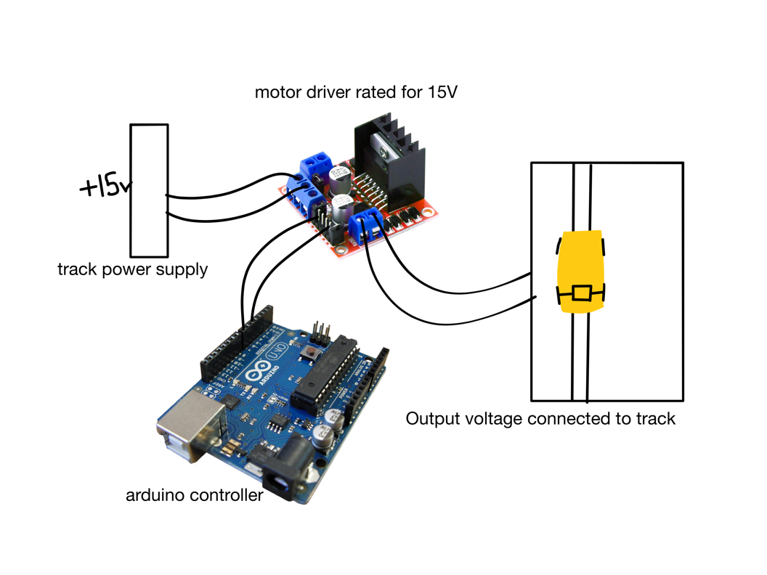

Diagram 6

This idea uses the track power supply to amplify the PWM signal from the microcontroller to the needed 15V. This is then applied to the track which controls the motor in the car. Although this approach will probably lead me to a good solution, the risk involved is quite high. I will need to connect the track power supply to the motor driver, and I need to connect the output of the motor driver to the track, which means that I will need to cut and solder a lot of wires that are built-in on the track. This means that one mistake could permanently damage it, forcing me to buy another one. As I have already spent quite a lot of the school’s budget buying the track, I don’t want to risk breaking it and having to buy another one. This makes me believe that this idea is unsuitable too.

### Initial Hardware Ideas Summary

Documenting these three ideas and researching further into them has allowed me to compare the three ideas so that I can decide which is the most suitable. My analysis and comparisons are shown in table 11.

|  |  |  |
| --- | --- | --- |
| Digital potentiometer | Servo Motor | Motor Driver |
| I will only cut and solder the wires attaching to a controller, therefore only affecting the controller and not the entire track. A controller is much easier and cheaper to replace that the entire track. | | I will have to cut and solder important wires affecting the entire track. |
| A lot of specialised parts needed for 15V digital potentiometers (special controllers). These might not be available. | I will need to design and make a mechanism that will pull the trigger on the controller. | Quite a lot of soldering and wiring that will need to be done: connecting track to motor driver to power supply and Arduino. |
| Physical/mechanical motion can introduce some inaccuracy. |
| No proof that I can control the digital potentiometer from my computer. | Servo motors and Arduinos have a lot of documentation I can use to help me. * | Motor driver circuits are definitely possible and there are some online resources I can use. * |
| All three solutions have hardware components which are relatively inexpensive:  Arduino: 40 DHS  Digital potentiometer: 15 DHS  Servo motor: 20 DHS  Motor driver: 20 DHS | | |

Table 11

I have decided that the servo motor idea is the most suitable and safest approach for my investigation. I will now explain my reasoning behind this.

Firstly, I can buy an Arduino and a servo motor that are guaranteed to be compatible. This will reduce the amount of testing and prototyping I will need to do to test if parts work together. Furthermore, both components are readily available and inexpensive. Secondly, the circuit with the servo motor and Arduino is completely independent of the Scalextric circuit, meaning that there is no way I can damage the original Scalextric electrical circuits. This means I will not need to buy a new track if I make a mistake.

Thirdly, using the trigger, and therefore original potentiometer, means that the track is being used exactly as it’s meant to be. This prevents any unexpected faults from happening. For example, maybe the motor driver outputs the wrong type of current, or maybe there are other hidden factors that I haven’t considered. Lastly, there are many tutorials that can help me learn and solve problems, as servo motors are widely used with Arduinos.

There are a few drawbacks of this approach. Firstly, I will need to design and manufacture a mechanism that will pull the trigger. However, this isn’t too big of a drawback, as I quite like 3D modelling and DT. I’m happy to put the time and effort into making the models and will hopefully be able to use the school’s facilities to manufacture it. The drawback I’m more concerned about is the reliability of the mechanical motion pulling the trigger. Although servo motors are very accurate and fast, there is a possibility that they can produce some inaccuracies. Hopefully I can design a mechanism that will minimise these inaccuracies.

Now that I have a clear idea of what the hardware will consist of, I can start to write my final requirements.

## Final Requirements

Using my project statement, and all of my research, meetings and my initial requirements as a reference, I’m able to create a collection of specific, measurable, achievable and relevant requirements. These requirements will inform the later stages of my investigation, as well as provide me with quantitative proofs when I do my testing and evaluation.

### General Final Requirements

1. The yellow, Chevrolet Camaro slot car will be used to train and evaluate my solution.
2. The slot car will be trained on the inside lane of the track.
3. My solution must employ the Object-Oriented Programming Paradigm

### End User Interface Requirements

1. Upon starting the program, the user must be shown a Tkinter window with:
   1. A welcome message
   2. A start button
2. After the start button is pressed, the validation routine will start. It must:
   1. Check if it is receiving a camera signal
   2. Use computer vision to check if the car is in frame
   3. Use computer vision to check if the track is in frame
   4. Check if it’s receiving signal from on-track sensors
3. After the validation is done, the user is led to a validation screen which has:
   1. A message explaining what this screen is.
   2. Labels and statuses (Passed or Failed) for the following:
      1. “Input from iPhone camera:” [status]
      2. “Car is seen by the camera:” [status]
      3. “Track is seen by the camera:” [status]
      4. “Input from on-track sensors:” [status]
   3. A message asking the user to do the necessary fixes (if any).
   4. A “Retry” button that will:
      1. Call a function to try validating everything again (requirement 5 again).
      2. Update the statuses
   5. A “Start Training” Button:
      1. When it is pressed, the user is led to the Training Screen.
4. On the Training Screen the user is shown:
   1. A message explaining what this screen is
   2. A graph showing the time taken to complete a lap against the lap number
      1. The graph should be updated every lap
   3. A “Stop” button, when pressed:
      1. Sets the track voltage to 0 so the car stops
      2. Stops the Training loop
   4. An “End Program” button, when pressed:
      1. Stops all running loops (if any)
      2. Closes the window and ends the program

### Data Collection and Processing Requirements

1. My solution must be a fusion solution: Using two or more sensors to get more accuracy.
   1. My iPhone XR’s live camera feed will be used as the video input to determine the car’s speed and displacement on the track.
   2. On-Track sensors will be the second sensor used to determine the displacement and speed of the car.
   3. The values of the two sensors will be compared to determine if they are reliable.
      1. This is done by checking if they’re within a fixed range of each other.
2. My iPhone camera will be suspended from the ceiling by three strings in a triangular arrangement at 140-160cm above the track.
   1. The Open CV Library should be used to compute data from the iPhone camera input.
      1. A calculation will be done to determine the distance to next corner.
      2. A calculation will be done to determine the speed.
3. The car will not be a standalone device and will instead be controlled by an external PC.
   1. The data gathered is transferred and collected on my PC.
4. The data is formatted to be used as a state for the machine learning model.

NOTE: This requirement will be made more specific after further investigation into Reinforcement Learning Algorithms in the Design section of this investigation.

1. I will be able to control the output voltage by pulling the trigger on the controller using a servo motor controlled by an Arduino and my laptop.

### Machine Learning Requirements

1. The agent starts off with a completely randomised policy
2. Every time when the agent needs to make a decision:
   1. Check if the car has passed the start line. If yes:
      1. The previous lap time will be recorded and stored in a dictionary with the key being the lap number
      2. The graph shown to the user will be updated
      3. The lap timer is reset
      4. The lap counter is incremented
   2. The agent is given the state, reward pair (gathered from the sensors):
      1. Validate the data given using a presence check.
      2. Return an error message if invalid and stop the training
   3. The agent applies changes to its policy
   4. The agent uses the state to determine its next action (The position of the servo motor)
   5. The action is performed
   6. The action is evaluated by calculating the reward using the reward function.
3. The Reward Function should include:
   1. If the car deslots, the cumulative reward is multiplied by 0.5
   2. A reward is given based off the speed carried through the corner.
4. If the car doesn’t reach the next on-track sensor withing a fixed time, the program will assume it has deslotted.

## Scope

After writing the requirements, I decided I would clarify the scope of this investigation. I decided to organise it in Table 12 to make it more visual.

|  |  |
| --- | --- |
| In Scope | Out of scope |
| Implementing a User Interface using Tkinter | Creating a simulation environment to train the model in. |
| Implementing a reinforcement learning algorithm and calculating Q-values | Implementing the ability to export and import machine learning models. |
| The model will only be trained on one track layout, on one lane, with one car. | Training a model to work on all six possible track configurations and lanes. |
| Computer vision to track the movement of car | Coding image classifier from scratch |
| Detecting whether the car has deslotted automatically. |  |

Table 12

### Scope clarification

Some elements that I have chosen to be in scope and out of scope aren’t self-explanatory, so I decided to explain my decisions in this section.

**Detecting deslots automatically:** Implementing this would allow for the model to train itself, instead of requiring the user to tell it if the car has deslotted. This can be done if the car doesn’t pass a specific on-track sensor after a specified amount of time for example. Another way would be to keep track of which gate needs to be activated next. If another gate (eg start gate) was triggered, the program can assume it has deslotted.

**Training for multiple tracks:** I decided not to include this in my scope because my project statement doesn’t mention that I need to be able to use it on multiple tracks. I believe that if the model can learn one track, it can learn any track.

**Image classifier from scratch:** I believe training and using a more efficient classifier made by professionals would lead to better results for my own investigation.

## Potential Solution Modelling

This section of my analysis will have some modelling of my proposed solution to this investigation. The modelling I produce here should act as inspiration and reference for when I start my design section. A diagram showing my potential solution is shown below.

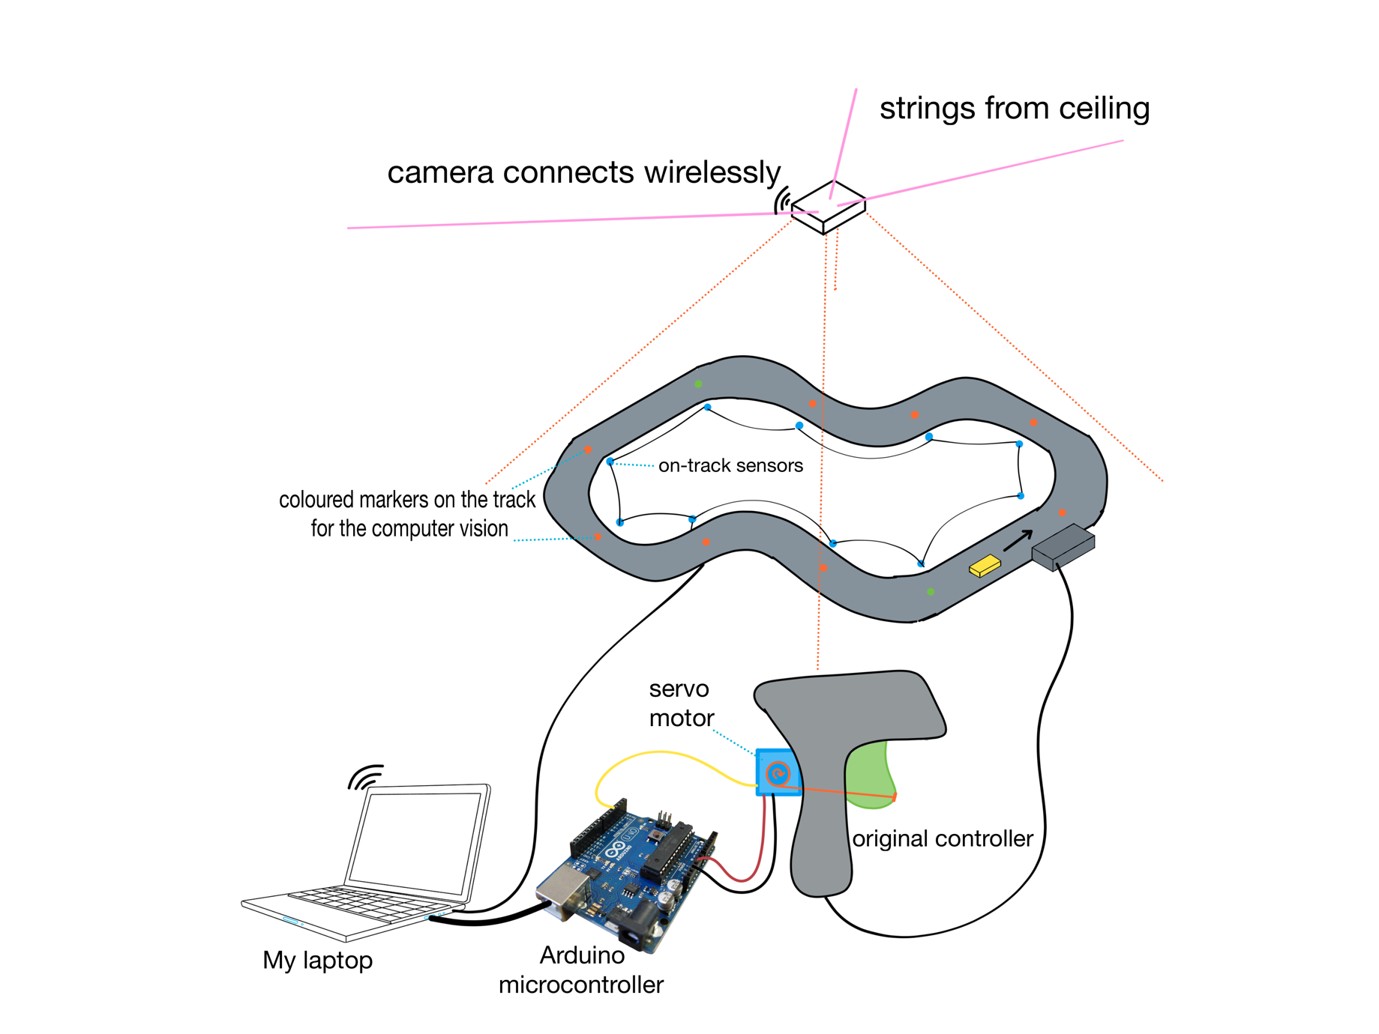

Diagram 7

There are four subsystems which will work together: measuring the car’s speed and distance to corner using the camera, measuring the position of the car using the on-track sensors, computing the best position for the servo motor and then moving the servo to the optimum position causing a change in voltage on the track. The basic operation is explained below.

The program will have a training loop active. With every iteration, it takes multiple frames from the camera. From these, it can calculate a predicted speed and position. It then checks if the car has recently passed an on-track sensor. If it has, it compares the two values to see if they’re reliable. If so, take an average of the two, if not use the on-track sensor measurement. This is because that measurement is likely to be the more reliable of the two. Next, the reward from the previous action will have been saved somewhere. We pass the current speed, distance to corner, colour of the dot on the corner (colour represents severity) and the reward from the previous action into the reinforcement learning algorithm to determine the optimum servo position. This position is then sent to the Arduino which commands the servo to move to a specific position. This changes the position of the trigger and therefore the voltage is changed. The program then calls the reward function. It waits until it has received new information about the car, like the exit speed or if the car has deslotted. From this, it calculates the reward from the previous action and saves it. Then the process is repeated, and over time the predictions of the RL model will improve.

## Analysis summary and reflection

The research carried out in this analysis has given me a good understanding of the hardware and software aspects of this investigation. Starting with my analysis of existing solutions, I gained a vague idea of what solutions to this specific problem look like, as well as learning from the advantages and disadvantages of all three solutions. Using the existing solutions as a reference, I was able to research into a wide variety of hardware components that I might need to use. Furthermore, Mr Forsyth’s experienced knowledge has also aided my understanding. All of this allowed me to come up with three potential solutions to the hardware side of this investigation. After analysing and comparing each, I was able to determine the most suitable hardware setup for my investigation. This being the servo motor controlling how much the trigger is pulled, and therefore the voltage on the track.

I also completed research into the possible software requirements for this investigation. Through this research I was able to determine the most suitable libraries and learning algorithms for a python implementation of this investigation. The most important aspects of the software side are the computer vision and the reinforcement learning algorithms, both of which I have no programming experience with. This means the learning and prototyping process will be vital.

Lastly, my meeting with Mr Wood and my research has allowed me to write my final requirements for this investigation. These requirements will be extremely important in my testing and evaluation, so I made sure they were specific and measurable.

# Documented Design

This section of my investigation is focused on documenting my design process, starting with a high-level overview of my proposed solution. Using my final requirements and previous modelling, I will identify the core features of my investigation and start to design each individually, before bringing them together in the later stages of my investigation. For each core idea, I will explain why they are core, what their basic function should be, and start the prototyping process. The prototyping process will encompass writing pseudo code, implementing it, testing it, evaluating the test results, and refining it until I am fully comfortable with each feature. This design section is crucial, as many of these features require me to learn new technologies I need to be comfortable with before I can start to implement my final solution.

## High-level Overview

This section will outline everything my solution must be able to do. Through creating this high-level summary of my project, I will be able to identify and go deeper into specific core elements for the future stages of my design.

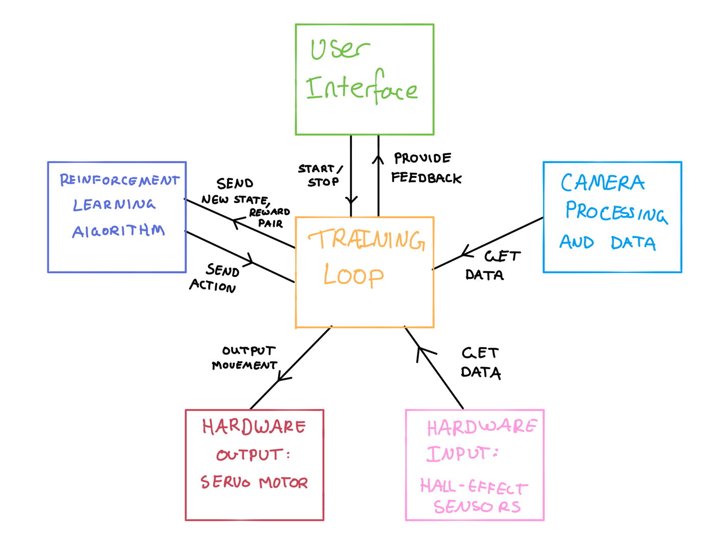

5

2

1

4

3

Diagram 8 – A diagram showing how I envision the different modules of the solution working together

Diagram 8 shows my modular programming approach. This can be done using classes in python. The numbers shown on diagram 8 are annotations, which are listed below.

1. **User Interface:** This is the only module that is visible and interactable for the user. This module is responsible for providing feedback to the user, like the progress/status of the learning algorithm, or if any errors are detected.
2. **Camera Processing and Data:** This module is responsible for calculating and formatting all the information that is collected from my camera setup. This data is then able to be used in the learning algorithm. This module is separated from the other modules to allow me to build and test it individually.
3. **Hardware:** The Hardware section is split into two different modules: hardware input and hardware output. This is because each module has very a different purpose and will likely need to use separate serial ports (see page 71 for an explanation of serial ports). They have been drawn separately to better illustrate how I think they will be implemented.
4. **Reinforcement Learning:** This module is responsible for controlling the behaviour of the slot car.It uses the state reward pair from the previous action to learn and predict the next best move for the slot car. Implementing a learning algorithm as a separate module has many benefits.Firstly, it allows me to build and test it individually, resulting in higher productivity. Secondly, different learning modules could be used interchangeably. This is useful for the future, if I want to make improvements or investigate which learning approach would be most effective.
5. **Training loop:** This module acts as a sort of glue between all the other modules. It is responsible for controlling the flow of data between the other modules. This could be implemented as a separate module, or could be part of the user interface module, as it will be controlled by that. Furthermore, this module also needs to send frequent updates to the user interface module, like the new graph or statuses.

I believe these 5 modules will be the most important features that make up my solution. As such, I have created a more detailed diagram of all my initial thoughts regarding these five modules (Diagram 9).

Diagram 9 varies a little from diagram 8, as it includes the training loop within the user interface module. Furthermore, the user interface module now also includes the validation routine that needs to be done. For each module in the graph, I have defined some of the key methods that will need to be implemented, as well as some of the storage requirements. Furthermore, colour coded arrows show how data is shared between each method.

My initial thoughts of the needed computations and methods

The three possible UI screens

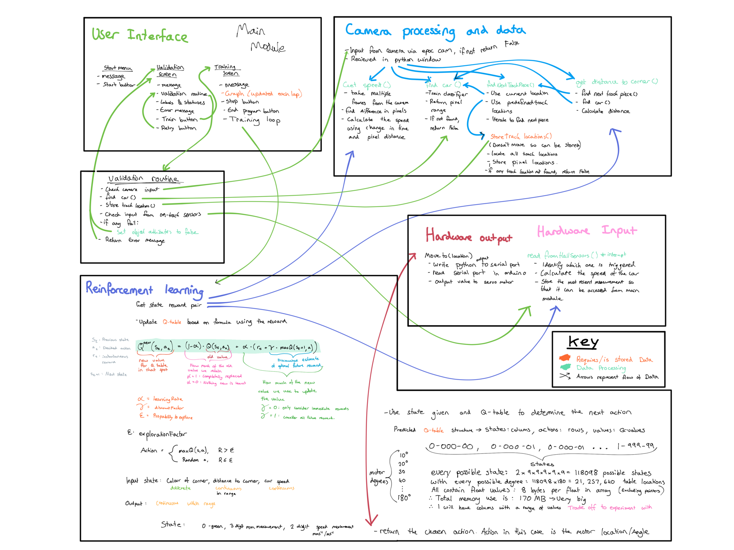

Table granularity vs size tradeoff. (see page 85)

Defining state format for my investigation. (+example)

Diagram 9 – More in-depth diagram concerning the 5 main modules of my solution

Q-value formula and important parameters.

After documenting all my initial thoughts in the form of diagrams, I have created a good starting point for myself to begin selecting and designing my core features.

## IPSO considerations

Before moving onto choosing my core features, I thought it would be useful to consider the IPSO for my solution. IPSO stands for Input, Processing, Storage and Outputs. Defining these now will give me a reference to how I want all the data to be manipulated, which will then help me test the functionality of my prototypes in the later stages of my design.

### Input

There are three possible inputs the program will need to handle: User input (start/stop), Camera Input and Hardware input. Each input and their required functionality are listed below.

* **User Input** – User Interface module: This is the input provided by the user, in the form of button presses. They can be handled using the ‘command=’ key-word-argument built into Tkinter. When a button is pressed, a specific function is called which can then perform the necessary task like changing the screen the user is on or stopping the program. Button inputs need to be handled to fulfil requirements 4.2, 6.4, 6.5, 7.3 and 7.4.
* **Camera Input** – Camera Processing and data module: The raw input is the live camera feed from my iPhone sent via WIFI to my laptop. This is done using the EpocCam application downloaded on both my phone and laptop. The camera feed will need to be processed to extract the necessary data. The camera input fulfils requirement 8.1.
* **Hardware input** – Hardware module: A microcontroller connected to multiple Hall Effect sensors (see page 68 for why I used Hall Effect sensors) will determine which sensor was triggered, then write that value to the serial port it is connected to. My laptop will then read the values from the serial port. These inputs will need to be processed to determine where it is on the track and at which speed its moving. The on-track sensor input fulfils requirement 8.2.

### Processing

Processing the incoming data is the most important aspect of this investigation. There are many different types of data that need to be processed, including camera images, hardware signals, and reinforcement learning processes. Each important process and their functionality are outlined below.

* **Camera feed** – Camera Processing and data module: Images from the camera are sent directly to my laptop and will need to be processed to extract the relevant information, like position of the car and its velocity. To extract this data, an image classifier will need to be trained and used to find the relevant objects in the photo. Furthermore, pixel measurements and some maths will be required to calculate the velocity of the car. This image processing fulfils requirement 9.1.
* **Hall Effect Sensors** – Hardware module: the data read from the serial port will need to be processed to determine which sensor has been activated, and therefore where the car is. By attaching two magnets to the front and back of the car and measuring the distance between them, the velocity can also be calculated by measuring the time between each activation. This processing fulfils requirement 8.2.
* **Input value comparison** - The position and velocity measurement need to be compared to determine if they are reliable. I believe that the on-track sensors will be more reliable, as they don’t require a lot of maths and use reliable sensors. Furthermore, results from the on-track sensors will be less frequent than the results from the camera, as the car needs to pass the sensor for a measurement to be acquired. As such, the on-track sensors will act as a validation for the camera result. Every time an on-track sensor is activated, it will do two things: validate the camera result to make sure that it is still performing as expected and use an average of the two values to pass into the Q-table. If there is no recent on-track sensor result, the pure camera one will be used. Comparing the two sensor inputs will fulfil requirement 8.3.
* **Agent decision making** – Reinforcement Learning module: This is the process by which the RL agent will decide which action to do based on the state of the environment. This can be done using Deep Q learning (using neural networks) or regular Q learning (using a Q-table). See page 69 to see why I chose to use regular Q learning. The input state and Q-table are used together to determine what the best action would be, by checking which action in the Q-table has the highest Q-value. However, the probability of exploration is one factor that also needs to be considered. This is what allows the agent to make random moves to gain more experience. Allowing the agent to make decisions fulfils requirement 14.4 and 14.5.
* **Reward Function** – Reinforcement Learning module: This function is important to determine how good or bad the action is. The reward function will need to be experimented with to determine how to judge the agents actions the best. However, I predict that the basic principle will be that a higher speed will result in a higher reward, and that a deslot will result in a big punishment. Implementing the reward function fulfils requirement 14.6 and 15.
* **Q-Value calculation** – Reinforcement Learning module: This calculation is what causes the slot car to learn over time. By using a predefined formula for calculating the new Q-values (See page 87 for more information), the Q-table can be updated to make sure the agent takes better actions in future. This calculation will use the previous and current state as well as the reward to determine how the value should change. Furthermore, the formula has many parameters which need to be stored. Updating the Q-values fulfils requirement 14.3

### Storage

Another important part of this investigation is storing relevant data. There are a few obvious features of this solution that needs to be stored, like the Q-table. The features and their functionality are explained below.

* **Q-Table** – Reinforcement Learning module: This table is a very important aspect of this investigation, as it stores all the Q-values for each action with each state. This data will need to be accessed and updated frequently, meaning that a mutable data structure with a constant/lowest possible search time complexity would be preferable. This could be implemented using a 2D linked list, a 2D NumPy array, hash table or a Pandas data frame. See page 84 as to why I’m using NumPy Arrays.)
* **Q-Value Parameters** – Reinforcement Learning module: Two important parameters the Q-value calculation uses are the learning rate and the discount factor. As these don’t change, they will be implemented as constants. However, python doesn’t have constants, but in my implementation, they will be used as if they were, using traditional conventions like all capitals for the constant identifiers.
* **Exploration probability**– Reinforcement Learning module: This is another important parameter for the learning algorithm, but dissimilar to the learning rate and discount factor, this value can change while the program is running. This is because I need the agent to explore the environment a lot at the start of the training but settle down towards the end to pick the best moves. This will likely be implemented as an attribute for the agent or reinforcement learning class.
* **Track Locations** – Camera Processing and Data module: As the track will be static in the image, I am able to store important track locations so that they can be used later and not have to be recalculated. This makes the process of finding the cars position more efficient.
* **Lap times** – User Interface module: After each lap, the time taken will need to be stored so that it can be processed into a graph and can be plotted. As the processing is handled by the Matplotlib library, it is not included in the processing section. This will likely be implemented as a linked list, as it needs to be able to grow with every lap taken, and python supports linked lists.

### Output

The only two outputs of this program will be the position of the servo motor and the graph displayed to the user. Both are explained below.

* **Servo Motor Control** – hardware module: A microcontroller reads the data written to the serial port by my laptop. This data is the position the servo motor needs to move to. Depending on the position of the motor, the voltage applied to the track can be controlled. Controlling the output voltage fulfils requirement 16.
* **Graph** – User interface module: This graph shows the cars improvement over time and needs to be embedded within the Tkinter user interface. Furthermore, the graph needs to be updated after every lap to show the user the most recent lap. To plot and display the graph, I can use the Matplotlib library. Showing the output graph to the user and updating it every lap fulfils the entirety of requirement 7.2.

## Identifying Core Features

This is the starting point of the main section of my design. By clearly stating all my core features, I will be able to start prototyping and testing with a specific focus on each important aspect. A core feature is one I deem to be fully necessary for my specific investigation. For each core aspect I will explain why I believe they are core and will provide some more information on their function.

### User Interface

This feature is what allows the user to interact and get feedback from the program. It needs to be specifically made for my investigation, especially if the training loop is embedded into the User interface. The user interface must be a core feature, as it will fulfil the entirety of my End User Interface requirements: requirements 4 to 7.

### Hardware Input

This feature is responsible for using the on-track sensors to gather information about the car’s speed and displacement. As mentioned in the ‘input value comparisons’ section in my IPSO considerations section, the on-track sensors will be used as a validation for the data gathered from the camera. As the camera provides a continuous measurement of the cars speed and position, this is the input that will be used for the RL algorithm. When hall-sensor measurements are acquired, they will be used to validate that the camera data is still reliable, and an average of the two will be taken to give to the RL algorithm. This must be a core feature, as it makes sure that my implementation is a Fusion solution, like Mr Forsyth suggested in our meeting. Furthermore, it is important to prototype this feature, as all the hardware and software needed is new to me, and I will need to become comfortable using it before I can successfully implement it in my final implementation.

When I first thought of the on-track sensors, I thought about using light gates, which are like the line detectors I researched in my analysis. I had hoped that the physics department at DC would have some light gates which are compatible with my computer and allow me to access the data. However, after discussing with the physics department, the light gates they had come with a datalogger that would automatically process the data from the sensors. As I wanted the raw data, I would need to look for another sensor I could use.

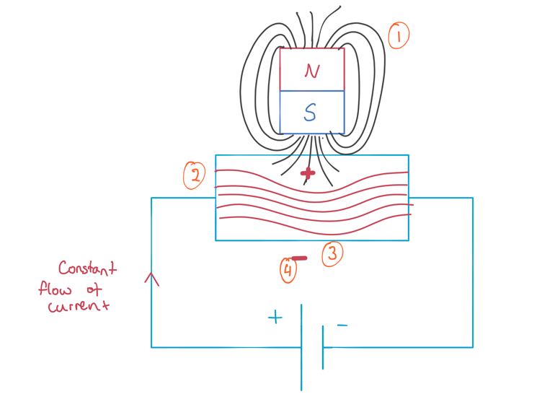Aman Doshi, one of my classmates, suggested Hall-Effect Sensors to me. A Hall-Effect sensor can sense the presence of a magnetic field. It does this by measuring the changing voltage of an electrically charged material when the device is placed in a magnetic field. A diagram I illustrated showing the Hall-Effect is shown in diagram 10. Usually, electrons travel in a relatively straight line, producing a small magnetic field. When a permanent magnet is held close, it interacts with the current’s magnetic field. These interactions are explained in the annotations.

1. The magnetic field from the permanent magnet interacts with the magnetic field created by moving electrons.

Diagram 10 – the Hall-Effect

1. This causes the electron paths to curve.
2. This produces a region of negative charge on one side of the material.
3. A region of negative means that the material now has a potential difference (voltage), that causes a current to start to flow. This current it what is measured by the hall-effect sensor.

If I attach small magnets to the car which are a fixed distance apart, I can calculate the speed of the car by measuring the time taken for both magnets to pass the sensor. I can also determine its position by knowing which sensor was triggered.

### Hardware Output

This feature is what controls the output to the slot car on the track. As I decided in my Analysis, a servo motor controlled by an Arduino will be used to physically pull the trigger on the controller. The output of my python program will write the required servo motor position to the serial port, which is then read by the Arduino. This is a core feature because it physically controls the movement of the slot car. Both the hardware input and output will need to be prototyped, because it’s all new to me as well.

### Computer vision

This feature is responsible for tracking the car and providing information to the reinforcement learning algorithm. This must be a core feature, as in my Analysis I decided this was the best way to gather continuous data on the car. It needs to determine the car’s current speed and the displacement to the next corner. In order to calculate both of these, I will need to find a relationship between distance and the pixels in the image (e.g. 5 pixels:1cm). I will also need to find a way to detect the car and the track locations. This will likely be done using an image classifier. If I know the pixel locations and the relationship between pixels and distance, I can use some maths to determine the displacement to the corner. Furthermore, I can calculate the speed by taking multiple consecutive images, calculating the distance between the two car locations, and then dividing that by the time taken between each image. As all the computer vision code is new to me, the prototyping will be very important.

### Reinforcement Learning algorithm

This feature is responsible for controlling the car and learning over time. This must be a core feature, as it is the entire purpose of my investigation: training an intelligent slot car. It encompasses three major parts: decision making, learning, and the reward function, all of which need to be prototyped and tested. The RL algorithm I will employ is Table Q learning instead of Deep Q learning. In my analysis, I researched into the Amazon DeepRacer, which used this type of algorithm to train the agent. I decided against using Deep Q learning, as the theory and maths behind it are too complex for me to implement. Furthermore, after researching into the Gym library I could use, I realised that all the tutorials basically taught the same thing: using the environments built into the library to train an agent. This isn’t useful for my investigation, as I need to train an agent on my own environment (the track). I decided to use regular Table Q learning as it seems to be suitable for my purpose and easier to implement. Furthermore, I will be able to implement it myself allowing me to fully control the learning algorithm. For Table Q learning, the possible states and actions are used to make a Q Table. For each action in each state, a measurement called the Q-Value is used to tell how good the action is.

Now that I have identified my core features, I can start to design them. Since my solution will be very modular, I will design each section individually. After completing all the individual design, I will have a clear idea of how they work, allowing me to then design how they will work together.

## Controlling Hardware

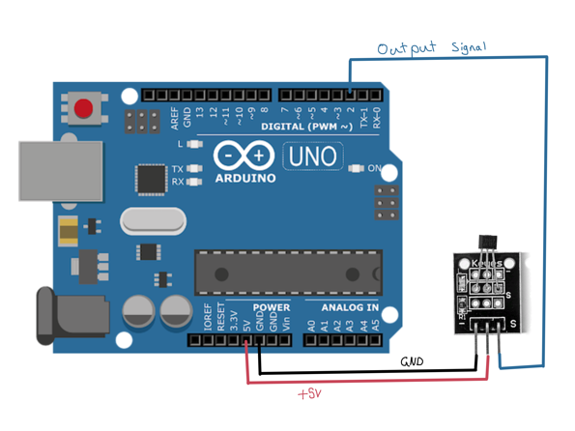

### Hardware Input

I will use an Arduino microcontroller connected to my laptop to control the Hall-Effect sensors. Diagram 11 shows the wiring required for 1 Hall sensor.

**Recalling requirement 8.2:**

On-Track sensors will be the second sensor used to determine the displacement and speed of the car.

I want my output to have the format:

Diagram 11

“sensorTripped timeTaken”

e.g.: “1 5000”

This format will provide me with all the information needed to fulfil requirement 8.2. The sensor number can be used to determine the displacement if I know the location of the sensor. Next, the time value (measured in milliseconds) will allow me to calculate the approximate speed. I can use the fixed distance between the magnets and the time to calculate the average speed. The speed is an average, as this method doesn’t account for acceleration between the two sensor activations. This won’t be a problem because the time between activations will be small, meaning that small accelerations will be negligible.

I will start this design by trying to get my desired output from a single hall sensor. The pseudocode I produced is shown below.

oldState 🡨 1

pinNumber 🡨 2

firstPass 🡨 True

loop():

newState 🡨 readNewState(pinNumber) # built in function

if newState == 0 and oldState == 1:

if firstPass:

StartTime 🡨 currentTimestamp() # built in function

firstPass 🡨 False

else:

endTime 🡨 currentTimestamp()

firstPass 🡨 True

writeToSerialPort(“pinNumber”, endTime-startTime)

newState 🡨 oldState

For my hall sensors, when a magnet is close, the output will be a 0, otherwise a 1. An example output is shown below.

11111111111100000000011111111111111111111000000000011111111111

In reality, the magnet was only brought close two times, but many zeros were registered. If I were to get time measurements between each pair of zeros, the time measurements would be useless. Therefore, this pseudocode has been designed to detect a change in state from a 1 to a 0 and take time measurements between each change in state.

In order to transfer this pseudo code into Arduino code, I will need to research into the built-in methods I used in the pseudo code and serial communication. To read the state from the hall sensors, I can use the digitalRead() function which has the syntax: value = digitalRead(pinNumber);. Next, to get the current timestamp, I can use the millis() function, which has the syntax: timestamp = millis(); and returns the time in milliseconds since the start of the program.

#### Serial Ports

A serial port is a communication interface through which information can be transferred in or out one bit at a time. For my investigation I will be using the USB port on my laptop, which is a serial port. Both my laptop and the Arduino can read and write to/from the serial port, allowing them to communicate. In order to use the serial port on the Arduino, I need to use the Serial library built in. This is done by using Serial.begin(baudRate). The baud rate is the maximum rate at which bits are sent to the port. As a default the baud rate is 9600, meaning 9600 bits per second. Then to read and write to the serial port, I can use the Serial.println() and Serial.read() methods.

Using the serial port in python works in a similar way. First, I need to import the serial library and instantiate a serial object:

ser = serial.Serial("/dev/tty.usbmodem14101", 9600, timeout=1)

The first parameter is the identifier for the serial port to use. This is necessary for python, as my laptop has multiple ports it needs to distinguish between, whereas the Arduino only has one USB port. The next parameter is the baud rate, set to 9600 like on the Arduino. Lastly, there are a few optional key-word-arguments (kwargs) like timeout and parity that can be controlled.

The Arduino code that I produced for a single hall sensor is shown in code snippet 3.

int hallSensorPin = 2;

int newState;

int oldState;

unsigned long startTime; // unsigned means only +ve numbers

unsigned long endTime; // unsigned long is the datatype required for storing times.

bool firstPass = true; // used to differentiate between the two sensor activations

void setup() {

pinMode(hallSensorPin, INPUT); // setup the pins

Serial.begin(9600); // setup the serial port

}

void loop(){

// read from the sensor

newState = digitalRead(hallSensorPin);

// check for a change of state

if ((newState == 0) and (oldState == 1)) {

if (firstPass) {

startTime = millis();

firstPass = false;

}

else {

endTime = millis();

Serial.println(String(hallSensorPin, DEC)+" "+ String(endTime-startTime, DEC));

firstPass = true;

}

}

oldState = newState;

}

Code snippet 3

**Expected output format:** “pinNumber timeTaken”

**Output:**

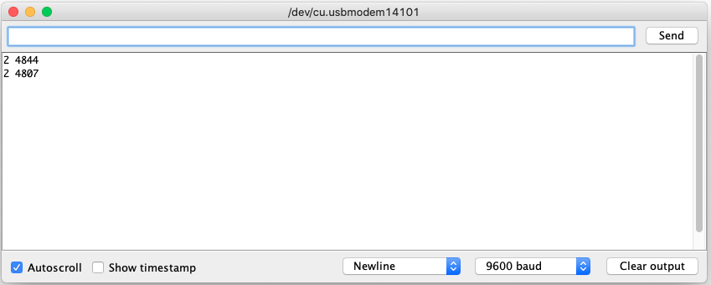

Time output in ms. ~ 5 seconds

Only one pin in this prototype: 2

2 4844

2 4807

From the output it is clear that this is prototype has been successful, meaning that I can start to expand it to multiple different hall sensors. However, before I start that, there is one improvement I can make to this. The datatypes for oldState and newState are int (which takes up 16 bits), whereas they should be replaced with byte (8 bits). Although the change isn’t dramatic, it is better practice to use only as much memory as I need. In this case, the number 0 or 1 can be stored using less bits if they are the byte datatype. (bit datatype doesn’t exist, otherwise I could use that: can only be 1 or 0)

As I will be using multiple hall sensors around the track, I decided it was smart to create a HallEffectSensor class. I will start by pseudo coding a skeleton for a HallEffectSensor class.

class HallEffectSensor:

Private:

PinNumber (byte)

newState (byte)

oldState (byte)

startTime (unsigned long)

endTime (unsigned long)

firstPass (Boolean)

Public:

readPin() : void

|  |  |  |  |
| --- | --- | --- | --- |
|  | Identifier | Types | Purpose |
| - | PinNumber | int | The pin number that the hall sensor is connected to the Arduino by. |
| - | newState | int | The hall sensor sends out a constant stream of 1 if there is no magnet present, or 0 if there is. These are used to detect a change in state. |
| - | oldState | int |
| - | startTime | Unsigned long | Using two timestamps allows me to calculate the time taken between activations. |
| - | endTime | Unsigned long |
| - | firstPass | Boolean | Used to determine if it should make a starting timestamp, or make an ending timestamp and calculate the time between activations. |
| + | readPin() | () : Void | Reads the status of the pin and prints the output to the serial port if needed. (same functionality as my previous prototype: code snippet 3) |

Using the class skeleton I produced, I can start to design the class in Arduino code. As the functionality of readPin() is the same as in my previous prototype, I can go straight to implementing it into the HallEffectSensor class. The code I produced is shown in code snippet 4.

class HallEffectSensor {

private:

byte pinNumber;

byte newState;

byte oldState;

unsigned long startTime;

unsigned long endTime;

bool firstPass;

public:

HallEffectSensor() { // Constructor

firstPass = true; // no parameters for the constructor

}

void setPinNumber(byte pin){

pinNumber = pin;

pinMode(pinNumber, INPUT);

}

void readPin() {

newState = digitalRead(pinNumber);

if ((newState == LOW) and (oldState == HIGH)) { // LOW == 0, HIGH == 1

if (firstPass) {

startTime = millis();

firstPass = false;

}

else {

endTime = millis();

Serial.println(String(pinNumber, DEC)+" "+String(endTime - startTime, DEC));

firstPass = true;

}

}

oldState = newState;

}

};

const int numSensors = 4;

const int pins[numSensors] = {2, 3, 4, 5};

// the physical pin numbers each sensor is attached to

HallEffectSensor sensors[numSensors]; // to define an empty array of objects,

// the constructor must have 0 parameters

void setup() {

Serial.begin(9600); // setup the serial port

for (int i=0; i<numSensors; i++){

sensors[i] = HallEffectSensor(); // initialising each object

sensors[i].setPinNumber(pins[i]); // and assigning them their own pin

}

}

void loop(){

for (int i=0;i<numSensors;i++){

sensors[i].readPin();

}

}

Code snippet 4

One major issue I had when converting my class and readPin() pseudocode into Arduino code was working with the array of HallEffectSensor objects. Since I wanted the number of hall sensors to be variable, I tried to avoid hardcoding in each individual sensor like this:

HallEffectSensor hallSensor1;

HallEffectSensor hallSensor2;

HallEffectSensor hallSensor3;

hallSensor1.readPin();

hallSensor2.readPin();

hallSensor3.readPin();

Instead, I decided to use an array of objects, allowing me to declare however many HallEffectSensor objects I want. However, there was an issue with this approach. Originally, I used a constructor with a parameter to assign each sensor object to their own pin. However, when declaring an empty array of type HallEffectSensor, the program wouldn’t compile as there were no parameters given to the constructor. To overcome this, I added another public method which assigns a pin to the object, meaning the constructor has no parameters. Then in the setup() function, I populate the sensors array and assign each of them to their own pin.

Another drawback of this prototype is that the numSensors and pins array are hardcoded into the program. During the technical implementation of this investigation, I will need this to match with the number of sensors I am using, so having the main program be able to control these would be helpful.

To test the functionality of this prototype, I will have to start by wiring multiple hall sensors connected to the Arduino. I will do this using a breadboard and 4 hall sensors. The circuit diagram I produced is shown in diagram 12.

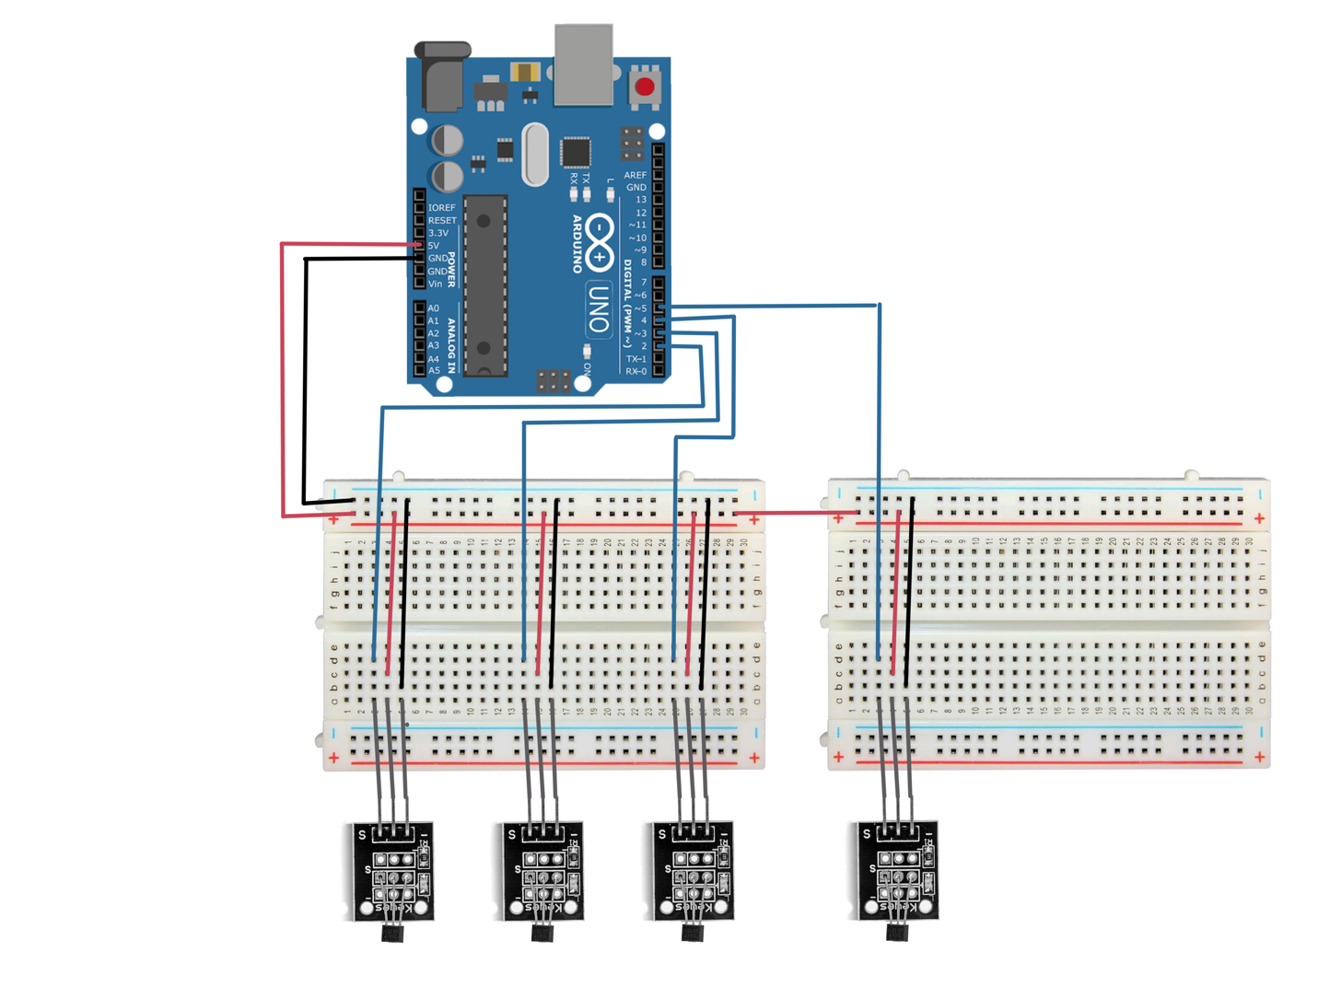

Sensors all attached in series for power and GND

Each sensor is given their own pin for the output

Diagram 12

**Expected output format:** “pinNumber timeTaken”

**Output:**

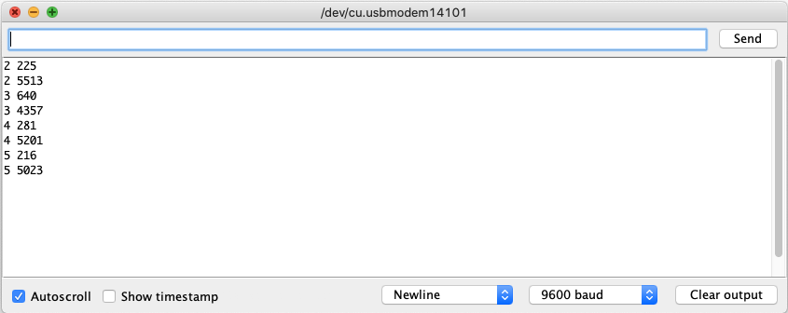

Each pin is able to measure small and large time intervals

Each pin is working

After these two prototypes I feel confident that the sensors are working reliably and that I can move on to prototyping the receiving end of this hardware input. This will be a python script that can read the output from the Arduino via the serial port. As I will be implementing the hardware input as a module, I will create a class with the required functionality.

Required functionality:

* A getSpeed() method, which will return the most recent recorded speed.
* A getDisplacement() method, which will return the pinNumber of the sensor which was most recently passed.
* A readSerialPort() method that will read data from the port and extract the needed information.

Pseudo Code:

class HallInput:

private:

ser (Serial)

speed (float)

displacement (int)

DISTANCE_BETWEEN_MAGNETS (const float)

calcSpeed(int) : float

public:

getSpeed(): float

getDisplacement(): int

readSerialPort(): void

Public METHOD readSerialPort():

line 🡨 self.ser.readLine()

strLine 🡨 binaryToString(line)

if strLine NOT EMPTY:

disp, time = strLine.split(“ “)

self.displacement = disp

self.speed = self.calcSpeed(time)

Private METHOD calcSpeed(int time):

Return self.DISTANCE_BETWEEN_MAGNETS / time

|  |  |  |  |
| --- | --- | --- | --- |
|  | Identifier | Types | Purpose |
| - | ser | Serial | Instance of the serial class to control reading from the serial port |
| - | speed | float | Stores the most recent speed value |
| - | displacement | int | Stores the most recent pin activated |
| - | DISTANCE_BETWEEN_MAGNETS | float | Used to calculate speed |
| - | calcSpeed() | (int): float | Uses the time argument and distance to calculate the speed of the car |
| + | readSerialPort() | (): void | Reads from the serial port and stores new values if they’re given. |
| + | getSpeed() | (): float | Getter method for speed |
| + | getDisplacement() | (): int | Getter method for displacement |

The python code I produced with reference to this pseudo code is shown in code snippet 5.

import serial

from time import sleep

class HallInput:

def __init__(self, distBetweenMagnets: float) -> None:

self.__ser = serial.Serial("/dev/tty.usbmodem14101", 9600, timeout=.5)

sleep(2) # allow time for the serial object to connect to port

Defining private / public variables/ constants as good practice

self.__DIST_BETWEEN_MAGNETS = distBetweenMagnets # meters

self.__ENCODING = "utf-8"

self.__EMPTY = ""

self.__speed = 0.0 # meters per second

Measurement units are subject to change, but SI unis are used for now.

self.__displacement = 0

def __calcSpeed(self, timeMillis: int) -> float:

if timeMillis == 0:

print("Time value is 0 causing division by 0 error")

Division by 0 error handling

return 0.0

else:

timeSec = timeMillis / 1000

return self.__DIST_BETWEEN_MAGNETS / timeSec

def readSerialPort(self) -> None:

The format I defined for the Arduino output allows for this.

line = self.__ser.readline()

strLine = line.decode(self.__ENCODING)

if strLine != self.__EMPTY:

disp, time = strLine.split(" ")

self.__displacement = int(disp)

self.__speed = self.__calcSpeed(float(time))

def getSpeed(self) -> float:

return self.__speed

def getDisplacement(self) -> int:

return self.__displacement

# 10cm = 0.1 m

Code to test the module

hallReader = HallInput(0.1)

for i in range(20):

hallReader.readSerialPort()

print(f"SensorNumber: {hallReader.getDisplacement()} Speed: {hallReader.getSpeed()}")

code snippet 5

**Expected functionality:** getSpeed() and getDisplacement() methods which use the data supplied from the serial port.

**Output:**

All sensors are working

SensorNumber: 0 Speed: 0.0

SensorNumber: 2 Speed: 0.1457725947521866

SensorNumber: 2 Speed: 0.1457725947521866

SensorNumber: 2 Speed: 0.1457725947521866

SensorNumber: 2 Speed: 0.1457725947521866

The most recent data from the serial port is saved

SensorNumber: 3 Speed: 0.20833333333333334

SensorNumber: 3 Speed: 0.20833333333333334

SensorNumber: 3 Speed: 0.20833333333333334

SensorNumber: 4 Speed: 0.26455026455026454

SensorNumber: 4 Speed: 0.26455026455026454

SensorNumber: 5 Speed: 0.2450980392156863

SensorNumber: 5 Speed: 0.2450980392156863

SensorNumber: 5 Speed: 0.2450980392156863

SensorNumber: 5 Speed: 0.2450980392156863

SensorNumber: 5 Speed: 0.2450980392156863

SensorNumber: 5 Speed: 0.2450980392156863

SensorNumber: 5 Speed: 0.2450980392156863

SensorNumber: 5 Speed: 0.2450980392156863

SensorNumber: 5 Speed: 0.2450980392156863

SensorNumber: 5 Speed: 0.2450980392156863

[Done] exited with code=0 in 11.341 seconds

Code snippet 5 proves that my hardware input is working. The output from the both the Arduino and the python module work as required. The only improvement that I could be make is one mentioned before; to control the values of NumSensors and pins in the Arduino script from the python module. However, I have not been able to find a reliable way to communicate this data. One possible solution is to send the data one byte at a time, but that is unreliable, as a single missing byte could cause the program to fail. For now, I will keep it hard coded into the Arduino script, but if I find a more reliable way to do this, I might implement it for my final solution.

### Hardware Output

As mentioned in my analysis, I will be using a servo motor connected to the controller to control the resistance on track. This will be done by using an Arduino which will communicate with my laptop via a serial port. Controlling the servo using the serial port will be similar to how I received the data from the hall sensors, but the other way around.

**Recalling requirement 12:**

I will be able to control the output voltage by pulling the trigger on the controller using a servo motor controlled by an Arduino and my laptop.

The wiring for the servo motor is very simple and is shown in diagram 13.

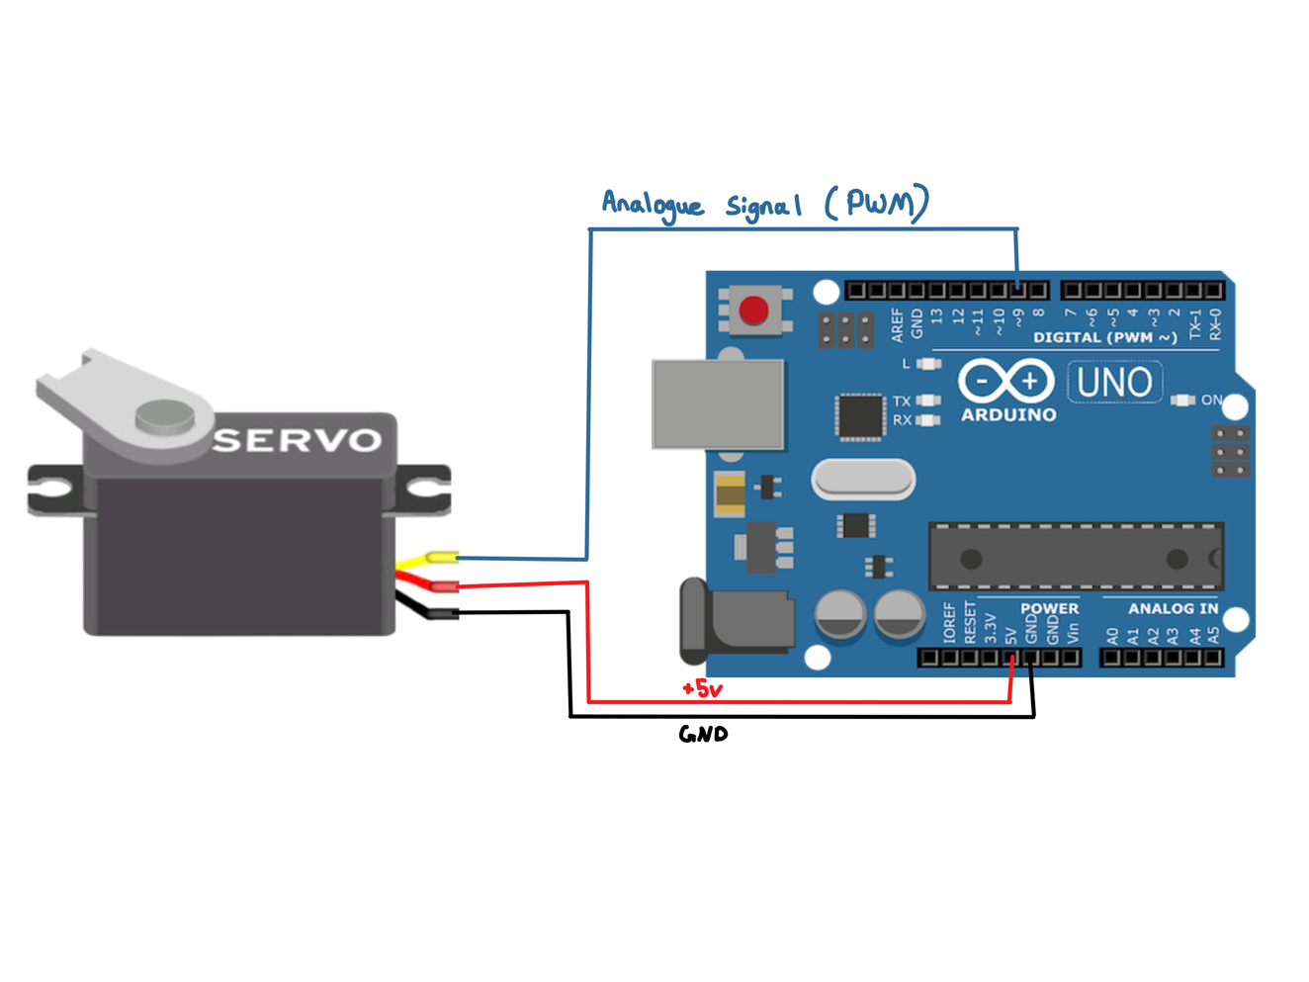

Diagram 13

The Pseudo code I designed for the Arduino is very simple, as it just needs to read information from the serial port and then move the servo motor.

servo <- new Servo object

Pin 9 is chosen because it can output a PWM* signal.

servo.attachToPin(9)

loop(){

If serial is availableToRead {

angle = Serial.read()

servo.MoveTo(angle)

}

}

To convert this into Arduino Code is quite simple, as attachToPin, availableToRead and moveTo are existing methods called attach(), available() and servo.write(). Furthermore, to make a servo object I need to include the servo.h library. The code I produced is shown in code snippet 6.

#include <Servo.h>

Servo servo;

int angle;

void setup() {

Serial.begin(9600);

servo.attach(9);

}

void loop() {

// check if there is any data to read

if (Serial.available() > 0) {

// read the incoming byte:

angle = Serial.read();

servo.write(angle);

}

}

Code snippet 6

To test the functionality of this code I need to develop the other half: my laptop sending the data. As this will also be implemented as a module, I will create another class for it.

class ServoController:

private:

ser (Serial)

prevAngle (int)

angleIsValid(int): Boolean

public:

setAngle(int): void

Implemented as a static method because it doesn’t need any class attributes.

@staticmethod

private METHOD angleIsValid(int angle):

if 0 <= angle <= 180:

return True

else:

return False

public METHOD setAngle(int angle):

if self.angleIsValid(angle):

if angle != self.prevAngle:

ser.write(angle.to_bytes(1, byteorder=“little”))

self.prevAngle <- angle

As the serial port communicates in bytes, I need to convert my variables into bytes to send them. The to_bytes() method is built into python and has the syntax:

value.to_bytes(size, byteorder=“big/little”)

else:

print(“angle is not valid”)

|  |  |  |  |
| --- | --- | --- | --- |
|  | Identifier | Types | Purpose |
| - | ser | Serial | Instance of the serial class to control writing to the serial port |
| - | prevAngle | int | Prevents the servo from making a useless motion. |
| - | angleIsValid() | (int): Boolean | Checks if the angle is within a specified range, which prevents the servo from trying to over rotate. |
| + | setAngle() | (int): void | Writes the angle to the serial port making the servo move. |

The python code I produced with reference to this pseudocode is shown in code snippet 7.

import serial

from time import sleep

class ServoController:

def __init__(self, mini: int, maxi: int) -> None:

self.__ser = serial.Serial("/dev/tty.usbmodem14101", 9600)

sleep(2)

New private attribute (explained below)

self.__prevAngle = -1

self.__VALID_RANGE = [mini, maxi+1]

def angleIsValid(self, angle: int) -> bool:

if angle in range(*self.__VALID_RANGE): # *[] expands the list

return True

Using the * will expand the elements in the list and allow me to use the two elements as arguments for the range() function.

else:

return False

def setAngle(self, angle: int) -> None:

if self.angleIsValid(angle):

if angle != self.__prevAngle:

self.__ser.write(angle.to_bytes(1, byteorder="little"))

self.__prevAngle = angle

else:

print("Angle was not within range specified by min and max")

After experimenting with this parameter, I didn’t notice any difference between using “big” or “little” for byteorder. the actual difference between them is which bit is more significant. Big: most significant bit is at the end of the array. Small: at the start of the array.

def closeSerial(self) -> None:

self.__ser.close()

code snippet 7

When implementing the pseudo code, I realised two improvements I could make. Firstly, instead of hardcoding the range to be between 0 and 180, I added the choice for the user. Next, I included a closeSerial() method. I should’ve included this on my other hardware module, as it is important to close the serial object when its done. One other improvement I could’ve made was to add some sort of feedback in the setAngle() method. E.g. returning True if it has been successfully written to the serial port, and False otherwise. This would allow me to make sure this module is still working in my main program.

In order to test the module I just built and the Arduino code, I wrote a quick testing sequence.

ranges = [[0,180], [20,160], [40,140], [0,0]]

for ran in ranges:

controller = ServoController(*ran)

print(f"Range: {ran[0]} -> {ran[1]}")

for i in range(0, 201, 10):

print(f"attempting set angle to {i}")

controller.setAngle(i)

sleep(1)

controller.closeSerial()

print()

code snippet 8

**Expected output:** for each of the ranges, it should try move the motor to the specified angle only if it’s within the range. It should print an error message if the angle is outside the range.

**Output:**

Range: 40 -> 140

attempting set angle to 0

Angle was not within range specified by min and max

attempting set angle to 10

Angle was not within range specified by min and max

attempting set angle to 20

Angle was not within range specified by min and max

attempting set angle to 30

Angle was not within range specified by min and max

attempting set angle to 40

attempting set angle to 50

…

attempting set angle to 140

attempting set angle to 150

Angle was not within range specified by min and max

…

…

Range: 0 -> 180

attempting set angle to 0

attempting set angle to 10

attempting set angle to 20

…

attempting set angle to 180

attempting set angle to 190

Angle was not within range specified by min and max

attempting set angle to 200

Angle was not within range specified by min and max

Range: 0 -> 0

attempting set angle to 0

attempting set angle to 10

Angle was not within range specified by min and max

attempting set angle to 20

Angle was not within range specified by min and max

attempting set angle to 30

Angle was not within range specified by min and max

…

Range: 20 -> 160

attempting set angle to 0

Angle was not within range specified by min and max

attempting set angle to 10

Angle was not within range specified by min and max

attempting set angle to 20

attempting set angle to 30

…

attempting set angle to 160

attempting set angle to 170

Angle was not within range specified by min and max

attempting set angle to 180

Angle was not within range specified by min and max

attempting set angle to 190

Angle was not within range specified by min and max

attempting set angle to 200

Angle was not within range specified by min and max

For clarity a lot of lines were cut as they fit the pattern

After running the test sequence, both the Arduino and the module worked as expected. Now that the software for the hardware module is complete, I can move onto the other core features of my investigation. I decided not to include the process of attaching the hardware, as it is just a matter of gluing things together and I have more important aspects to focus on.

## Reinforcement learning

### Table Representation Research

As I will be using table Q learning for this investigation, I need to define how I will store the Table. As mentioned in the storage section of my IPSO considerations, I need to research into the four possible ways I could implement this table: 2D linked list, 2D NumPy array, Hash Tables, or Pandas Data frame. The result of this research is shown in table 13.

|  |  |  |  |
| --- | --- | --- | --- |
| 2D Linked List | 2D NumPy Array | Hash Tables | Pandas Data frame |
| Built into Python | Library | Self-implement / built-in (dictionary) | Library |
| Slower than NumPy | Very fast indexing | O (1) indexing | Quite slow indexing |
| Simple and easy to implement | Good documentation | Dictionaries are simple to use. If I self-implement I have full control. | Good documentation |
| 2D NumPy arrays are more efficient | More suitable for smaller data sets | Good for very large data sets |
|  | Good for sparse arrays (many empty elements) | Data is stored in seemingly random locations: hash locations are unpredictable. | Good for merging different datasets |
|  | Good for performing many numerical calculations | Efficient reordering/ reshaping of data |
|  | More suitable for numeric processing data | Because similar data isn’t stored in similar positions, finding a max Q value for a specific state is made more difficult | More suitable for database-like data |
| Data is stored in an order, which is easy to work with | Data is stored in an order, which is easy to work with | Data is stored in an order, which is easy to work with |

Table 13

From the table I can see that 2D NumPy arrays are the most suitable for my investigation. It has good efficiency and is specialised for storing multidimensional numerical data. My method will need to have high lookup and edit efficiency as I will be using and changing the Q values stored very often.

I decided against using Hash Tables, as they seem less suitable for my purpose. In Q learning, an action is chosen based off the maximum Q value for that state. A 2D table is suitable because I can just check one row/column and easily find the maximum. However, A hash table seems less suitable, as that would require me to hash every action to find the hash location, then access the value in each location, then compare them afterwards.

I also decided against the Pandas Data frame. The main reason for this is because that library is built on top of NumPy and is specialised for much larger data sets than my table. Because of this specialisation, it has many advantages that aren’t usable for my implementation (these are the rows coloured in orange font in the table).

### Table Formatting considerations

Now that I know which method I’m using to represent the table, I need to consider the format of all the data in my table. In my high-level overview I started thinking of a possible structure for it using groups, which I will now elaborate on.

Usually in Table Q learning, the columns on the table represent all the possible states, and the rows represent all the possible actions. I will need to define what my states and action will look like.

**Actions:**

This will be all the possible angles on the servo motor. As a maximum this will be 181 different positions (0-180°) However, as I’m using it move the wiper on a potentiometer, it is likely that this range will be smaller: 0-90° maybe.

**States:**

In my High-level overview (diagram 9) I decided that my states would be a combination of current speed, distance to corner, and colour of corner (representing severity). An example of a state format would be:

0 000 00

The first digit represents severity of next corner. As my track only has 2 types of severity, I can use a 0 for straights (not severe) and a 1 for a turn (more severe). The next three digits are the value of the distance to the corner. As the distance to corner will be measured in millimetres, three digits should be enough to represent all distances (they won’t be larger than 1m = 1000mm). The last two digits are for the car’s speed, which will likely be measured in mm / s. The car is unlikely to travel faster than 100 mm/s, so two digits should be enough to represent each speed. (This assumption is incorrect, see pg 107)

Using this format for the states, there are a maximum 200,000 different states (2x105). Therefore, the total number of elements will be 36,200,000 (200,000 x 181). The size of this 2D array in bytes can be found by multiplying the number of elements by the size of the datatype stored. As it will store floats (4 bytes each), this means the size of the table will be 144.8 MB (36,200,000x4) plus a little more for the overhead data. A table of this size will be slow and take a very long time to train all the Q values.

Because of this, I decided that it might help to have each column represent a range of values. For example, instead of there being 100 individual states for all possible speed values, there could be 10 individual ones if they all represented a range of 10 speeds. This would save memory and reduce the training time, but it might also reduce the precision of the outcome. This is the Table granularity VS size trade-off I mentioned in my High-level overview.

### Prototyping

Now that I have a clear understanding of how I want to implement the Q-Table, I can start to design the Reinforcement learning module. As I only have vague idea of how the RL algorithm will work, I decided to pseudocode the main logic of it. I started by using a very English-like pseudocode, as the concepts involved are quite complex and this will help me get a better understanding.

Main logic:

1. Get the first state (S1) from the sensors.
2. Use the state (S1) to determine an action (A1).
3. Let the action (A1) happen (have some delay so that the hardware can do its thing)
4. Get the next state from the sensors (S2)
5. Pass the next state (S2) into the reward function and store the return value (Rinst) into a variable.
6. Pass S1, A1, S2 and Rinst into the QValue calculator function and store the returned Qvalue into a variable.
7. Update the Qtable with the new Q value at index S1, A1

NOTE: After step 7 there are two ways to repeat this process. Either I use S2 as S1 and repeat from step 4, or I get a new state entirely in step 1. The only reason for getting a new state would be that S2 is inaccurate, as some time will’ve passed when doing all the Qvalue logic, and the car may not be in S2 anymore. If I have a very big Qtable this, could be an issue as it takes time to index into and update a large Qtable. However, as I’m using a small Qtable, I believe that this time difference won’t be very significant, and I can just use S2 as S1 in the next decision process.

Reward function (S2):

1. Initialise instantaneous reward (Rinst) to 0
2. Check if the car has deslotted, True:
   1. multiply cumulative reward by 0.5
   2. Set the Rints to -1000 (or other very small value)
3. Else: Determine* a value for Rinst based on the car’s current speed (using S2 passed in)
4. Return Rinst

* NOTE: To determine this, I will have to define a relationship between speed and reward (for example directly proportional using a constant K I can change). Another consideration is how I want to implement this. I could make a nested function within the reward function, as it is only ever needed by the reward function. However, one problem with this is that the function will be redefined every time the outer function is called. Since the reward function will be called every decision, implementing it as a nested function would be inefficient.

calcNewQValue (S1, A1, S2, Rinst):

1. There should be references to the agent attributes:
   1. Learning Rate
   2. Discount Factor
2. Use the formula:

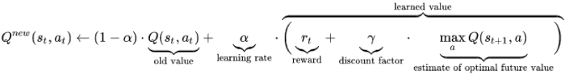

* 1. Do and save the result from: (1-learningRate) * Qtable.getData(A1,S1). (oldValue)
  2. Find the optimal future reward from: Qtable.getActionWithMaxQValue(S2)
  3. Multiply this by the discount factor attribute
  4. Find the learned value by adding together Rinst and the discounted optimal future reward. (learnedValue)
  5. Calculate the new Qvalue from: oldValue + (learningRate * learnedValue)
  6. Return new Qvalue.

Now that I have much clearer understanding of the algorithm, I decided to design a separate class for the QTable, which will have a composition relationship with a QLearningAgent class, as shown in diagram 14.

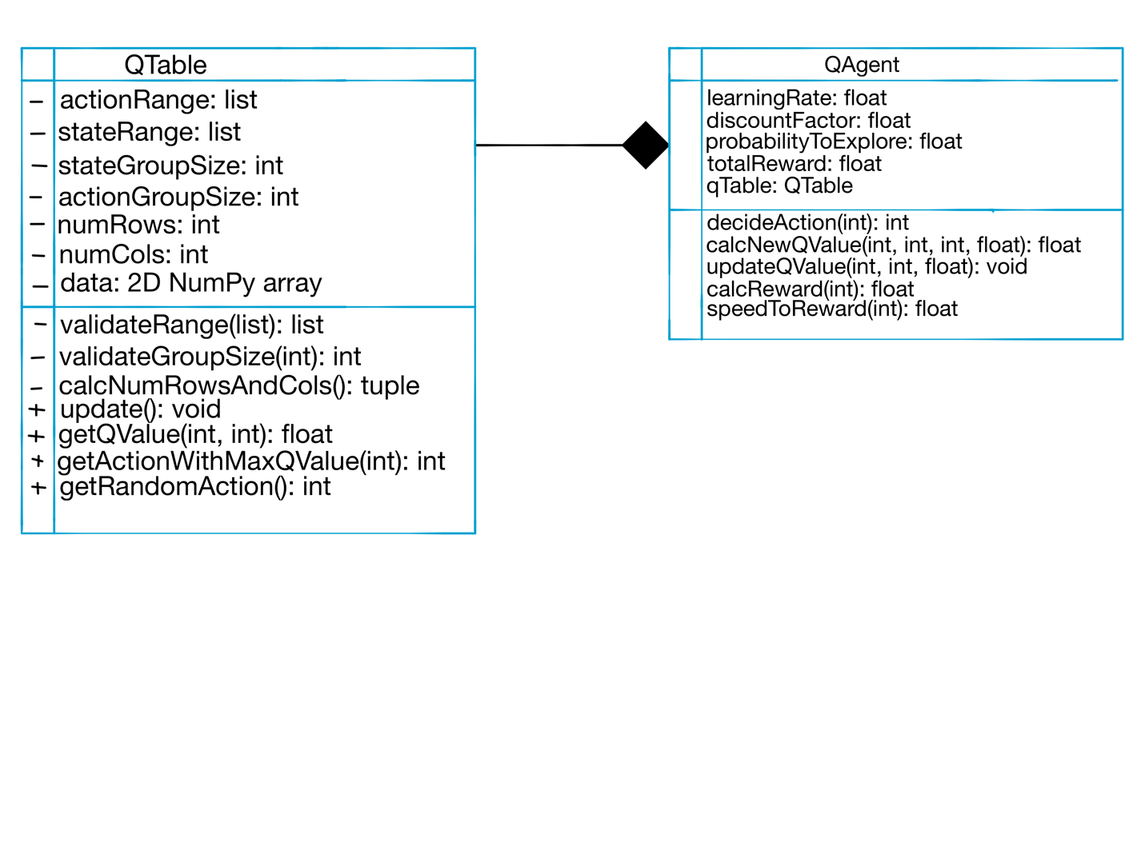

I tried to design this class so that I can use it in the same way the pseudocode I produced does. This means making specific public methods that can abstract away the complexities of using the Qtable.

All the methods that will be needed by the agent.



Diagram 14

In diagram 14, I included some of the methods and attributes I thought were necessary for each class. Moreover, the filled in diamond represents a composition relationship, as each Q learning agent must have a Qtable as well. At this point I am confident enough with the algorithm that I can start to code it. I decided to start with the QTable, as this can be tested independently and is required to test the QAgent.

The code I produced is shown in code snippet 9 below.

import numpy as np

from random import randint

class QTable:

def __init__(self, statesRange: list, actionRange: list, stateGroupsSize: int, actionGroupSize: int) -> None:

# Validate all parameters

self.__stateRange = self.__validateRange(statesRange)

self.__actionRange = self.__validateRange(actionRange)

self.__stateGroupSize = self.__validateGroupSize(stateGroupsSize)

self.__actionGroupSize = self.__validateGroupSize(actionGroupSize)

# provide feedback if any parameters are invalid

if self.__stateRange == [] or self.__actionRange == []:

print("Table NOT created: range invalid")

return None

if self.__stateGroupSize == 0 or self.__actionGroupSize == 0:

print("Table NOT created: group size invalid")

return None

Using NumPy arrays as I determined that these will be the most suitable.

# initialise the table

self.__numRows, self.__numCols = self.__calcNumRowsAndCols()

self.__data = np.zeros((self.__numRows, self.__numCols), dtype=float)

np.set_printoptions(precision=3, suppress=True, linewidth=120) # just to make the output look decent

print(f"{self.__numRows} x {self.__numCols} Table created")

The two validation methods are implemented as static methods, as they don’t require any attributes from an object.

@staticmethod

def __validateRange(theRange: list) -> list:

if len(theRange) != 2:

return []

for i in range(len(theRange)):

try:

theRange[i] = int(theRange[i])

except ValueError:

print(f"range bound: {theRange[i]} is not an integer")

return []

if theRange[0] < theRange[1]:

return theRange

else:

print("lower bound cannot be >= upper bound")

return []

@staticmethod

def __validateGroupSize(size: int) -> int:

try:

size = int(size)

except ValueError:

print(f"{size} is not a valid size for a group")

size = 0

This method uses each group’s width and their range to determine how many rows and columns the table needs.

return size

def __calcNumRowsAndCols(self) -> tuple:

stateRangeWidth = self.__stateRange[1] - self.__stateRange[0]

actionRangeWidth = self.__actionRange[1] - self.__actionRange[0]

Each row/ column in the table will use the lower bound of that group. Another row/column is needed to represent the upper bound of the range.

numRows = actionRangeWidth // self.__actionGroupSize + 1

numCols = stateRangeWidth // self.__stateGroupSize + 1

return numRows, numCols

def __actionToIndex(self, action: int) -> int:

return action // self.__actionGroupSize

def __stateToIndex(self, state: int) -> int:

return state // self.__stateGroupSize

To convert between QTable indices and the corresponding groups.

def __indexToAction(self, index: int) -> int:

return index * self.__actionGroupSize

def __stateGivenIsValid(self, state: int) -> bool:

if state in range(self.__stateRange[0], self.__stateRange[1]+1):

return True

else:

print(f"state was outside the range specified: {state}")

return False

def __actionGivenIsValid(self, action: int) -> bool:

if action in range(self.__actionRange[0], self.__actionRange[1]+1):

return True

else:

print(f"action was outside the range specified: {action}")

return False

def update(self, state: int, action: int, value: float) -> None:

if self.__stateGivenIsValid(state) and self.__actionGivenIsValid(action):

row = self.__actionToIndex(action)

The validation is needed to prevent ‘index out of range’ errors.

col = self.__stateToIndex(state)

self.__data[row, col] = value

else:

print("table not updated")

def getQValue(self, state: int, action: int) -> float:

if self.__stateGivenIsValid(state) and self.__actionGivenIsValid(action):

row = self.__actionToIndex(action)

Built in NumPy method to determine the index of the largest value in a row/ column. The axis parameter allows me to control which one: 0: vertical, 1: horizontal. It returns an array of the max index for all columns, so I index into the column I want.

col = self.__stateToIndex(state)

return self.__data[row,col]

else:

print("location not found on Q table")

return 0.0

def getActionWithMaxQValue(self, state: int) -> int:

if self.__stateGivenIsValid(state):

col = self.__stateToIndex(state)

index = self.__data.argmax(axis=0)[col]

return self.__indexToAction(index)

else:

print("couldn't find max Qvalue")

return self.__actionRange[0] # lowest possible action (stop the car)

def getRandomAction(self) -> int:

row = randint(0, self.__numRows-1)

return self.__indexToAction(row)

def printTable(self):

print(self.__data)

code snippet 9

To test that this works, I designed a small test program:

if __name__ == '__main__':

These values will make the table have 7 rows and 6 columns. Each group in the rows will be 10 wide. Each group in the rows will be 20 wide.

from random import random

# fill the table with random values to test

table = QTable([0,60], ["0","100"], 10, "20")

for action in range(0,120, 20):

for state in range(0,70, 10):

table.update(state, action, random())

# Test 1:

print("\nTest 1")

errorTable = QTable([0,0], [0,100], 1, 1)

errorTable = QTable(["Four","ten"], ["5", 2], 1, 1)

table.printTable()

# Test 2:

print("\nTest 2")

print(table.getQValue(56, 12))

# Test 3:

print("\nTest 3")

for state in range(0, 70, 10):

print(table.getActionWithMaxQValue(state))

# Test 4:

print("\nTest 4")

for i in range(3):

print(table.getRandomAction())

**Test 1:** Testing the table creation

**Expected Output:** errors shown for the ‘errorTable’ variables. 2D NumPy array of random float values with 7 columns and 6 rows

**Output:**

Success: [0,0] shouldn’t be a valid range, so an error message is shown

Test 1

lower bound cannot be >= upper bound

Table NOT created: range invalid

Success: “Four” can’t be interpreted as an Int, so an error message is shown. Furthermore, the second range is also invalid as 5 > 2, so message is shown.

range bound: Four is not an integer

lower bound cannot be >= upper bound

Table NOT created: range invalid

[[0.053 0.973 0.732 0.006 0.43 0.333 0.526]

Success: for the valid inputs, the correct table with 7 columns and 6 rows was produced.

[0.357 0.771 0.16 0.511 0.969 0.151 0.033]

[0.141 0.561 0.662 0.302 0.213 0.199 0.164]

[0.071 0.236 0.42 0.364 0.364 0.587 0.876]

[0.954 0.802 0.202 0.526 0.057 0.386 0.354]

[0.6 0.869 0.446 0.299 0.256 0.658 0.588]]

For the next stages of my testing, I will show a more readable version of the table outputted:

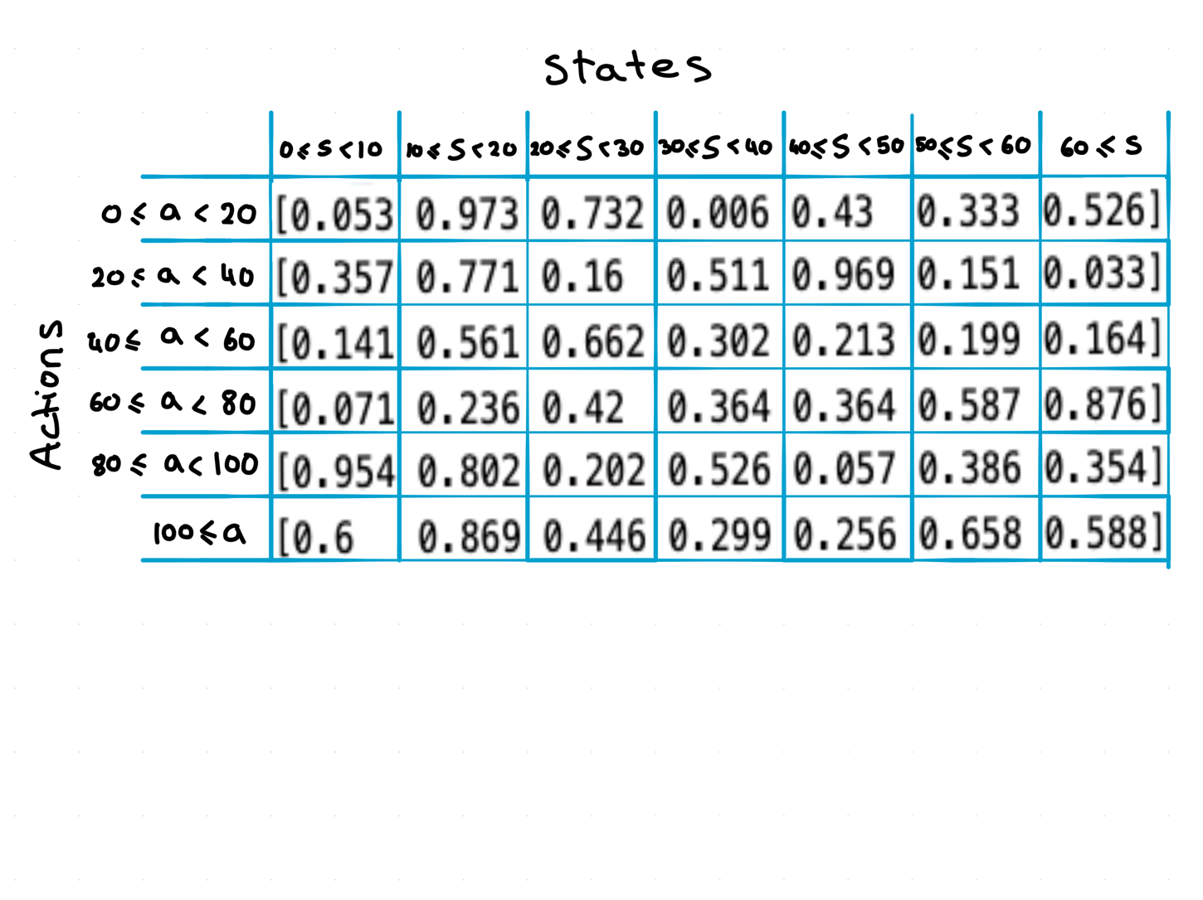

Table 14

**Test 2:** Testing the getQValue method to see if the correct q value is returned.

**Expected output:** looking for state 56 and action 12, the returned QValue should be the value held in the groups 50 ≤ s < 60 and 0 ≤ a < 20. For this table, it should be the value which rounds to 0.333

**Output:**

Test 2

0.33274457960709336

As the correct value was returned, this method is working. I decided to also test the method using wrong inputs. The output is as follows:

print(table.getQValue(200, 4))

-> state was outside the range specified: 200

location not found on Q table

0.0

print(table.getQValue(4,200))

-> action was outside the range specified: 200

location not found on Q table

0.0

print(table.getQValue("four", "five"))

-> state was outside the range specified: four

location not found on Q table

0.0

For all three of the wrong inputs, the program returned the correct message, showing that this method is working well.

**Test 3:** Testing the getActionWithMaxQValue function to make sure it is returning the correct action

**Expected output:** for each iteration in the test, the expected output is shown in bold next to it. This value was arrived at by looking at the table and looking which row the max value is in (using the lower bound of the group).

**Output:**

Test 3

80 **80**

0 **0**

0 **0**

80 **80**

20 **20**

100 **100**

60 **60**

From the test cases I can see that this method is working as expected. Furthermore, it used the same validation as in test 3, so wrong inputs will be handled the same way.

**Test 4:** Testing the getRandomAction method.

**Expected output:** It should return a random action in the table. To make sure it is random, I used three

iterations to see if there was some variation.

**Output:**

Test 4

40

80

100

As there is variation and they are all possible actions within the table, this method is working as expected.

For Future reference, I decided to make a table outlining the attributes and functionality of this class. I can

Use this table as a reference when designing the class I will use for my final implementation.

|  |  |  |  |
| --- | --- | --- | --- |
|  | Identifier | Types | Purpose |
| - | stateRange | list | Range of possible states |
| - | actionRange | list | Range of possible actions |
| - | stateGroupSize | int | Size of each group within states |
| - | actionGroupSize | int | Size of each group within actions |
| - | numRows | int | The number or rows on the table |
| - | numCols | int | The number of columns on the table |
| - | data | 2D NumPy array | The array containing all the Q values. |
| - | validateRange() | (list): list | Returns the original list if it is a valid range, otherwise returns an empty list. |
| - | validateGroupSize() | (int): int | Returns the original group size if it is valid, otherwise returns 0 |
| - | stateGivenIsValid() | (int): bool | Returns True if the state is within stateRange, else False |
| - | actionGivenIsValid() | (int): bool | Returns True if the action is within the actionRange. Else False |
| - | calcNumRowsAndCols() | (): tuple | Returns a tuple containing the number of rows and columns |
| - | stateToIndex() | (int): int | Converts the given state or action to the respective index or vice versa. |
| - | actionToIndex() |
| - | indexToAction() |
| + | Update() | (int, int, float): void | Updates the table at the state and action specified |
| + | getQValue() | (int, int): float | Returns the stored Q value at that location in the table. |
| + | getActionWithMaxQValue() | (int): int | Uses the passed in state to find the best action for that state, then returns the action. |
| + | getRandomAction() | (): int | Returns a random action from the table. |
| + | printTable() | (): None | Prints out the Q table. |

Table 15

Now that I have the QTable class working, I can start to prototype the QAgent class. All the needed class attributes and methods are shown in the table 16, which I can use as a reference when prototyping and designing my final implementation.

|  |  |  |  |
| --- | --- | --- | --- |
|  | Identifier | Types | Purpose |
| - | learningRate | Float | When calculating the new Qvalue, the learning rate determines how much of the new value it retains. 0: doesn’t learn at all, 1: learns all. |
| - | discountFactor | Float | This factor determines how heavily the estimated future reward impacts the newQ value. 1: future reward heavily influences the new Qvalue, 0: only the immediate reward is used, possible future rewards are ignored. |
| - | probablilityToExplore | Float | The probability for the agent to choose a random action. |
| - | SPEED_TO_REWARD | int | The constant that defines the relationship between speed and reward. |
| - | totalReward | float | The total cumulative reward that the agent has gathered. |
| - | qTable | QTable | The Qtable that is used to make decisions. |
| + | decideAction() | (int): int | A method to decide on an action. It either chooses a random action or uses the Qtable to determine the best action. |
| + | calcNewQValue() | (int, int, int, float): float | Uses the formula, shown in the Pseudocode for this RL algorithm, to calculate the new Qvalue. |
| + | updateQValue() | (int, int, float): None | Used to update the Qtable with the passed in value. This could be the new Qvalue or a value I want to pass in. |
| + | calcReward() | (int, bool): float | Calculates the reward which is given to the agent. This method needs to be implemented well to make sure the agent learns. |
| - | speedToReward() | (int): float | Uses the constant defined earlier to calculate the reward for a certain speed. |
| + | printQTable() | (): None | Prints out the Qtable. |

Table 16

The code I produced to prototype the QAgent class is shown below.

from QTable import QTable

from random import random

I’m using Key-word arguments, as there are so many parameters, that passing them individually will make my code harder to read.

DEBUG = False

class QAgent:

def __init__(self, **kwargs) -> None:

self.__learningRate = kwargs["learningRate"]

self.__discountFactor = kwargs["discountFactor"]

self.__probabilityToExplore = kwargs["probabilityToExplore"]

For future reference: It might be nice to have some sort of feedback from the QTable constructor to know if the table has been created successfully.

self.__SPEED_TO_REWARD_K = 1

self.__totalReward = 0.0

self.__qTable = QTable(kwargs["stateRange"],

kwargs["actionRange"],

kwargs["stateGroupSize"],

kwargs["actionGroupSize"])

def decideAction(self, state: int) -> int:

These debug statements allow me to easily switch between printing debugging information, and just running the program.

if random() < self.__probabilityToExplore:

if DEBUG:

print("random action chosen")

return self.__qTable.getRandomAction()

else:

if DEBUG:

print("chose max Qvalue")

return self.__qTable.getActionWithMaxQValue(state)

def calcNewQValue(self, curState: int, nextState: int, action: int, reward: float) -> float:

oldValue = (1-self.__learningRate) * self.__qTable.getQValue(curState, action)

discountedOptimalFutureReward = self.__discountFactor * self.__qTable.getActionWithMaxQValue(nextState)

Calculating the formula in logical chunks to make it easier to follow.

learnedValue = reward + discountedOptimalFutureReward

newQvalue = oldValue + (self.__learningRate * learnedValue)

if DEBUG:

print(f"old Value: {oldValue} dicOptFut: {discountedOptimalFutureReward} learned: {learnedValue}")

print(f"New Q value: {newQvalue}")

return newQvalue

def updateQValue(self, state: int, action: int, value: float) -> None:

self.__qTable.update(state, action, value)

def calcReward(self, speed: int, carHasDeslotted: bool) -> float: # Reward function

instReward = 0.0

The punishment can be any small number

if carHasDeslotted:

self.__totalReward * 0.5

instReward = -1000.0

else:

instReward = self.__speedToReward(speed)

return instReward

def __speedToReward(self, speed: int) -> float:

return speed*self.__SPEED_TO_REWARD_K

def printQTable(self):

self.__qTable.printTable()

code snippet 10

Now that the entire learning module is complete, I will try to test it. However, these learning modules are hard to test accurately without a reliable environment to get the states from. As I haven’t completed the other modules, I can’t test it on my environment (slot car track). Instead, I designed a simple simulation to see if the agent was learning at all. As this is just a simulation, I can’t guarantee that the module works fully, but it can help me predict if the module will work in future. The test program I wrote is shown below.

These parameters will need to be experimented with to see which combination will work the best for my investigation.

params = {"stateRange": [0,5],

"actionRange": [0,5],

"stateGroupSize": 1,

"actionGroupSize": 1,

"learningRate": 0.95, # how much of the new value it retains

"discountFactor": 0.05,# how much future rewards will influence the Qvalue

"probabilityToExplore": 0.1}

# Test:

# possible States: 0-5

# possible Actions: 0-5

# speed = reward for this test case.

if __name__ == '__main__':

agent = QAgent(**params)

Something to keep in mind is that Q-Learning takes many iterations to train. For my investigation, it will take a decent amount of time to train.

state1 = 0

speed = 0

for i in range(100000): # Training loop

deslotted = False

action = agent.decideAction(state1)

speed = action

# I could punish the car for standing still, but it would learn that taking other

# options should result in a higher result, so punishing it isnt neccesary

if random() < state1/20: # lower state (lower speeds) has less chance of deslotting

if random() < action/20: # lower speed chosen = lower chance of deslotting

deslotted = True # The car should learn that higher speeds are risky

instantReward = agent.calcReward(speed, deslotted)

The main logic of this training loop is based off the pseudocode I produced earlier.

if DEBUG:

print(f"iteration {i} with state {state1}")

print(f"action: {action}")

print(f"reward = {instantReward}")

# change the speed based off the action chosen

if action == 0:

state2 = 0

elif action >= state1 and state1 < 5: # increase the state if a high speed is chosen

state2 = state1 + 1

elif action <= state1 and state1 > 0: # decrease the state if a low speed is chosen

state2 = state1 - 1

newQvalue = agent.calcNewQValue(state1, state2, action, instantReward)

agent.updateQValue(state1, action, newQvalue)

state1 = state2

agent.printQTable()

**Expected Output:** As higher speeds and states are more likely to deslot in this simulation, it should learn to avoid being in/ picking high speeds. As such the Q values in the bottom and right sides of the table should be very low, whereas slower speeds will have higher rewards.

**Output:**

6 x 6 Table created

[[ 0.25 0.25 0.25 0.25 0.25 0.25 ]

[ 1.1 1.107 1.1 1.25 -46.514 1.238]

[ 2.1 2.2 -45.495 2.25 -0.13 -0.14 ]

Highest state

[ 3.1 3.247 0.718 0.63 -44.4 0.746]

[ 4.1 1.675 4.1 -43.548 -43.64 3.893]

[ 5.15 -42.587 5.1 -949.75 -949.548 -949.5 ]]

highest action

I have colour coded the output to make it more visual and easier to analyse. It is evident that the higher states and the especially the higher actions had very low Q values. This is in-line with my predictions, showing that the RL algorithm likely works as expected. Although there is some noise introduced into the values by the random nature of my simulation, the Agent managed to train the general behaviour that I needed.

## Computer Vision

As stated before, the entire aspect of computer vision is new to me. As a start, I decided I would research into possible ways to do object detection.

### Image Classifiers

The first method that I found was object detection using an image classifier. This means training a model on an object, then using it to detect that object in other images. When looking deeper into this, I could see that this approach was going to be quite complex and possibly unsuitable for my investigation. Firstly, I would need to train the classifier, which comes with other complexities like gathering a high quantity of high-quality images. Secondly, using a cascade classifier (common type of image classifier) is quite processor intensive, so using it every frame would be extremely processor intensive, making my program slow. I decided not to look further into this, and instead found another way of object detection: Colour detection.

### Colour Detection

This method of object detection uses colours to differentiate objects. By defining a range of RGB or HSV colour values, I can use an efficient method built into OpenCV called cv2.inRange() to generate a mask of all the locations with the desired colour. Using this mask, I can determine groups of the same colour which will be the object. Using colour detection will be helpful with finding the track locations, as I will be labelling them with coloured stickers. However, this method may not be suitable for detecting the car. As the car is moving, the brightness of the colour will vary according to its location. I.e., if the car passed through a shadow, the yellow colour will be darker. I could extend the colour range to include darker yellows, but this would also mean that other colours similar to yellow (like orange or brown) could be included in the mask, which would reduce the accuracy. I decided to research yet another method of object detection: Static Background Subtraction.

### Static Background Subtraction

This method involves training a background subtractor model. This can be done automatically using the built in cv2.createBackgroundSubtractorMOG2(). This model can be trained using a user-defined learning rate. After being trained, the learning rate can be set to 0, meaning that the background subtractor model will stop training. I can then use the trained model to create a mask of the foreground. This is done by determining which objects in the frame are moving. As my car will be moving, this will count as the foreground. This leaves me with a mask of just the moving objects, and as the car is the only thing moving, it will be a mask of only the car’s pixels.

### Prototyping

As I now have a vague idea of how I want to implement each computer vision feature, I can start to experiment with the two methods of object detection I have chosen. I decided to start with the background subtractor. As there isn’t a lot of thinking required to use the built-in module, I was confident enough to skip pseudo coding this part. The experimental prototype I produced is shown below.

import cv2 as cv

cap = cv.VideoCapture(0)

fgbg = cv.createBackgroundSubtractorMOG2(detectShadows=False)

Initializing the BGSub model. The detectShadows parameter is set to False, as it will cause the model to run slower and I don’t need it.

while True:

_, frame = cap.read()

Here I apply the BGSub model to get a mask. I don’t specify the learning rate because for this test, the default value works well.

if frame is None:

print("no frame")

break

fgMask = fgbg.apply(frame)

cv.imshow("mask", fgMask)

key = cv.waitKey(1)

Break on ESC key

if key == 27:

break

Code snippet 11

**Output:**

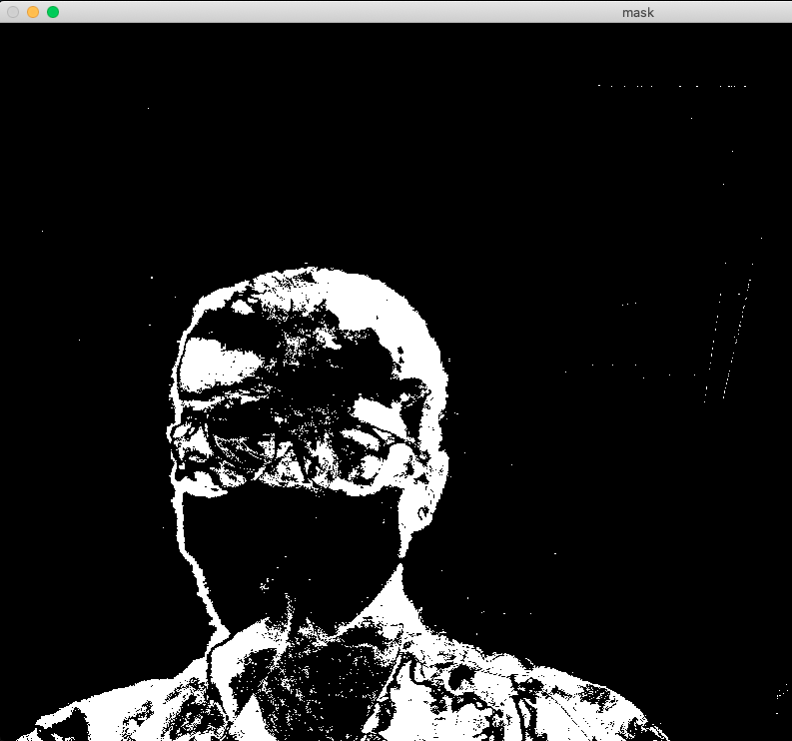

All the moving pixels are colored white.

The next challenge I had to face was how to use this mask to detect the different objects within the frame. I experimented with things like blob detection, but they didn’t lead me to a reliable solution. Instead, I decided to create my own simple object detector. Since my car is the only thing that is going to be moving, it means that there will only be one blob of colour in each frame. If I take an average location from all the white pixels in the frame, I can get the average location of the car. There is one downside to this of course, as the measurement for speed and displacement will be less accurate using a moving average. However, even the most sophisticated object detection methods will have inaccuracies involving averages and probabilities, meaning that this average solution should work similarly well, given that nothing else in the frame is moving.

I decided to start prototyping this part of the camera module. The code I produced for my first prototype is shown below.

import cv2

import numpy as np

cap = cv2.VideoCapture(1)

fgbg = cv2.createBackgroundSubtractorMOG2(detectShadows=False)

while True:

Setting up the objects and reading the frames are the same as in code snippet 11.

_, frame = cap.read()

if frame is None:

print("no frame")

break

Filtering through each pixel in the mask to see which ones are white. Then I store the indices of them.

fgMask = fgbg.apply(frame)

result = np.where(fgMask == 255)

xCoords = result[1]

yCoords = result[0]

This Try Except statement is needed, as sometimes the untrained BGSub model creates an empty mask. This results in a ‘Not a Number’ error which I need to handle

try:

meanX = int(np.mean(xCoords))

meanY = int(np.mean(yCoords))

except ValueError:

print("NaN error")

cv2.circle(frame, (meanX, meanY), 50, (0,255,0), 3)

key = cv2.waitKey(1)

if key == 27:

break

cv2.imshow("Frame", frame)

code snippet 12 – prototype 1

**Expected output:** the output should be the frame seen by the camera and a green circle with a radius of 50 surrounding the car I want to track.

**Output:**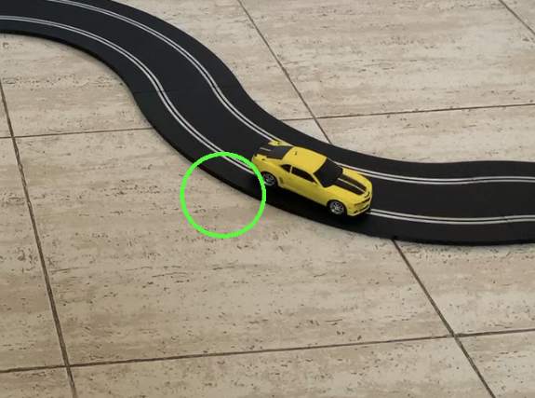

As I can’t document the live video feed on this word document, I have added an image to show the general output of the prototype. It is clear that the circle is tracking the approximate location of the car, but that the accuracy of the search is not good enough. This seems to be caused by the BGSub model having some noise in its output (almost like random positives). Two screenshots of the mask are shown below.

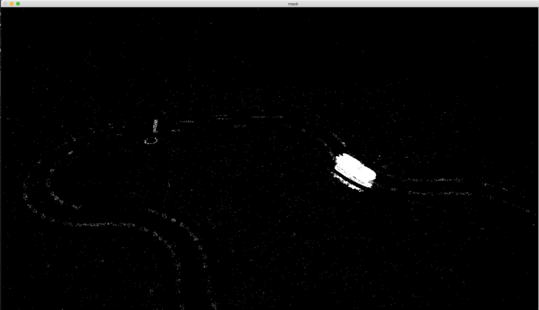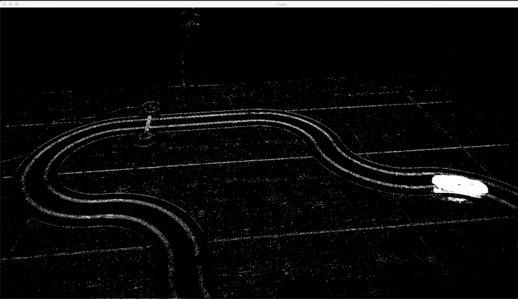

This camera angle has some issues with shadows causing the average to be biased as well. For my real angle (above the track) I will need to make sure the lighting is even so that shadows won’t make too much of a difference.

Inaccurate pixels and noise can cause the average to be further from the car.

I was not happy with the performance of this first prototype. To improve this, I thought of an idea inspired by the Binary Search algorithm. The pseudo code I wrote explaining my idea is shown below

1. Get average x and y values of car
2. Use the averages to zoom into the general region of the average
3. In the zoomed image, take new averages.
4. Repeat this process from step 2 with the new averages
5. Terminate when the specified number of zooms is reached

By zooming into the general region of the car, there are less pixels in the image. This means that the car’s moving pixels will have more prominence, meaning the average will be closer to the location of the car. The diagram I created explaining this visually is shown below.

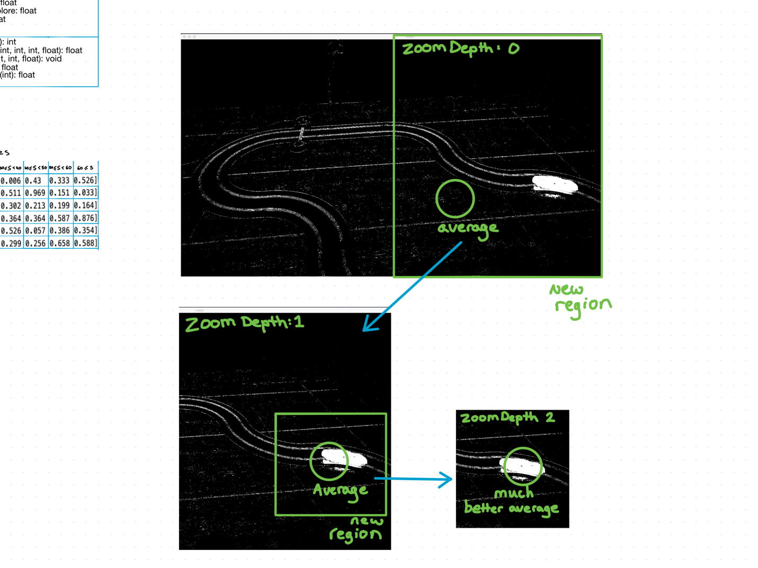

Hopefully I am left with a much better average when I reach the zoom depth limit.

Like Binary search, I move to the next step using the half which contains the car

This average is taken from the entire image and is therefore unreliable.

Diagram 15

The code I produced for prototype 2 is shown below:

def showCarLocation(self zoomDepth: int, zoomPerc: float) -> None:

# part of the CameraInput class

while True:

This code is part of an incomplete cameraInput class which has these methods and attributes defined elsewhere. (They will be documented when I’ve completed the entire module.)

frame = self.__readFrame()

if self.__readFailure:

return None

foreGroundMask = self.__backgroundSubtractor.apply(frame)

meanX, meanY = self.__CalcAverageLocation(foreGroundMask)

# original mean: (red circle)

cv.circle(frame, (meanX, meanY), 50, (0,0,255), 3)

size = self.__width

The size of the new region is a percentage of the original size, passed in as zoomPerc

for _ in range(zoomDepth):

size = int(size*zoomPerc)

newForeGround, x1, y1, x2, y2 = self.__getZoomedMask(foreGroundMask, meanX, meanY, size)

meanX, meanY = self.__CalcAverageLocation(newForeGround)

meanX += x1

The meanX and Y will have coordinates from the smaller mask. X1 and y1 need to be added so that their coordinates are relative to the total frame.

meanY += y1

# final region: (white box)

cv.rectangle(frame, (x1,y1), (x2,y2), (255,255,255), 3)

I’m getting the zoomed mask from the entire frame every time, so that the coordinates returned are relative to the entire frame.

# final mean: (green circle)

cv.circle(frame, (meanX, meanY), 50, (0,255,0), 3 )

cv.imshow("Output", frame)

These checks are required to make sure the frame is within the original image, preventing the program from trying to access a pixel that doesn’t exist.

key = cv.waitKey(1)

if key == 27:

break

def __getZoomedMask(self, curMask, meanX: int, meanY: int, size: int) -> tuple:

x1 = meanX-size if meanX-size >= 0 else 0

y1 = meanY-size if meanY-size >= 0 else 0

x2 = meanX+size if meanX+size <= self.__width else self.__width

y2 = meanY+size if meanY+size <= self.__height else self.__height

return curMask[y1:y2, x1:x2], x1, y1, x2, y2

def __CalcAverageLocation(self, mask):

maskPositiveCoords = np.where(mask == 255)

xCoords = maskPositiveCoords[1]

yCoords = maskPositiveCoords[0]

if len(xCoords) > 0:

As mentioned in prototype 1, sometimes an untrained BGSub model returns an empty mask, resulting in a NaN error.

meanX = int(np.mean(xCoords))

meanY = int(np.mean(yCoords))

return meanX, meanY

else:

print("NaN Error")

return -1, -1

code snippet 13 - prototype 2

To test this code, I called all the necessary methods:

I’m pre-training the BGSub model on 50 frames to prevent me getting any NaN errors.

if __name__ == '__main__':

cam = CameraInput()

trained = cam.trainBackground(50)

cam.showCarLocation(4, 0.5)

Through some experimentation, these values for zoom depth and percentage seem to work well: 4 iterations of zooming in by 50%.

**Expected Output:**  The entire frame from the camera, with a red circle showing the original average position, a green circle showing the improved average position, and a white square showing the final zoomed in section.

**Output:**

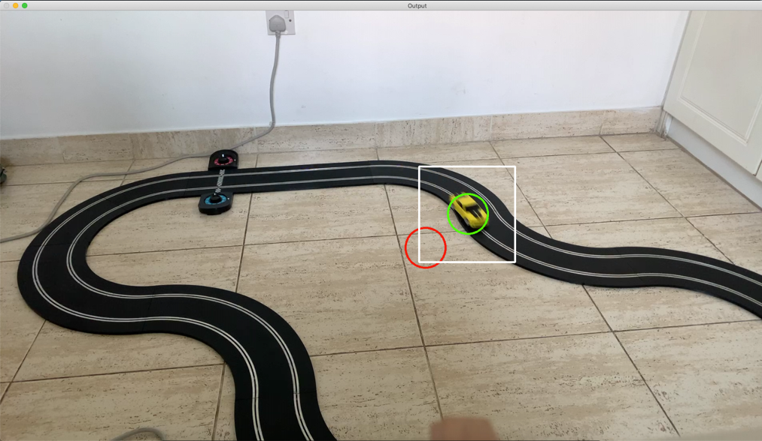

It is very clear that the new algorithm provides an accurate position of the car.

Looking at another zoomed in Image:

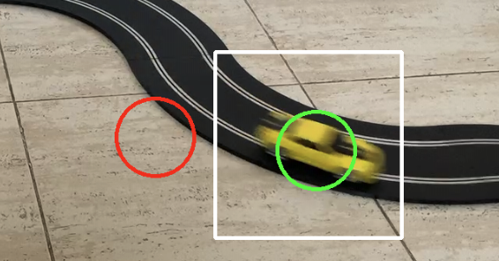

Now that I can accurately get the car location, I can start to work on calculating the car’s speed. I can do this quite simply using the pseudocode below.

1. oldLocation 🡨 getCarLocation()
2. time.sleep(specifiedTime)
3. newLocation 🡨 getCarLocation()
4. PixelDistance = getDistBetweenCoords(oldLocation, newLocation)
5. distance = pixelsToDistance(pixelDistance)
6. return distance / specifiedTime

Private METHOD detDistBetweenCoords(coord1, coord2):

return the value of the formula:

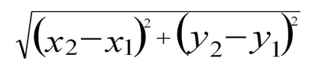

To calculate K I did the following: I knew that the width of the track is 2m wide. If the camera is squared with the track, 2000mm ÷ image width, will result in the Distance (in mm) per pixel.

Private METHOD pixelsToDistance(pixelDistance):

K = 2000 / Self.__width

Return pixelDistance * K

The final prototype I produced for this is shown below:

def getCarSpeed(self, zD: int, zP: float) -> float:

startTime = time()

startCoords = self.getCarLocation(zD,zP)

endCoords = self.getCarLocation(zD,zP)

endTime = time()

distance = self.__getDistBetweenCoords(startCoords, endCoords)

speed = distance / (endTime-startTime)

Usually this would only return the speed, but I modified it for my testing.

return startCoords, endCoords, speed

def __getDistBetweenCoords(self, p1: tuple, p2: tuple) -> float:

xDist = p2[0] - p1[0]

yDist = p2[1] – p1[1]

pixelDist = sqrt((xDist**2) + (yDist**2))

return self.__pixelToDist(pixelDist)

def __pixelToDist(self, distance: float) -> float:

k = 2000 / self.__width

This method can always be modified later if this calculation is unsuitable.

return distance*k

def __getZoomedMask(self, curMask, meanX: int, meanY: int, size: int) -> tuple:

x1 = meanX-size if meanX-size >= 0 else 0

y1 = meanY-size if meanY-size >= 0 else 0

x2 = meanX+size if meanX+size <= self.__width else self.__width

y2 = meanY+size if meanY+size <= self.__height else self.__height

return curMask[y1:y2, x1:x2], x1, y1

def __CalcAverageLocation(self, mask) -> tuple:

I came across many problems with NaN errors being produced, despite having a trained model already. One major issue were the parameters passed in. When doing too many iterations or zooming in a lot each time, NaN errors were produced. This message will remind me in future if I make the same mistake.

maskPositiveCoords = np.where(mask == 255)

xCoords = maskPositiveCoords[1]

yCoords = maskPositiveCoords[0]

if len(xCoords) > 0:

meanX = int(np.mean(xCoords))

meanY = int(np.mean(yCoords))

return meanX, meanY

else:

print("NaN Error Received, check zoom parameters")

return -1, -1

def getCarLocation(self, zoomDepth: int, zoomPerc: float) -> tuple:

frame = self.__readFrame()

if self.__readFailure:

return None, None

foreGroundMask = self.__backgroundSubtractor.apply(frame)

meanX, meanY = self.__CalcAverageLocation(foreGroundMask)

size = self.__width

for _ in range(zoomDepth):

size = int(size*zoomPerc)

newForeGround, x1, y1 = self.__getZoomedMask(foreGroundMask, meanX, meanY, size)

meanX, meanY = self.__CalcAverageLocation(newForeGround)

meanX += x1

This method has the exact same logic as the showCarLocation() method I designed in prototype 2, except it doesn’t render the frame; it just returns the values.

meanY += y1

return meanX, meanY

def draw(self, locations):

frame = self.__readFrame()

This method was made only for testing purposes, as it will show me where the measurements are taken from, so I can determine if they’re reliable.

for x,y in locations:

cv.circle(frame, (x,y), 10, (0,255,0))

while True:

cv.imshow("frame", frame)

key = cv.waitKey(1)

if key == 27:

break

code snippet 14 – prototype 3

The testing code I wrote is shown below.

if __name__ == '__main__':

cam = CameraInput()

Train The BGSub to reduce NaN errors

trained = cam.trainBackground(50)

locations = []

if trained:

for _ in range(10):

start, end, spd = cam.getCarSpeed(4, 0.5)

print(f"from {start} to {end} spd: {spd}")

locations.append(start)

Output messages and location indicators will allow me to predict if speed measurements are reliable.

locations.append(end)

else:

print("not trained")

cam.draw(locations)

**Expected Output:** A frame showing locations where the car’s distance has been measured. There should also be 10 output messages showing start and end coordinates along with speed.

**Output:**

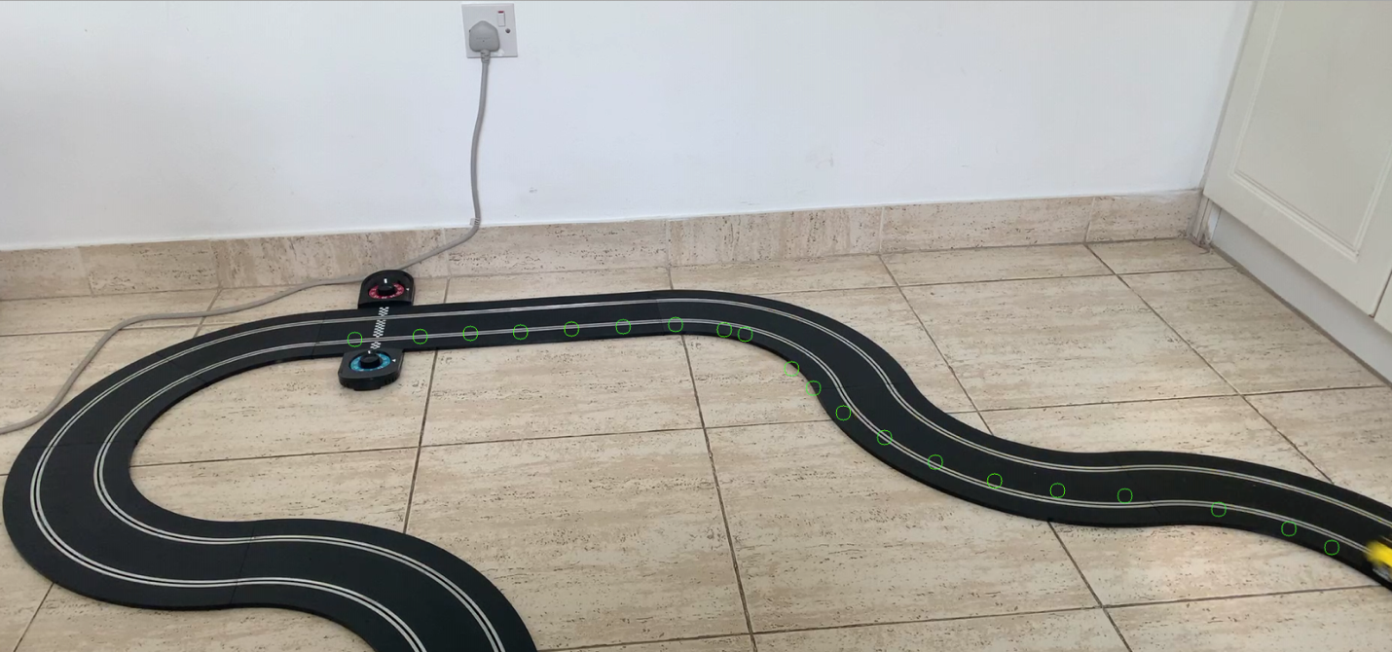

9

6

Training complete

It’s difficult to guarantee that the speeds are accurate, but looking at the speeds and the markers on the track, the speed values seem to be reliable.

from (521, 452) to (608, 448) spd: 708.844783183555

from (675, 444) to (742, 442) spd: 551.2374216234776

from (810, 438) to (879, 435) spd: 517.4850959301976

from (949, 432) to (1014, 439) spd: 508.86303066791385

from (1042, 445) to (1104, 491) spd: 479.0685637311687

from (1133, 517) to (1173, 550) spd: 289.0526321592886 **6**

from (1228, 583) to (1296, 616) spd: 559.1952714101886

from (1375, 641) to (1459, 654) spd: 706.3509721425629

from (1549, 661) to (1674, 679) spd: 980.5699443102825 **9**

from (1768, 705) to (1825, 730) spd: 433.62179141172663

Looking at the fastest and slowest speeds and comparing them to the distances on the frame, it looks like the algorithm is performing well. Furthermore, the average speed of the car is around 0.5m s-1, which is realistic. After experimenting with the speed values, I realised that I made an invalid assumption during my Table Formatting section of my Reinforcement Learning Design (pg. 85). I thought the car wouldn’t travel faster than 100mm s-1, whereas these results clearly show that it does. There are two simple solutions I can use: either I change the state to have three digits instead of two, or I change the units on the speed value to cm s-1. As units don’t make any difference, I will go with the latter.

Now that I have completed the functionality for tracking the car, I will start to design the functionality for finding the on-track markers. The first things I need to find are the RGB colours for each of the coloured stickers I’m going to use. For my design and prototyping stage, I will be using coloured Post-It notes. I decided to create a simple calibration program which I can use to get the colour values for a specific pixel.

My goal for the calibration software is to be able to print out the colour of the pixel I click on with the mouse. I did this using this code.

import cv2 as cv

import numpy as np

class Calibrator:

def __init__(self):

self.__y, self.__x = 500,500

self.__cam = cv.VideoCapture(1)

def __onClick(self, event, x, y, flags, param):

Click event for the mouse is bound to this method.

if event == cv.EVENT_LBUTTONDOWN:

self.__x = x

self.__y = y

def run(self):

while True:

Draw a circle and the exact pixel on screen to show where the user clicked.

_, frame = self.__cam.read()

cv.setMouseCallback("frame", self.__onClick)

frame[self.__y, self.__x] = (0,255,0)

cv.circle(frame, (self.__x, self.__y), 20, (0,255,0), 3)

When the spacebar is pressed, show the colour of the pixel in the BGR format. (default for OpenCV is BGR not RGB)

cv.imshow("frame", frame)

key = cv.waitKey(1)

if key == 32:

_, newFrame = self.__cam.read()

print(newFrame[self.__y,self.__x])

if key == 27:

break

cal = Calibrator()

cal.run()

code snippet 15

Using this method, I can get a range of colours which represent the coloured Post-It notes I’m using. I will need to calibrate my colours frequently, as different lighting conditions will change the colour values. Now that I have the colour values I’m looking for, I can start to prototype the algorithm that will search for the colours. Since there will be many checkpoints, I can’t just take an average location of the mask. I will need to use a blob detector. OpenCV has a built-in simple blob detector which I can use to find the location of the colours. After some research into the simple blob detector, I found that it works best on images with a white background which have been blurred. I decided to investigate the blur methods OpenCV has. There are many ways to blur an image, including Matrix averaging, Gaussian blurring, Median blurring and more. I decided to use the basic Matrix averaging method, as it is the simplest and should give me my desired result. The pseudocode I designed for this algorithm is shown below.

1. Define lower and upper bounds for green and orange colours
2. Initialise the blob detector
3. Read a frame from the camera
4. Make a green mask using the cv.inRange() method and my defined lower and upper bounds.
5. Make an orange mask using the same method and the orange lower and upper bounds.
6. Invert both masks
7. Blur both masks using cv.blur() method
8. Use the detector on both masks to find blobs
9. For each blob, draw a green circle around it if it’s a green colour, else an orange circle.

Using the pseudo code as a reference, I created this prototype code.

import cv2 as cv

import numpy as np

Defining the lower and upper bounds using the range of values from the calibration program I made earlier.

greenLower = np.array([63, 185, 170])

greenUpper = np.array([83, 225, 210])

orangeLower = np.array([35, 140, 230])

orangeUpper = np.array([55, 180, 255])

cam = cv.VideoCapture(1)

detector = cv.SimpleBlobDetector_create()

while True:

_, frame = cam.read()

greenMask = cv.inRange(frame, greenLower, greenUpper)

Inverting and blurring. I blur the image a lot (15 on both axis) to increase the pixel density as much as possible. (The importance of this is explained later)

greenMask = cv.bitwise_not(cv.blur(greenMask, (15,15)))

orangeMask = cv.inRange(frame, orangeLower, orangeUpper)

orangeMask = cv.bitwise_not(cv.blur(orangeMask, (15,15)))

greenKeyPoints = detector.detect(greenMask)

orangeKeyPoints = detector.detect(orangeMask)

for object in greenKeyPoints:

x = int(object.pt[0])

y = int(object.pt[1])

cv.circle(frame, (x,y), 50, (0,255,0), 3)

Drawing the circle for each blob of colour.

for object in orangeKeyPoints:

x = int(object.pt[0])

y = int(object.pt[1])

cv.circle(frame, (x,y), 50, (0,0,255), 3)

cv.imshow("frame", frame)

key = cv.waitKey(1)

if key == 27:

break

code snippet 16

**Expected Output:** A constant video feed where all the coloured Post-Its I placed on the track are circled with their respective colour.

**Output:**

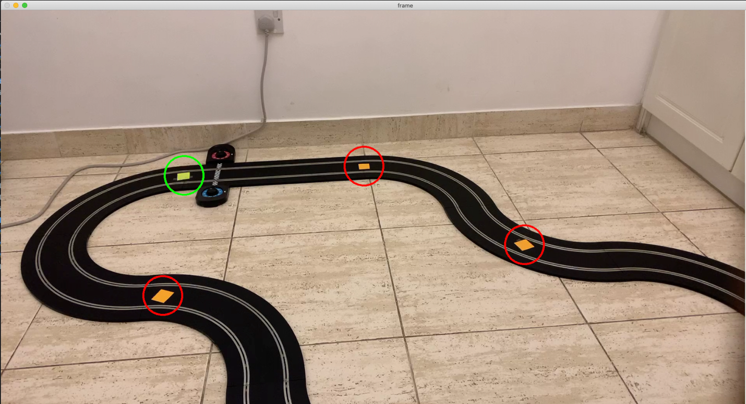

The range of colours I defined allows slightly different oranges to both be detected.

The output indicates that the program is working well. Furthermore, if I add more Post-Its or move some, the program is able to track them perfectly. Now that I have completed this section of the Computer Vision module, I can put both together to create my final prototype of the completed module.

#### Blurring

Before I move onto creating the full module, I need to explain what the point is of blurring an image. In this case, blurring the image will increase the pixel density of the image. This means that there are more of the object’s pixels around the object, which makes it easier to detect. As the Post-Its I used are quite small objects, I need to blur the mask a lot so that they show up more, making it easier for the blob detector to find them.

After working with blurring images to make them easier to detect, I realised that I didn’t use any blurring when I detected the moving car. Another use of blurring an image is to reduce noise in the image. As there is a lot of noise in the BGSub mask, this could mean that blurring the image could make my moving object detection even better. I decided to do some tests with blurring the image and the results are shown below.

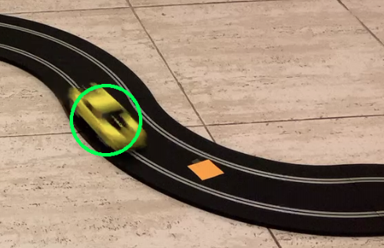

The circle tracked the car near-perfectly all the way around the track for many different speeds.

Rather annoyingly, blurring the image almost works just as well as the zooming algorithm I spent 6 hours designing. Both methods reduce the noise in the image making the average more reliable, and blurring sometimes works so well that the foreground mask is empty and I get a NaN Error. Instead of discarding my previous algorithm and replacing it with blurring the image, I will include both techniques together to hopefully achieve the most reliable result possible. If the algorithm needs to work quickly, I can set the zoom Depth parameter to 0, meaning none of the zooming process is done. If I need a more accurate result, or I need to ignore other smaller moving objects, I can use the zooming process to achieve this.

Now that both parts of the Computer Vison Input are complete, I just need to put them together into one module and create one last method, which calculates the distance between the car and the next track Location. The pseudocode for this last method is shown and annotated below.

Public METHOD getDistToNextTrackLocation(carLocation1, carLocation2): **1**

locDistances = {} **2**

for location in self.__trackLocations: **3**

dist = self.__getDistBetweenCoords(location, carLocation1) **4**

locDistances[location] = dist

loc1, loc2 = getTwoLocWithSmallestDist(locDistances) **5**

newLoc1Dist = self.__getDistBetweenCoords(loc1, carLocation2)

newLoc2Dist = self.__getDistBetweenPoints(loc2, carLocation2)

if newLoc1Dist < locDistances[loc1]: **6**

return locDistances[loc1]

else:

return locDistances[loc2]

**Annotations**

1. It would be neat to use the same two frames for this method and the getCarSpeed() method, as then both measurements come from the same point in time. This does mean modifying the getCarSpeed() method a little.
2. The distances will be stored as a dictionary with the key being a tuple (which is possible if its immutable). This is because I then have a reference for which distance belongs to which track location.
3. As mentioned in the diagram in my High-Level overview, the track locations are static, and therefore can be stored instead of needing to search for them every time.
4. This method already exists and is used in the getCarSpeed() method
5. This method can be implemented using a method called nsmallest() from the heapq library. I can use it to find the dictionary keys with the n (in my case 2) smallest values assigned to them. This method is one of the most efficient ways to do this, as it makes use of a binary tree organised specifically to make this searching efficient.
6. Whichever location that has the distance decreasing between it and the car, is the location the car is moving towards, therefore that is the next track location. If the distance increases, the car has already passed that point.

After writing this pseudocode, I realised that I want to split the method into two separate methods: one called getNextTrackLocation(), and one called getDistToNextTrackLoaction() which will call getNextTrackLocation() then getDistBetweenPoints(). The reason for this, is because I might be able to reuse the getNextTrackLocation() method later when I need to check if the car has deslotted.

Using the pseudocode and my previous prototypes, I can finally create the finished camera Input module. The final prototype code is shown below.

import cv2 as cv

import numpy as np

Only importing the relevant methods from these libraries as good practice.

from time import time

from math import sqrt

from heapq import nsmallest

class CameraInput:

def __init__(self, greenRange: list, orangeRange: list) -> None:

# initializing OpenCV objects

self.__cameraFeed = cv.VideoCapture(1)

self.__backgroundSubtractor = cv.createBackgroundSubtractorMOG2(detectShadows=False)

self.__detector = cv.SimpleBlobDetector_create()

# getting image dimensions

self.__readFailure = True

frame = self.__readFrame()

if self.__readFailure: # frame needs to be read to get img size

print("Camera module not created")

It’s important to note that this statement won’t stop the object from being created. If I want to check if the object hasn’t been created, I will need to raise an error here, which can then be handled by the program calling this class.

return None

imgShape = frame.shape

self.__width = imgShape[1]

self.__height = imgShape[0]

# getting colour ranges

self.__greenRange = self.__validateColourRange(greenRange)

self.__orangeRange = self.__validateColourRange(orangeRange)

if self.__greenRange == [] or self.__orangeRange == []:

print("invalid colour range")

return None

else:

The cv.where() method requires the conditions to be NumPy arrays. Here the lists passed in are converted.

self.__greenRange = np.array(self.__greenRange)

self.__orangeRange = np.array(self.__orangeRange)

# initializing empty Track locations

self.__trackLocations = {}

self.__GREEN = 0

Constants could be defined in global scope, but I don’t need them anywhere but in this class, so I define them here.

self.__ORANGE = 1

self.__DESLOT_THRESHOLD = 10

# =============== Private Methods =============================

def __readFrame(self):

Here I’m using an attribute to store if the camera ever has issues reading a frame. I can use this attribute later to validate that the camera is working.

successful, frame = self.__cameraFeed.read()

if not successful:

self.__readFailure = True

print("frame could not be read")

return None

else:

self.__readFailure = False

return frame

These values are hard coded as they will never change as long as I’m using BGR colours. They could be defined as constants in the global scope for good practice, but I didn’t feel that it was necessary for this prototype.

@staticmethod

def __validateColourRange(colourRange: list) -> list:

if len(colourRange) != 2:

return []

for i, bound in enumerate(colourRange):

for j, colourVal in enumerate(bound):

try:

val = int(colourVal)

if val >= 0 and val <= 255: #BGR colours: 0-255

colourRange[i][j] = val

I raise a value error here to make the except code-block run and display the correct message.

else:

raise ValueError

except ValueError:

print(colourVal, "is not a valid colour")

return []

return colourRange

def __getCarLocation(self, zoomDepth: int, zoomPerc: float) -> tuple:

frame = self.__readFrame()

if self.__readFailure:

Applying a weak blurring effect to the image to reduce noise.

return None, None

foreGroundMask = self.__backgroundSubtractor.apply(frame)

foreGroundMask = cv.blur(foreGroundMask, (5,5))

meanX, meanY = self.__CalcAverageLocation(foreGroundMask)

size = self.__width

If needed, my zooming algorithm can be used as well. (depends on the parameters)

for _ in range(zoomDepth):

size = int(size*zoomPerc)

newForeGround, x1, y1 = self.__getZoomedMask(foreGroundMask, meanX, meanY, size)

meanX, meanY = self.__CalcAverageLocation(newForeGround)

meanX += x1

meanY += y1

return meanX, meanY

def __getZoomedMask(self, curMask, meanX: int, meanY: int, size: int) -> tuple:

x1 = meanX-size if meanX-size >= 0 else 0

y1 = meanY-size if meanY-size >= 0 else 0

x2 = meanX+size if meanX+size <= self.__width else self.__width

y2 = meanY+size if meanY+size <= self.__height else self.__height

return curMask[y1:y2, x1:x2], x1, y1

def __CalcAverageLocation(self, mask) -> tuple:

maskPositiveCoords = np.where(mask == 255)

xCoords = maskPositiveCoords[1]

These NaN errors often occur when the car moves out of the camera’s frame. I could potentially use this in my real implementation as another way to automatically detect a deslot.

yCoords = maskPositiveCoords[0]

if len(xCoords) > 0:

meanX = int(np.mean(xCoords))

meanY = int(np.mean(yCoords))

return meanX, meanY

else:

print("NaN Error Received, check zoom parameters")

return -1, -1

def __getDistBetweenCoords(self, p1: tuple, p2: tuple) -> float:

xDist = p2[0] - p1[0]

yDist = p2[1] – p1[1]

The units on this have been changed to cm. Both the distance to next corner and speed values will have cm / cm s-1 as their units now.

pixelDist = sqrt((xDist**2) + (yDist**2))

return self.__pixelToDist(pixelDist)

def __pixelToDist(self, distance: float) -> float:

k = 200 / self.__width

return distance*k

def __getCarSpeed(self, startCoords: tuple, endCoords: tuple, time: float) -> float:

distance = self.__getDistBetweenCoords(startCoords, endCoords)

return distance / time

I made this method public so that I can call it multiple times if needed.

# ================= Public Methods ==================

def updateTrackLocations(self, numToFind: int, maxIters: int) -> bool:

for _ in range(maxIters):

As all the track locations may not be detected using one frame, I have made it so that it can use multiple frames to detect the different track pieces.

numLocsFound = 0

self.__trackLocations = {}

frame = self.__readFrame()

if self.__readFailure:

print("track locations not updated")

return False

greenMask = cv.inRange(frame, *self.__greenRange)

greenMask = cv.bitwise_not(cv.blur(greenMask, (15,15)))

orangeMask = cv.inRange(frame, *self.__orangeRange)

orangeMask = cv.bitwise_not(cv.blur(orangeMask, (15,15)))

greenKeyPoints = self.__detector.detect(greenMask)

orangeKeyPoints = self.__detector.detect(orangeMask)

The coordinates of the different track pieces are stored as the keys in the dictionary. This is possible as the coordinates will always be unique per blob the detector finds.

for object in greenKeyPoints: # green is 0

x = int(object.pt[0])

y = int(object.pt[1])

self.__trackLocations[(x,y)] = self.__GREEN

numLocsFound += 1

for object in orangeKeyPoints: # orange is 1

x = int(object.pt[0])

y = int(object.pt[1])

Once it finds however many track locations it needs to, the loop terminates.

self.__trackLocations[(x,y)] = self.__ORANGE

numLocsFound += 1

if numLocsFound == numToFind:

print("all locations found and saved")

print(self.__trackLocations)

return True

If it finds too many or too little locations, it means the colour ranges are incorrect and need to be recalibrated

print("Max iterations reached:")

if numLocsFound > numToFind:

print("Too many locations found")

else:

print("Too little locations found")

print(self.__trackLocations)

print("Please calibrate the colours")

return False

def trainBackground(self, numFrames:int) -> bool:

for _ in range(numFrames):

frame = self.__readFrame()

if self.__readFailure:

print("Failed to train background")

return False

I have merged the two parts of the computer vision module into one method. This allows me to use the same two frames for both measurements (as explained in annotation 1 for my pseudocode).

else:

self.__backgroundSubractor.apply(frame)

print("Training complete")

return True

def getCarInfo(self, zD: int, zP: float) -> dict:

info = {}

Using a dictionary allows me to return all the data neatly collected in one organized data structure.

startTime = time()

startCoords = self.__getCarLocation(zD,zP)

endCoords = self.__getCarLocation(zD,zP)

endTime = time()

The two frames that need to be used are collected here.

elapsedTime = endTime-startTime

info["carLocation"] = endCoords

info["carSpeed"] = self.__getCarSpeed(startCoords, endCoords, elapsedTime)

info["nextTrackLoc"] = self.getNextTrackLocation(startCoords, endCoords)

info["nextTrackLocDist"] = self.__getDistBetweenCoords(endCoords, info["nextTrackLoc"])

info["nextTrackLocType"] = self.__trackLocations[info["nextTrackLoc"]]

if info["carSpeed"] < self.__DESLOT_THRESHOLD:

info["deslotted"] = True

If the car has a very slow speed (not moving), it likely means it has deslotted. If the speed is below a certain threshold I defined, I say it has deslotted.

else:

info["deslotted"] = False

return info

def getNextTrackLocation(self, carLoc1: tuple, carLoc2: tuple) -> tuple:

locDistances = {}

This is the algorithm I pseudo coded. The testing will include this algorithm’s performance.

for loc in self.__trackLocations:

dist = self.__getDistBetweenCoords(carLoc1, loc)

locDistances[loc] = dist

loc1, loc2 = nsmallest(2, locDistances, key=locDistances.get)

newLoc1Dist = self.__getDistBetweenCoords(carLoc2, loc1)

newLoc2Dist = self.__getDistBetweenCoords(carLoc2, loc2)

deltaDist1 = newLoc1Dist - locDistances[loc1]

Using the heapq.nsmallest() method I explained in my pseudocode.

deltaDist2 = newLoc2Dist - locDistances[loc2]

if deltaDist1 < deltaDist2:

return loc1

else:

This is the testing method I made to visualize the performance of the algorithm.

return loc2

def test(self):

while True:

These parameters appear to work well for the zooming algorithm.

frame = self.__readFrame()

info = self.getCarInfo(1, 0.1)

cv.circle(frame, (info["carLocation"]), 50, (0, 255, 0), 3)

cv.circle(frame, (info["nextTrackLoc"]), 50, (255,255,255), 3)

if info["deslotted"]:

cv.circle(frame, (info["carLocation"]), 50, (0,0,255), 3)

cv.imshow("f", frame)

key = cv.waitKey(1)

if key == 27:

print("The returned info looks like:")

print(info)

break

Code snippet 17

For the testing of this algorithm, I decided only to test the new features. These are the car information (stored as a dictionary) and the getNextTrackLocation() method. The test program I wrote is shown below.

# Test 1

badRange1 = [[0, -1, 255],[200, 45, 6]]

badRange2 = [["four", "56", "34"], ["255", "3", "35"]]

errorCam = CameraInput(badRange1, badRange2)

# Test 2

greenRange = [[80, "220", 200], [110, 255, "220"]]

orangeRange = [[40, 140, "230"], [70, 180, 255]]

cam = CameraInput(greenRange, orangeRange)

success = cam.updateTrackLocations(6, 50)

if success:

cam.trainBackground(50)

cam.test()

**Test 1:** Testing the validation

**Expected output:**  The validation routine should find that -1 and “four” are invalid colour values,

returning a message explaining the problem.

**Output:**

-1 is not a valid colour

four is not a valid colour

invalid colour range

The validation routine is working well, but there is one improvement that could be made. If a list of

[-1, 300, “a”] is passed in, the message shown to the user will only include the first invalid input. This is

because it terminates after the first value is invalid. This could be improved by not terminating it

immediately, and using a flag variable to indicate that there was an invalid element.

**Test 2:** Testing the getNextTrackLocation() method

**Expected output:** I have designed the testing program to display a green circle around the car’s position and a white circle around the Track location it predicts to be the next one. Furthermore, if the car has deslotted, a red circle is drawn around the car. Next, when I press the escape key, it should print out an example of what the ‘info’ dictionary looks like.

**Output:**

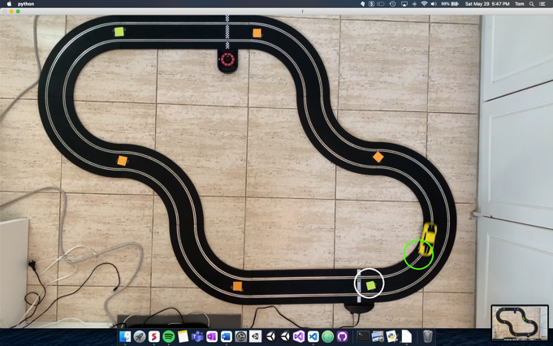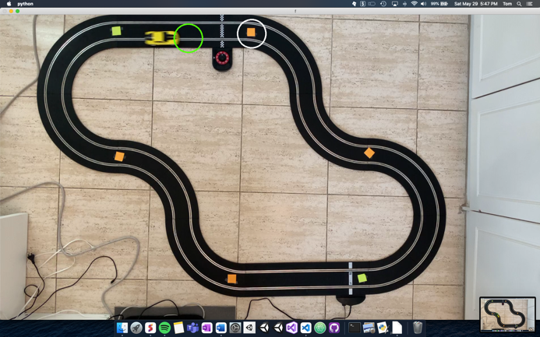

New camera angle explained below

The green circle is a little inaccurate due to this frame being taken slightly before the two measurement frames are.

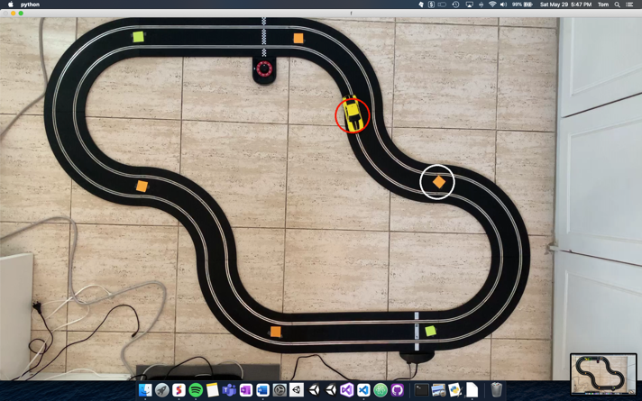

When the car is stood still, a red circle is drawn indicating a deslot.

As I can’t show every frame, I have included a few screenshots showing the performance of the algorithm.

The returned info looks like:

{'carLocation': (709, 89), 'carSpeed': 35.918393993102256, 'nextTrackLoc': (880, 70), 'nextTrackLocDist': 17.922116419230303, 'nextTrackLocType': 1, 'deslotted': False}

From the output I can see that the entire module is working as expected. Furthermore, the output is in a neat format for me to use later. The output contains all the information needed to fulfil the entirety of final requirement 8.1 and 9.1.

### Amending Final Requirement 9

Final requirement 9 states “My iPhone camera will be suspended from the ceiling by three strings in a triangular arrangement at 140-160cm above the track.”

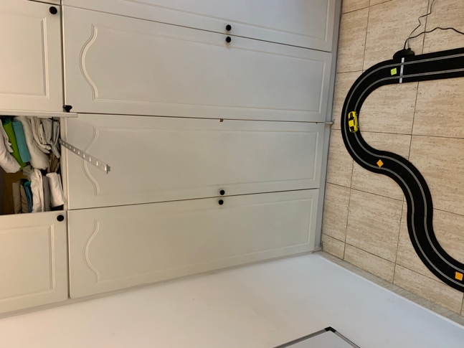When working on the final part of my Computer Vision module design, I came up with a better way to suspend my iPhone. It is shown in figure 46. It involves using a metal bar protruding from a cupboard, which is weighted at one end. I can then attach my phone to the end of the bar using magnets or tape. This new bar technique is more stable than the string technique, however, it has a few disadvantages. Firstly, I can only use this technique in my house, as there is no cupboard like this at my school. This means I must do all the testing at home. Given the current COVID-19 situation, having to do the testing at home is better than having to do the testing at school, because I would still be able to work on it if I was in quarantine. Another disadvantage is the fixed height. The bar is at the height of the cupboard, which is fixed. This means I can’t line the camera’s frame up with the track, as I could do before by changing the length of the strings. Overall, I believe the simplicity and stability of the metal bar method outweighs its disadvantages, so I will use this method in all future testing. This does mean that I must alter my requirement and redefine how I do the pixel to distance conversion, as the distance is no longer 200cm. The new requirement 9 is as follows:

Figure 46

9. My iPhone camera will be suspended above the track using a metal bar fixed at specific height of 190cm.

Next, I need to redefine the relationship between pixels and distance. I decided to make another calibration program that I can use. The calibration will work as described below.

1. User clicks at the two widest points around the track.
2. Using the x coordinates of the two points, I can calculate how many pixels are between them.
3. Use the track width (200cm) and the number of pixels to calculate the pixel to distance relationship.

The calibration program is very simple and is shown below:

import cv2 as cv

Every time I click somewhere on the image, the x location of where I clicked is shown. I can use them to calulate the number of pixels between them.

cap = cv.VideoCapture(1)

def onClick(event, x, y, flags, param):

if event == cv.EVENT_LBUTTONDOWN:

print("clicked at x: ", x)

print("the x coord of where you click is printed")

while True:

_, frame = cap.read()

cv.setMouseCallback("frame", onClick)

cv.imshow("frame",frame)

key = cv.waitKey(1)

if key == 27:

break

code snippet 18

**Output:**

the x coord of where you click is printed

clicked at x: 124

clicked at x: 1569

Using this I found that the track is 1445 pixels wide on my image. After modifying my pixelToDistance() method in my prototype code, my Computer Vision module design is complete.

### Amending Final Requirement 11

As referenced in the note for requirement 11, I need to modify it to make the requirement more specific now that I know how what the state should look like. I have modified the requirement to be:

1. The data that is collected is formatted and given to the RL algorithm using:
   1. . An average value for speed and distance is calculated using the camera and hall sensor inputs
   2. . The speed, distance and severity will be formatted using 5 digits:

11.2.1. The first digit represents the severity of the corner. 0 for straights, 1 for turns.

11.2.2. The next 2 digits represent the car’s distance to next corner measured in cm.

11.2.3. The last 2 digits represent the car’s speed measured in cm s-1.

11.3. The state will be passed into the RL algorithm as a 5-digit long integer.

## User Interface

The User Interface for this investigation will probably be the easiest module to implement. As I already have some experience using Tkinter, I won’t need to learn much to complete my prototypes. As such I can start to design each aspect of the interface with close reference to the Final User Interface requirements I made in the Analysis section of this investigation.

Best practice for using Tkinter is to use an Object-oriented approach. I decided to design a UML Class Diagram that will have modules fulfilling all the final user interface requirements. The diagram is shown in diagram 16 below and each main section will be explained individually below.

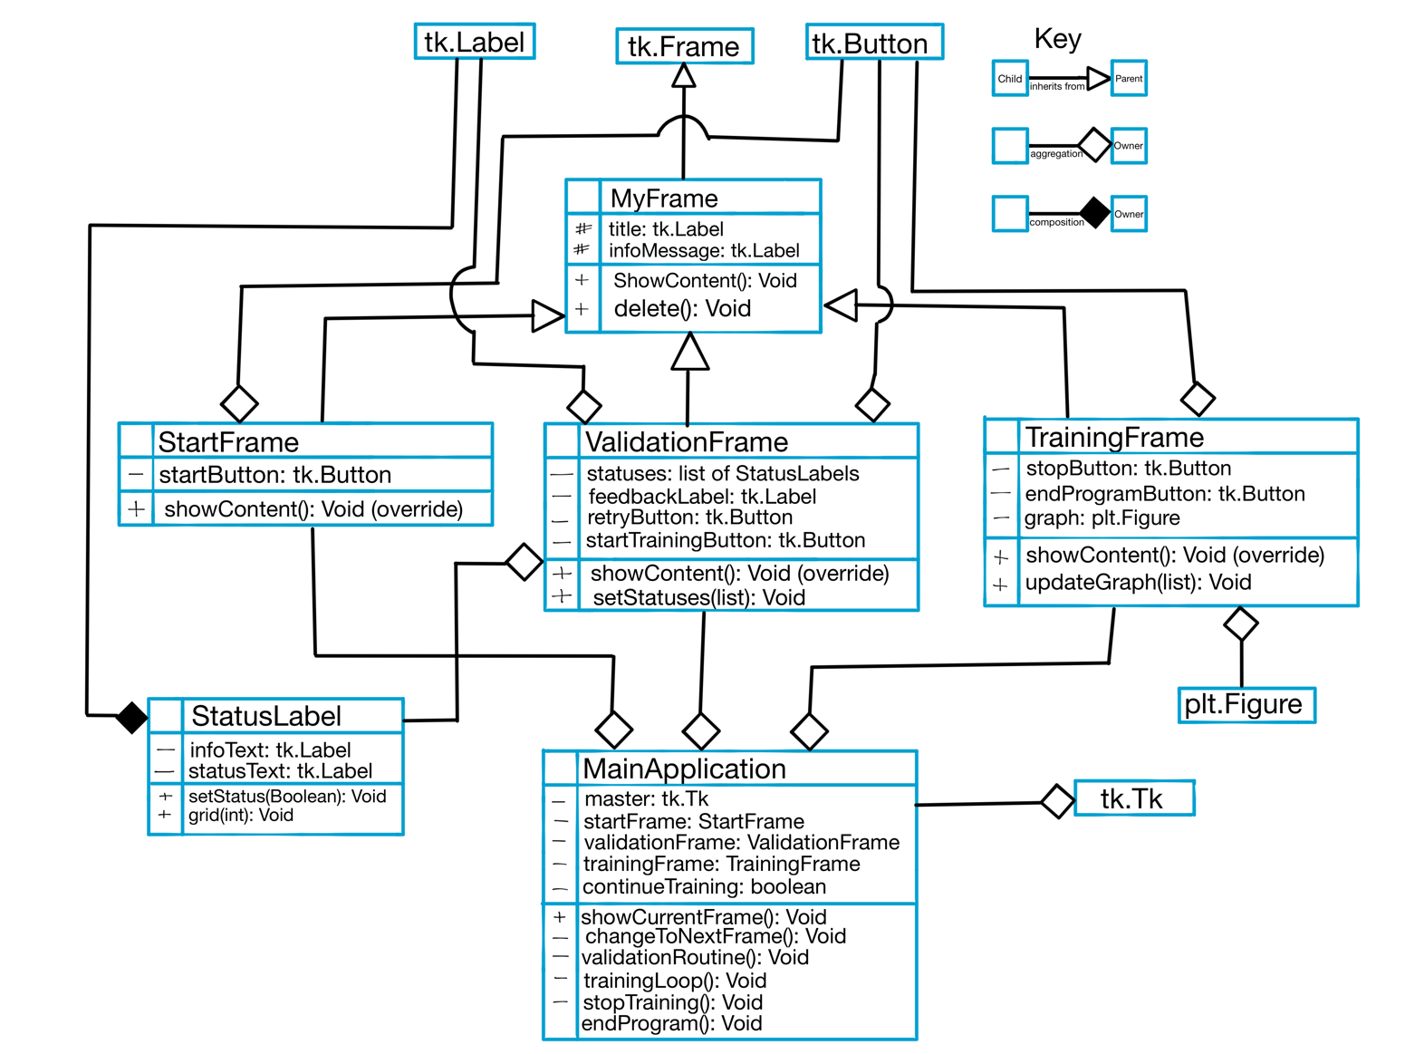

Diagram 16

### Diagram Explanation

#### MainApplication

This class is the main controller of the User Interface. It handles all the logic pertaining to showing the user the correct screen. As such, it needs to store references to each of the three frames. Furthermore, the training loop as well as the validation routine will be part of the main application class. This class will take advantage of the polymorphism* allowed by creating the MyFrame class, as each frame will have a showContent() method which it can call.

#### MyFrame

Recalling requirements:

4.1: “upon starting the program, the user is shown a welcome message.”

6.1: “the user is led to the validation screen which has a message explaining what the screen is”

7.1: “on the training screen the user is shown a message explaining what the screen is”

The requirements state that each screen must have a message explaining what the screen is. To fulfil this, I decided to make a utility class from which all three of my frames can inherit from. It has protected attributes ‘title’ and ‘infoMessage’ to allow any class that inherits from it to have these attributes as well. Furthermore, it also has a showContent() method which is left blank, and will need to be overridden by the child class. The reason for creating this class is to allow for polymorphism to be used by the main application for any frame that inherits from this class. The MyFrame class inherits from the Frame class in the Tkinter library. This was done so that myFrame has all the default attributes and methods of a tkinter frame, so can be used as one.

#### StartFrame

Recalling requirements:

1. “Upon starting the program, the user is shown:”
   1. “A welcome message”
   2. “A start button”

The start frame is responsible for welcoming the user to my program. It should be simple and visually appealing. It inherits from MyFrame in order to have all of its attributes and methods. The showContent() method will need to be overridden, so that it can show its own specific content. Lastly, a Tkinter Button will be made to allow the user to switch between from frame to the validation frame. Implementing the start button can be done by assigning a function to the command for a button. When the button is pressed, the function is called and the frames are changed.

#### ValidationFrame

Recalling requirements:

1. the user is led to a validation screen which has:
   1. “A message explaining what this screen is.
   2. “Labels and statuses (Passed or Failed) for the following:
      1. “Input from iPhone camera:” [status]
      2. “Car is seen by the camera:” [status]
      3. “Track is seen by the camera:” [status]
      4. “Input from on-track sensors:” [status]
   3. A message asking the user to do the necessary fixes (if any).
   4. A “Retry” button that will:
      1. Call a function to try validating everything again (requirement 5 again).
      2. Update the statuses
   5. A “Start Training” Button:
      1. When it is pressed, the user is led to the Training Screen.

The validation frame needs to show the user the statuses of all the inputs. 7.1 is fulfilled via the inheritance from MyFrame. To fulfil requirement 7.2, I designed a new StatusLabel class. The main reason for this is because I want to have black text for the information and coloured text for the status.

E.g. : Input from camera: Passed. Tkinter labels can’t have multiple colours, so I decided to make my own custom label class which is made up of two separate labels, one for the information and one for the status. Making it a class will also allow me to instantiate 4 of them for each item I need to validate. To fulfil 7.3 I can use another label to show some feedback text if any of the items are invalid. Moving onto requirement 7.4 and 7.5, I can do these in the same way I did the start button for the startFrame: linking each button to a function that is called when the button is pressed. For the retry button, I will need to link it to the validation routine, so that it called the entire routine again. For the start training button I can link it to the same function as the start button, which will change the frame.

#### TrainingFrame

Recalling requirements:

1. On the Training Screen the user is shown:
   1. A message explaining what this screen is
   2. A graph showing the time taken to complete a lap against the lap number
      1. The graph should be updated every lap
   3. A “Stop” button, when pressed:
      1. Sets the track voltage to 0 so the car stops
      2. Stops the Training loop
   4. An “End Program” button, when pressed:
      1. Stops all running loops (if any)
      2. Closes the window and ends the program

On the training screen, once again requirement 7.1 is fulfilled thanks to the inheritance from MyFrame. The buttons can also be done using the same method as in the other frames. What’s special about this frame is that a graph needs to be embedded into the tkinter window. I will be using Matplotlib to graph the data, but I need to use a special extension to generate a tkinter widget I can use. When I reach the point where I’m going to implement it, I will try to find some tutorials to help me. The next challenge is to make the graph update every frame. This could be done using the after() method built into Tkinter. I cannot use time.sleep() for this, as it will interfere with the clock used by the Tkinter window. Furthermore, I will eventually reach the recursion depth limit or get a stack overflow error if I use time.sleep and then call the same function. From my previous experience coding the flappy bird AI using Tkinter, using the built-in after() method does not result in a recursion depth limit error, as I could train the program all day long without any errors.

Now that I have a clear idea of how I want my User Interface to be structured, I can start to code my prototype. Using diagram 16 as a reference, the code I produced is shown and annotated below.

import tkinter as tk

from PIL import Image, ImageTk

import matplotlib.pyplot as plt

from matplotlib.backends.backend_tkagg import FigureCanvasTkAgg

Defining my constants up here as good practice.

WINDOW_SIZE = (650,500)

BG_COLOUR = "#FFFFFF"

RED = "#FF0000"

GREEN = "#20CC20"

FONT = "Verdana"

PATH = "/Users/Tom/Desktop/CS-A-level/NEA/Media/"

REFRESH_AFTER = 1000 # 1000ms = 1 second

class MyFrame(tk.Frame):

Here I create my own basic frame class inheriting from Tkinter’s frame class. This means it has all the functionality of a regular Tkinter Frame, but with the extra functionality I have added. As each frame will have a title and information message, I have added these as protected attributes to child classes will have them as well.

def __init__(self, master: tk.Tk) -> None:

tk.Frame.__init__(self, master,

width=WINDOW_SIZE[0],

height=WINDOW_SIZE[1],

bg=BG_COLOUR)

self._title = tk.Label(self,

font=(FONT, 35),

text="title text")

self._infoMessage = tk.Label(self,

font=(FONT,15),

text= "info text")

def showContent(self): # to be overridden later

Creating this method to be overridden later and to allow for polymorphism.

pass

def delete(self) -> None:

self.grid_forget()

self.destroy()

class StartFrame(MyFrame):

def __init__(self, master: tk.Tk, changeFrameFunc) -> None:

super().__init__(master)

self.__IMAGESIZE = (200,75)

# https://stackoverflow.com/questions/54716337/tkinter-how-to-place-image-into-a-frame

# Used this solution by Partho63 to add an image to the frame.

# He says the best practice is to use a canvas.

When creating the start frame, I thought it would look nice to add my FormulAI logo. For this I need to add it as an image. Maybe for the future: as better practice store the image name as a contant.

self.__canvasForImage = tk.Canvas(self,

width=WINDOW_SIZE[0],

height=100)

image = Image.open(PATH+"FormulAI_Logo.png")

self.__canvasForImage.image = ImageTk.PhotoImage(image.resize(self.__IMAGESIZE, Image.ANTIALIAS))

self.__canvasForImage.create_image(WINDOW_SIZE[0]//2, 50,

image=self.__canvasForImage.image)

The title and infoMessage attributes already exists thanks to inheritance, so all I need to do is configure the text.

self._title.config(text="Welcome To FormulAI!")

self._infoMessage.config(text=

"""\nFormulAI is an A-level NEA project designed by Tom Rietjens at Dubai College. \n \n

Please press the start button below to proceed!\n\n""")

In Python, functions can be handled as objects, and can therefore be passed into functions like this. Although the method is outside this class’s scope, it can still call it because I have passed it in as a parameter.

self.__startButton = tk.Button(self,

height=2,

width=10,

text="Start!",

font=(FONT, 25),

command=changeFrameFunc)

Overriding the showContent method to display everything specific to this frame. I decided to use grid() instead of pack(), as I can more easily control the position of the widgets this way.

def showContent(self) -> None:

self.__canvasForImage.grid(row=0)

self._title.grid(row=1)

self._infoMessage.grid(row=2)

self.__startButton.grid(row=3)

class StatusLabel:

def __init__(self, master: tk.Tk, infoText: str) -> None:

self.__infoText = tk.Label(master,

Here I make the StatusLabel class. It is a combination of two labels but organized so that I can use them as one object in the validation screen.

text=infoText +": ",

font=(FONT, 25))

self.__statusText = tk.Label(master,

text="Failed",

fg=RED,

font=(FONT, 25))

def grid(self, row: int) -> None:

self.__infoText.grid(row=row, column=0)

self.__statusText.grid(row=row, column=1)

def setStatus(self, status: bool) -> None:

self.__status = status

if self.__status:

self.__statusText.config(text="Passed",

fg=GREEN)

else:

self.__statusText.config(text="Failed",

fg=RED)

class ValidationFrame(MyFrame):

def __init__(self, master: tk.Tk, changeFrameFunc, retryFunc) -> None:

super().__init__(master)

self._title.config(text="Validation Screen")

self._infoMessage.config(text=

"""This is the screen where you must make sure all the inputs

are working as expected.\n""")

self.__statuses = [StatusLabel(self, "Input from iPhone camera"),

StatusLabel(self, "Car is seen by the camera"),

StatusLabel(self, "Track is seen by the camera"),

StatusLabel(self, "Input from on-track sensors")]

The benefit of making my own StatusLabel class is shown here.

self.__feedbackLabel = tk.Label(self, font=(FONT, 15))

self.__allValid = False

self.__retryButton = tk.Button(self,

height=2,

Once again, I pass in the function objects as parameters so that these buttons can call them when they are pressed

width=10,

text="Retry",

font=(FONT, 25),

command=retryFunc)

self.__startTrainingButton = tk.Button(self,

height=2,

width=15,

text="Start Training!",

font=(FONT, 25),

command=changeFrameFunc)

def setStatuses(self, allStatuses: list) -> None:

self.__allValid = True

self.__feedbackLabel.config(text="All inputs are valid!\n",

fg=GREEN)

I can update the statuses using the output from the validation routine.

for i, statusLabel in enumerate(self.__statuses):

if allStatuses[i]:

statusLabel.setStatus(True)

else:

statusLabel.setStatus(False)

self.__allValid = False

self.__feedbackLabel.config(text="Please do the necessary fixes\n",

fg=RED)

Overriding the method to show frame specific content. I don’t really like how I’ve implemented the rows here (using curRow), so that is something I can consider improving later.

def showContent(self) -> None:

self._title.grid(row=0, columnspan=2)

self._infoMessage.grid(row=1, columnspan=2)

for i, statusLabel in enumerate(self.__statuses):

statusLabel.grid(i+2)

curRow = len(self.__statuses)+3

self.__feedbackLabel.grid(row=curRow, columnspan=2)

if self.__allValid:

self.__startTrainingButton.grid(row=curRow+1, columnspan=2)

else:

self.__retryButton.grid(row=curRow+1, columnspan=2)

class TrainingFrame(MyFrame):

def __init__(self, master: tk.Tk, changeFrameFunc, stopLoopFunc) -> None:

super().__init__(master)

# setting up Tkinter widgets

self._title.config(text="Training Screen")

self._infoMessage.config(text=

"""This is the screen which shows you the progress of the Reinforcement

learning algorithm that is being applied to the car.""")

self.__stopButton = tk.Button(self,

height=2,

width=15,

text="STOP",

fg=RED,

font=(FONT, 25),

command=stopLoopFunc)

self.__endProgramButton = tk.Button(self,

height=2,

width=15,

text="End Program",

font=(FONT, 25),

command=changeFrameFunc)

# setting up the graphs

# I'm using both:

# https://www.geeksforgeeks.org/how-to-embed-matplotlib-charts-in-tkinter-gui/

# https://pythonprogramming.net/embedding-live-matplotlib-graph-tkinter-gui/

# to help me embed the graph into the window

Following these two tutorials to help me embed and update a live graph within Tkinter

self.__fig = plt.Figure(figsize=(3,3), dpi=100)

self.__fig.set_tight_layout(True)

self.__myPlot = self.__fig.add_subplot(111)

self.__canvasGraph = None

There is probably a more efficient way to do this, but this is what they used in the tutorial. Since this is just a prototype, I only need the functionality, not efficiency.

def updateGraph(self, newData: list) -> None:

xList = []

yList = []

for x, y in newData:

xList.append(int(x))

yList.append(int(y))

Creating a Tkinter widget I can use in my Tkinter window.

self.__myPlot.clear()

self.__myPlot.plot(xList, yList)

self.__myPlot.set_xlabel("Lap Number")

self.__myPlot.set_ylabel("Time Taken")

self.__canvasGraph = FigureCanvasTkAgg(self.__fig, master=self)

self.__canvasGraph.draw()

Once again, I’m overriding this method to show frame specific content.

def showContent(self) -> None:

self._title.grid(row=0, columnspan=2)

self._infoMessage.grid(row=1, columnspan=2)

if self.__canvasGraph is not None:

self.__canvasGraph.get_tk_widget().grid(row=2, columnspan=2)

self.__stopButton.grid(row=3, column=0, columnspan=1)

self.__endProgramButton.grid(row=3, column=1, columnspan=1)

class MainApplication:

Initializing all the frames for me to use later.

def __init__(self, master: tk.Tk) -> None:

self.__master = master

self.__master.minsize(width=WINDOW_SIZE[0],

height=WINDOW_SIZE[1])

I need to pass in the function objects.

self.__master.title("FormulAI")

self.__startFrame = StartFrame(self.__master, self.__changeToNextFrame)

self.__validationFrame = ValidationFrame(self.__master, self.__changeToNextFrame, self.__doValidationRoutine)

self.__trainingFrame = TrainingFrame(self.__master, self.__changeToNextFrame, self.__stopTraining)

Storing a reference to the current frame.

self.__currentFrame = self.__startFrame

def __changeToNextFrame(self) -> None:

When each of the relevant buttons are pressed, this method is called and is responsible for changing the frame shown to the user.

if self.__currentFrame == self.__startFrame:

self.__currentFrame.delete()

self.__currentFrame = self.__validationFrame

self.__doValidationRoutine(True)

elif self.__currentFrame == self.__validationFrame:

self.__currentFrame.delete()

self.__currentFrame = self.__trainingFrame

self.__continueTraining = True

self.__doTrainingLoop()

elif self.__currentFrame == self.__trainingFrame:

self.__trainingFrame.delete()

Thanks to polymorphism, I am able to do this.

self.__master.destroy()

self.__endProgram()

This parameter is only for testing. I needed some way to test both the failing and passing for this routine.

def showCurrentFrame(self) -> None:

self.__currentFrame.pack()

self.__currentFrame.showContent()

def __doValidationRoutine(self, toFail:bool=False) -> None:

if toFail:

output = [True, True, False, True]

else:

output = [True for x in range(4)]

self.__validationFrame.setStatuses(output)

self.showCurrentFrame()

def __doTrainingLoop(self) -> None:

self.showCurrentFrame()

# do the training

print("trained")

# to test the graph updating:

To test the live graph updating, I decided to read data from a file which I can update while the program is running. For my real implementation I will get the data from the sensors and pass that it.

newData = []

with open(PATH+"sampleData.txt", "r") as file:

for line in file:

line = line.strip()

x,y = line.split(",")

newData.append((x,y))

self.__currentFrame.updateGraph(newData)

if self.__continueTraining:

self.__master.after(REFRESH_AFTER, self.__doTrainingLoop)

else:

Using the built-in after method to make the training loop repeat.

print("training stopped")

def __stopTraining(self) -> None:

self.__continueTraining = False

def __endProgram(self) -> None:

print("Stopping Training loop...")

self.__stopTraining()

print("Closing Serial Ports...")

print("Closing Camera Input...")

# close everything

print("\nComplete")

if __name__ == "__main__":

root = tk.Tk()

app = MainApplication(root)

app.showCurrentFrame()

root.mainloop()

### Testing the User Interface

#### Start Frame

**Expected output:** The start frame should have a welcome message and a button that will lead the user to the next frame.

**Output:**

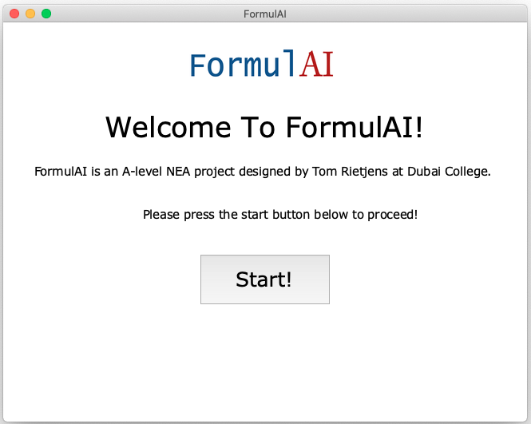

This logo adds some colour to the screen making it more visually appealing.

Proper welcome message.

Working start button that will lead the user to the validation screen.

I am happy with the output from the starting screen. Pressing the button I am led to the validation screen:

#### Validation Frame

**Expected output:** A frame with a title, information message, four status labels (one of which has failed), a feedback message and a retry button. After the retry button is pressed, all the statuses should pass, meaning the retry button changes to the Start Training button.

**Output:**

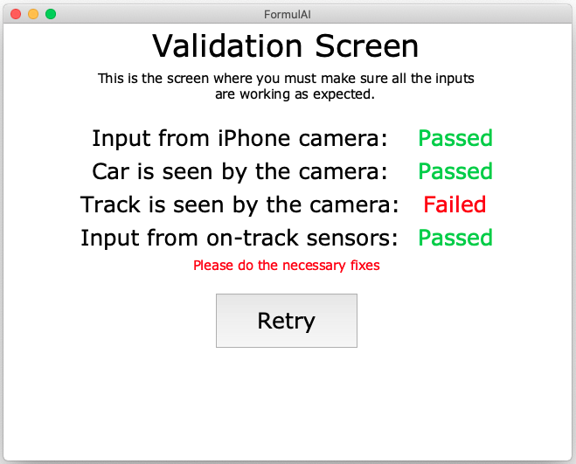

For my actual implementation, I might want to make this feedback more specific.

Pressing the retry button:

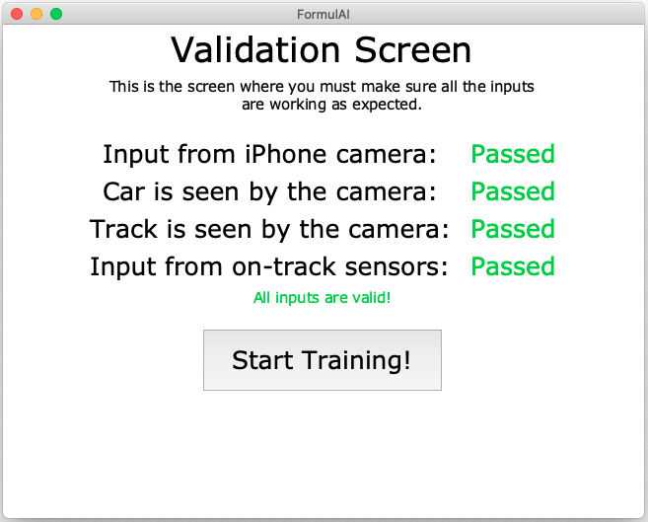

The retry button is replaced by the Start Training button when all the inputs are valid.

The aesthetics of this screen could be improved for the real implementation, but I’m happy with the functionality.

#### Training Frame

**Expected Output:** This frame must have a title and information message like the other two frames. More importantly, it must have a live graph displayed to the user with all the data from the text file that I can modify. With every modification to the test file, the graph should also update. Lastly, it must have buttons which stop the training loop and end the program.

**Output:**

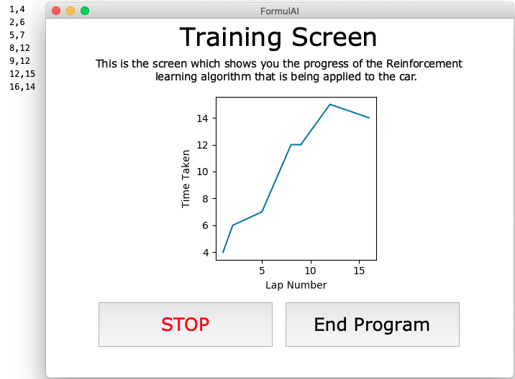

As I updated the values on this text file, the graph would update with the new information.

The output works as expected and it has everything it needs to fulfil the requirements I have made. However, there are some improvements that I might want to make for my final implementation. Firstly, the user doesn’t get any feedback on the information on the car. It might be nice to have a feedback label that is able to tell me information like current car speed, car location, next track location and if the car has deslotted. Furthermore, it might be nice to add the option to pause the training, not just stop it. This would be especially useful when the car deslots during training. Lastly, the graph is quite small, so I might want to make the entire window bigger to accommodate for a larger graph. These are all simple and small changes that aren’t required but would make the overall experience better. Overall, I’m happy with the performance of my User Interface prototype.

## Documented Design Reflection

My investigation requires a very wide range of technologies that will need to be implemented, ranging from Hardware to Machine Learning and Computer Vision. This design has given me a great understanding of each of these individual technologies, to the point where I’m comfortable using complex and efficient algorithms within them. Every core aspect, except for the User Interface, required me to learn something completely new. This design section has forced me to reach out and explore new technologies, fuelling my curiosity for computer science and even beyond into hardware and robotics. Through pseudocode and prototyping, then evaluating and refining, I have ended up with four working prototypes, which I can use as a reference when I move to building the actual implementation.

# Glossary

**STEM Subjects:** STEM stands for science, technology, engineering and mathematics. It is a broad term used to classify these types of subjects.

**Machine Learning:** A form of computer algorithm that improves automatically through experience. It is seen as a part of Artificial Intelligence.

**Semiconductors:** A solid substance that has an electrical conductivity between that of a conductor and an insulator. The conductive properties can be controlled, making it extremely useful for use in electronics.

**Standalone Computer System:** A combination of hardware and software which is able to operate independently of other hardware or software.

**Programming paradigm:** Ways of classifying programming languages based off their features. Each language can be classified into multiple paradigms. For example: Python can be coded structurally or object oriented.

**Structural Programming:** A programming paradigm where programs are constructed using multiple smaller chunks of code designed to do a specific thing. Code within a function has a local scope, meaning that it can’t access data outside the function unless it is passed in as a parameter.

**Object Oriented Programming:** A programming paradigm based on the concept of objects. Each individual object contains its own data in the form of fields (called attributes), and code (called methods). One approach to OOP is the class-based approach, where each object is an instance of classes.

**Newtons First Law:** An object standing still or travelling at a constant velocity will continue to travel at a constant velocity unless acted on by an external resultant force.

**Piezoelectric Material:** A material which releases an accumulated electric charge in response to mechanical stress being applied to it.

**Centrifugal Force:** An inertial force that appears to act on all objects when viewed in a rotating frame of reference. In other words: A force acting outward from the centre of the circle when an object turns. (Force acting inward is called the centripetal force.)

**Amplitude Modulation:** Small changes applied to a wave’s amplitude to encode information in a carrier wave.

**Frequency Modulation:** Small changes applied to a wave’s frequency to encode information in a carrier wave.

**Point Cloud:** a 3D rendering of an environment produced by a Lidar sensor using many pulses of laser light.

**Neural Network:** (Artificial Neural Network): A computing system vaguely inspired by the biological neural networks in animal brains. It is a collection of connected units called neurons which loosely model the neurons in a biological brain. They can be represented using an undirected, weighted graph.

**PWM (Pulse width modulation):** A method of controlling the average electrical power by effectively chopping it up into discrete parts. Controlling the average power sent to a motor will control the speed at which it spins.

**Polymorphism:** Where one object is interacted with as if it were the type of its parent class. For example, both a triangle and a square could inherit from a Shape class. Using polymorphism, one can treat both triangle and square objects as a shape.

# References

*Brno University of Technology: PDF document on Self-Driven Slot Car Racing*

<https://annals-csis.org/proceedings/2008/pliks/45.pdf>

*Electronics and equipment installation guide*

<https://www.hw.cz//files/FRC2010-SlotCarEquipment.pdf>

*GitHub repository for code similar to Freescale Slot Car Racer*

<https://github.com/zhearing/Freescale_CCD>

*Georgia Institute of Technology: PDF document on Autonomous Slot-car system*

<https://citeseerx.ist.psu.edu/viewdoc/download?doi=10.1.1.642.2155&rep=rep1&type=pdf>

*Microcontroller provided by Freescale:*

<https://www.nxp.com/docs/en/reference-manual/MCF51JM128RM.pdf>

*Choosing the right accelerometer*

<https://www.mouser.com/pdfdocs/choosing-the-right-accelerometer-white-paper.pdf>

*Face Tracking Camera:*

<https://create.arduino.cc/projecthub/Little_french_kev/face-tracking-camera-afbef5>

*Amazon’s DeepRacer:*

<https://aws.amazon.com/deepracer/>

*Amazon’s DeepRacer: In-depth developer guide*

<https://docs.aws.amazon.com/deepracer/latest/developerguide/deepracer-how-it-works.html>

*Proximal Policy Optimization Algorithms:*

<https://arxiv.org/pdf/1707.06347.pdf>

*Soft Actor Critic Policy optimisation algorithm:*

<https://spinningup.openai.com/en/latest/algorithms/sac.html>

*Neuro-Evolution of Augmenting topologies:*

<http://nn.cs.utexas.edu/downloads/papers/stanley.ec02.pdf>

*digital potentiometer documentation*

<https://www.analog.com/media/en/technical-documentation/data-sheets/AD5171.pdf>

*Servo motor controlled by Arduino examples:*

<https://www.allaboutcircuits.com/projects/servo-motor-control-with-an-arduino/>

<https://www.instructables.com/Arduino-Servo-Motors/>

*motor driver used with Arduino examples:*

<https://create.arduino.cc/projecthub/ryanchan/how-to-use-the-l298n-motor-driver-b124c5>

<https://www.buildwithelectronics.co.za/Blog/Arduino-Controlled-Slot-Car-Scalextric->